Causation Model Answer

Explain why the Revolt of the Earls failed in 1075. [12 marks]

|  |
| --- |
| You may use the following in your answer:  You must also use information of your own. |

|  |  |
| --- | --- |
| Reason One  *[Introduce and fully explain your first reason]*  *[Use your own knowledge to explain the reason giving examples where possible]* | Useful phrases  *The first reason for… This meant that…*  *This was important because… For example…*  *This led to…. As a result of… This is shown by…* |
| The first reason for the failure of the Revolt of the Earls in 1075 was the Danes arriving too late in order for support the rebellion . This was important because a key part of the rebels plan was to unite the English and Danish opponents of the Normans in order to have a large enough army to defeat the Normans. As a result of the Danes arriving too late to support the rebellion, the Earls did not have sufficient military power to seriously threaten the Normans. | |
| Reason Two  *[Introduce and fully explain your second reason]*  *[Use your own knowledge to explain the reason giving examples where possible]* | Useful phrases  *Another reason for… This meant that…*  *This was important because… For example…*  *This led to…. As a result of… This is shown by…* |
| Another reason for the failure of the Revolt of the Earls in 1075 was the decisive actions of Lanfranc. For example, Lanfranc sent two royal armies north who succeeded in preventing the rebel armies from combining into a single military force. As a result, the Earls did not have sufficient military power to seriously threaten the Normans. | |
| Reason Three  *[Introduce and fully explain your third reason]*  *[Use your own knowledge to explain the reason giving examples where possible]* | *A final reason for… This meant that…*  *This was important because… For example…*  *This led to…. As a result of… This is shown by…* |
| A further reason for the failure of the Revolt of the Earls in 1075 was the leaking of the plan by Waltheof to Lanfranc. This was important because it meant that Lanfranc and Odo were aware of the plot before the Earls had even begun to put their plan into action. This meant Lanfranc was always one step ahead and could take decisive action such as sending royal armies to prevent the rebels forming one military force. As a result, the Earls did not have sufficient military power to seriously threaten the Normans. | |

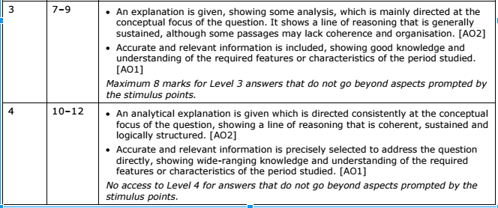

**TASKS:** Read back through your own answer, and the model answer.

Identify THREE features that the two answers share e.g. Both answers use examples of challenges faced by the Weimar Government.

1. …………………………………………………………………………………………………………………………………………………………….

…………………………………………………………………………………………………………………………………………………………….

2. …………………………………………………………………………………………………………………………………………………………….

…………………………………………………………………………………………………………………………………………………………….

3. …………………………………………………………………………………………………………………………………………………………….

…………………………………………………………………………………………………………………………………………………………….

Identify THREE features of the model answer which could have improved your answer. e.g. The model answer is clearly structured into three distinct reasons.

1. …………………………………………………………………………………………………………………………………………………………….

…………………………………………………………………………………………………………………………………………………………….

2. …………………………………………………………………………………………………………………………………………………………….

…………………………………………………………………………………………………………………………………………………………….

3. …………………………………………………………………………………………………………………………………………………………….

…………………………………………………………………………………………………………………………………………………………….

Rewrite ONE of your paragraphs/reasons in light of these reflections. [if not enough space, write in your book]

…………………………………………………………………………………………………………………………………………………………….

…………………………………………………………………………………………………………………………………………………………….

…………………………………………………………………………………………………………………………………………………………….

…………………………………………………………………………………………………………………………………………………………….

…………………………………………………………………………………………………………………………………………………………….

…………………………………………………………………………………………………………………………………………………………….

…………………………………………………………………………………………………………………………………………………………….