Conflict 1919-1939
Revision Booklet

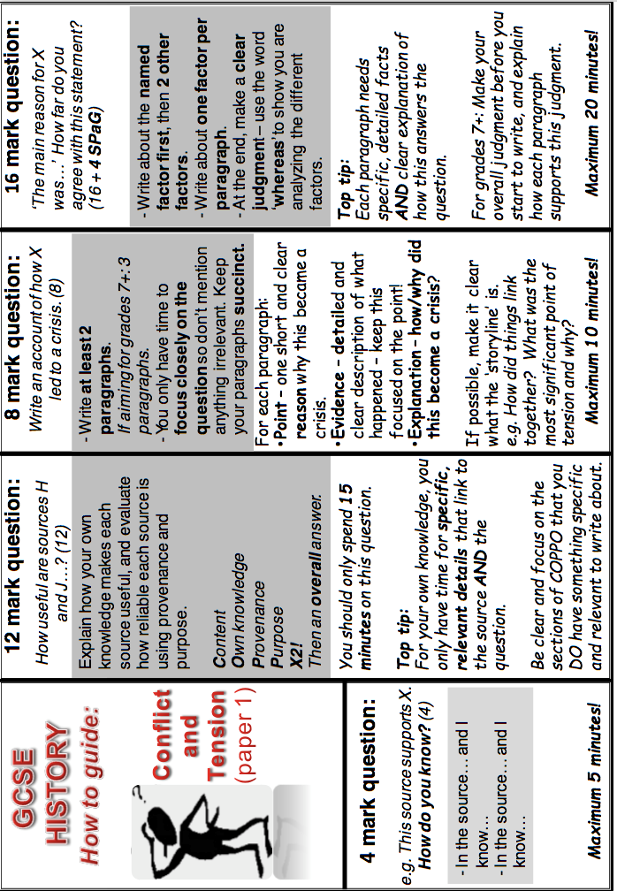
Treaty of Versailles Revision Notes

Background
- The Treaty was drawn up at the Paris Peace Conference, which was held in Versailles in France.
- The purpose of the Conference was to allow the leaders of the victorious powers to meet in order to decide how to deal with the defeated powers.
- The Conference last for a year, with the Treaty of Versailles finally being signed in June 1919.

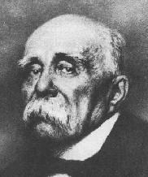
The Leaders
Georges Clemenceau (Prime Minister of France)
A hard, tough politician with a reputation for being uncompromising.
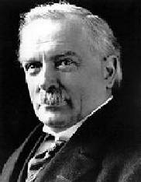
David Lloyd George (Prime Minister of Britain)
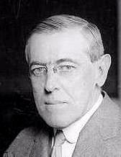
A realist and very experienced politician.

Woodrow Wilson (President of the USA)
An idealist and a reformer.

The Aims of the Leaders
Georges Clemenceau (France)
- France had suffered very severely in terms of damage to the country and loss of life during WWI. They were determined not to allow such devastation to ever happen again.
- They wanted Germany to pay for all of the damages from the war.
- They wanted Germany to lose all of the land they had gained and more.
- They wanted the German armed forces to be destroyed completely.
- The purpose behind all of these demands was to ensure that Germany was crippled so that it could not attack France again.

David Lloyd George (Britain)
- Britain had suffered during WWI, but not to the same extent as France. Lloyd George was aware that there would have to be compromises.
- He thought that Germany should be punished justly (not too harshly)
- His main aim was to stop Germany from having a navy as he wanted Britain to ‘rule the seas’ so that they could maintain their empire.

Woodrow Wilson (USA)
- The USA had not suffered much during the war as they had joined late and there was no fighting in their own country.
- At the Treaty of Versailles Wilson proposed the Fourteen Points, which he believed would end the war fairly and prevent another war in the future.
- His two main ideas at the Conference were self-determination (independence/the right to choose their own future) for the countries of eastern Europe and the League of Nations.

The Terms of the Treaty (GARGLE)

Guilt - clause 231, Germany accepted blame ‘for causing all the loss and damage’ of the war.
Armed forces - army: 100,000
- conscription banned
- no submarines
- no aeroplanes
- 6 battleships
- Rhineland de-militarised
Reparations - £6,600 million – in instalments, until 1984
Germany lost land
League of Nations
Extra points - forbade Anschluss (union of Austria with Germany)
- Estonia, Latvia and Lithuania independent states.
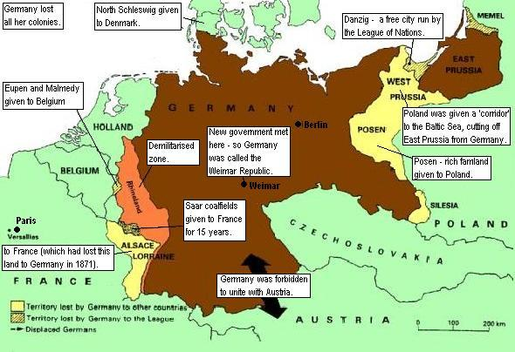

The impact of
the Treaty of
Versailles on the
borders of Europe.

The Allies’ Reactions to the Treaty

Georges Clemenceau (France)
Liked the harsh things that were in the Treaty:
1. Reparations (would repair the damage to France)
2. The tiny German army (would prevent Germany from attacking France)
3. The de-militarised zone in the Rhineland (would protect France by creating a buffer zone)
4. France got Alsace-Lorraine, and some German colonies.
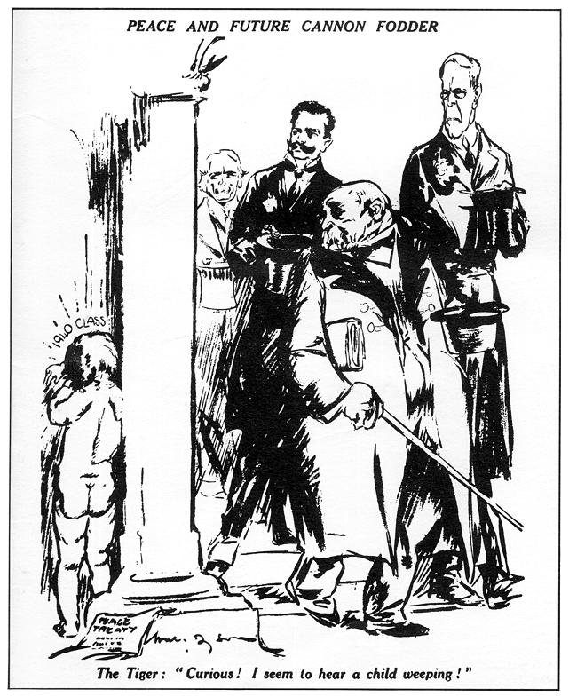
But he was disappointed with the Treaty:
a. He wanted the Treaty to be harsher
b. He wanted Germany to be split up into smaller countries.

David Lloyd George (Britain)
Many British people wanted to ‘make Germany pay’, and Lloyd George liked:
1. The fact that Britain got some German colonies (expanded the British Empire),
2. The small German navy (helped Britain to continue to 'rule the waves').

But Lloyd George was disappointed with the Treaty:
a. He thought that the Treaty was far too harsh and would ruin Germany,
'Peace and future cannon fodder' - a British cartoon of 1920.
'The Tiger' was a nickname for Clemenceau. In the caption, Clemenceau is saying: 'Curious! I seem to hear a child weeping'.
How old will the weeping child be in 1940? This cartoon is suggesting that there will be another war in the future because of Versailles, when the child will be old enough to be a soldier. Why would Versailles cause another war?

b. He thought it would cause another war in 25 years time

Woodrow Wilson (USA)
Wilson got:
1. A League of Nations,
2. Self-determination for the peoples of Eastern Europe,

But he was disappointed with the Treaty:
a. Some of his ‘Fourteen Points’ did not get into the Treaty,
b. When Wilson went back to America, the Senate refused to join the League of Nations, and even refused to sign the Treaty of Versailles.

German reaction to the Treaty (U BRAT)
Unfair – Germany thought it was unfair that they were not represented at the Treaty so they had to accept a harsh Treaty without any choice or even a comment. It was also an insult that they were not allowed to join the League of Nations.
Blame – Germany thought that the war guilt should be shared.
Reparations – Germany was crippled by the reparations, the country was already practically economically destroyed after the war and people could not even afford to buy food.
Armed forces - With such small armed forces Germany would be unable to defend themselves if they were attacked and German pride in the army was also hurt.
Territory – Loss of so much German territory was a blow to their pride. The loss of industrial areas such as the Saar (coalfields) also damaged the economy.

The impact of the Treaty on Germany

- At first Germany refused to sign the Treaty because they thought it was so unfair.
- Rather than hand over their ships, the German navy sank them in protest.
- It then looked as though war would break out again. It was clear that Germany would not be able to win and so the German leader, Ebert, was forced to sign the Treaty.
- Ebert’s right-wing opponents attempted a revolution against him (the Kapp Putsch), but this ended due to strikes in Berlin as essential services such as power and transport were stopped.
- In 1922, Germany then fell behind with reparation payments.
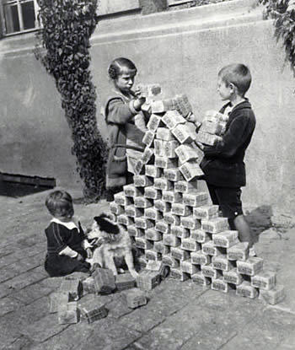
- As a result French and Belgian soldiers entered the industrial Ruhr region to take what was owed to them in the form of goods and raw materials.
- The German government ordered the workers to go on strike to prevent France and Belgium from being able to take anything. The French, however, killed 100 workers and expelled 100,000 protesters from the region.
- The strike had also meant that Germany no longer had enough goods to trade in order to make money.
- The government attempted to solve this problem by printing more money. This in turn cause hyper-inflation (the money became virtually worthless). Workers had to be paid daily instead of weekly as they had to carry all the money in wheelbarrows and the price of food soared.
Children use money as building blocks - due to the effect of .....................................hyper-inflation it is virtually worthless.
The impact of the treaties on eastern Europe
Czechoslovakia
- As well as the Treaty of Versailles, other smaller treaties were also agreed at the Paris Peace Conference which dealt with the establishment and expansion of countries in eastern Europe.
- The most important country that was created was Czechoslovakia. The Allies hoped that it would provide a country which would be economically and politically stable in eastern Europe.
- In reality, it was not very stable, as it contained many different national groups, and as a result there were many ethnic tensions. (see graph)
Poland
- Poland had been an important country in the 1600s but had been divided up by Russia, Germany and Austria.
- The Allies wanted to re-create Poland so that it could act as a watchdog on Germany and also for a barrier against communist Russia.
- Poland, however, had no natural frontiers such as rivers or mountains, which made it vulnerable to attack.
- As a result from the very outset there was fighting between Poland and Russia.
- Poland had also been given access to the sea, through the ‘Polish corridor’ which covered a German city called Danzig. This was bitterly resented by the Germans.

Yugoslavia
- Yugoslavia was an example of Wilson’s idea of self-determination in action.
- It was also meant to make the area it was in more stable.
- Like Czechoslovakia, the new state contained a lot of different national groups, which again led to ethnic tensions. (see map below)

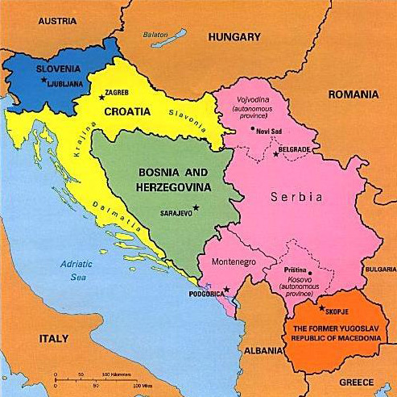
Yugoslavia and the different ethnic groups that it contained.

YUGOSLAVIA

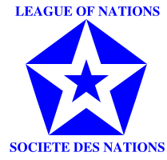
The League of Nations
Background
- Set up in 1920 by the Treaty of Versailles.
- Originally the idea of Woodrow Wilson who wanted the League to be like a world parliament.
- Based in Geneva, Switzerland.
- 42 countries joined at the start. By the 1930s this had risen to 60.
- May 1920, the US Senate voted against Versailles, thus the country did not join the League.
- The USSR did not join the League.
- Germany was not allowed to join as a punishment for causing WWI.
- The leading members were Britain and France, helped by Italy and Japan.

Aims (SIDE)
Stop war (collective security)
Improve live and jobs
Disarmament
Enforce the Treaty of Versailles (encourage trade, economic and social agencies, health care, end slavery).

The powers of The League
- Covenant (Articles 10-17, members promised to keep the peace).
- Condemnation (the League could tell a country it was doing wrong).
- Arbitration (the League could offer to decide between two countries).
4. Sanctions (stopping trade).
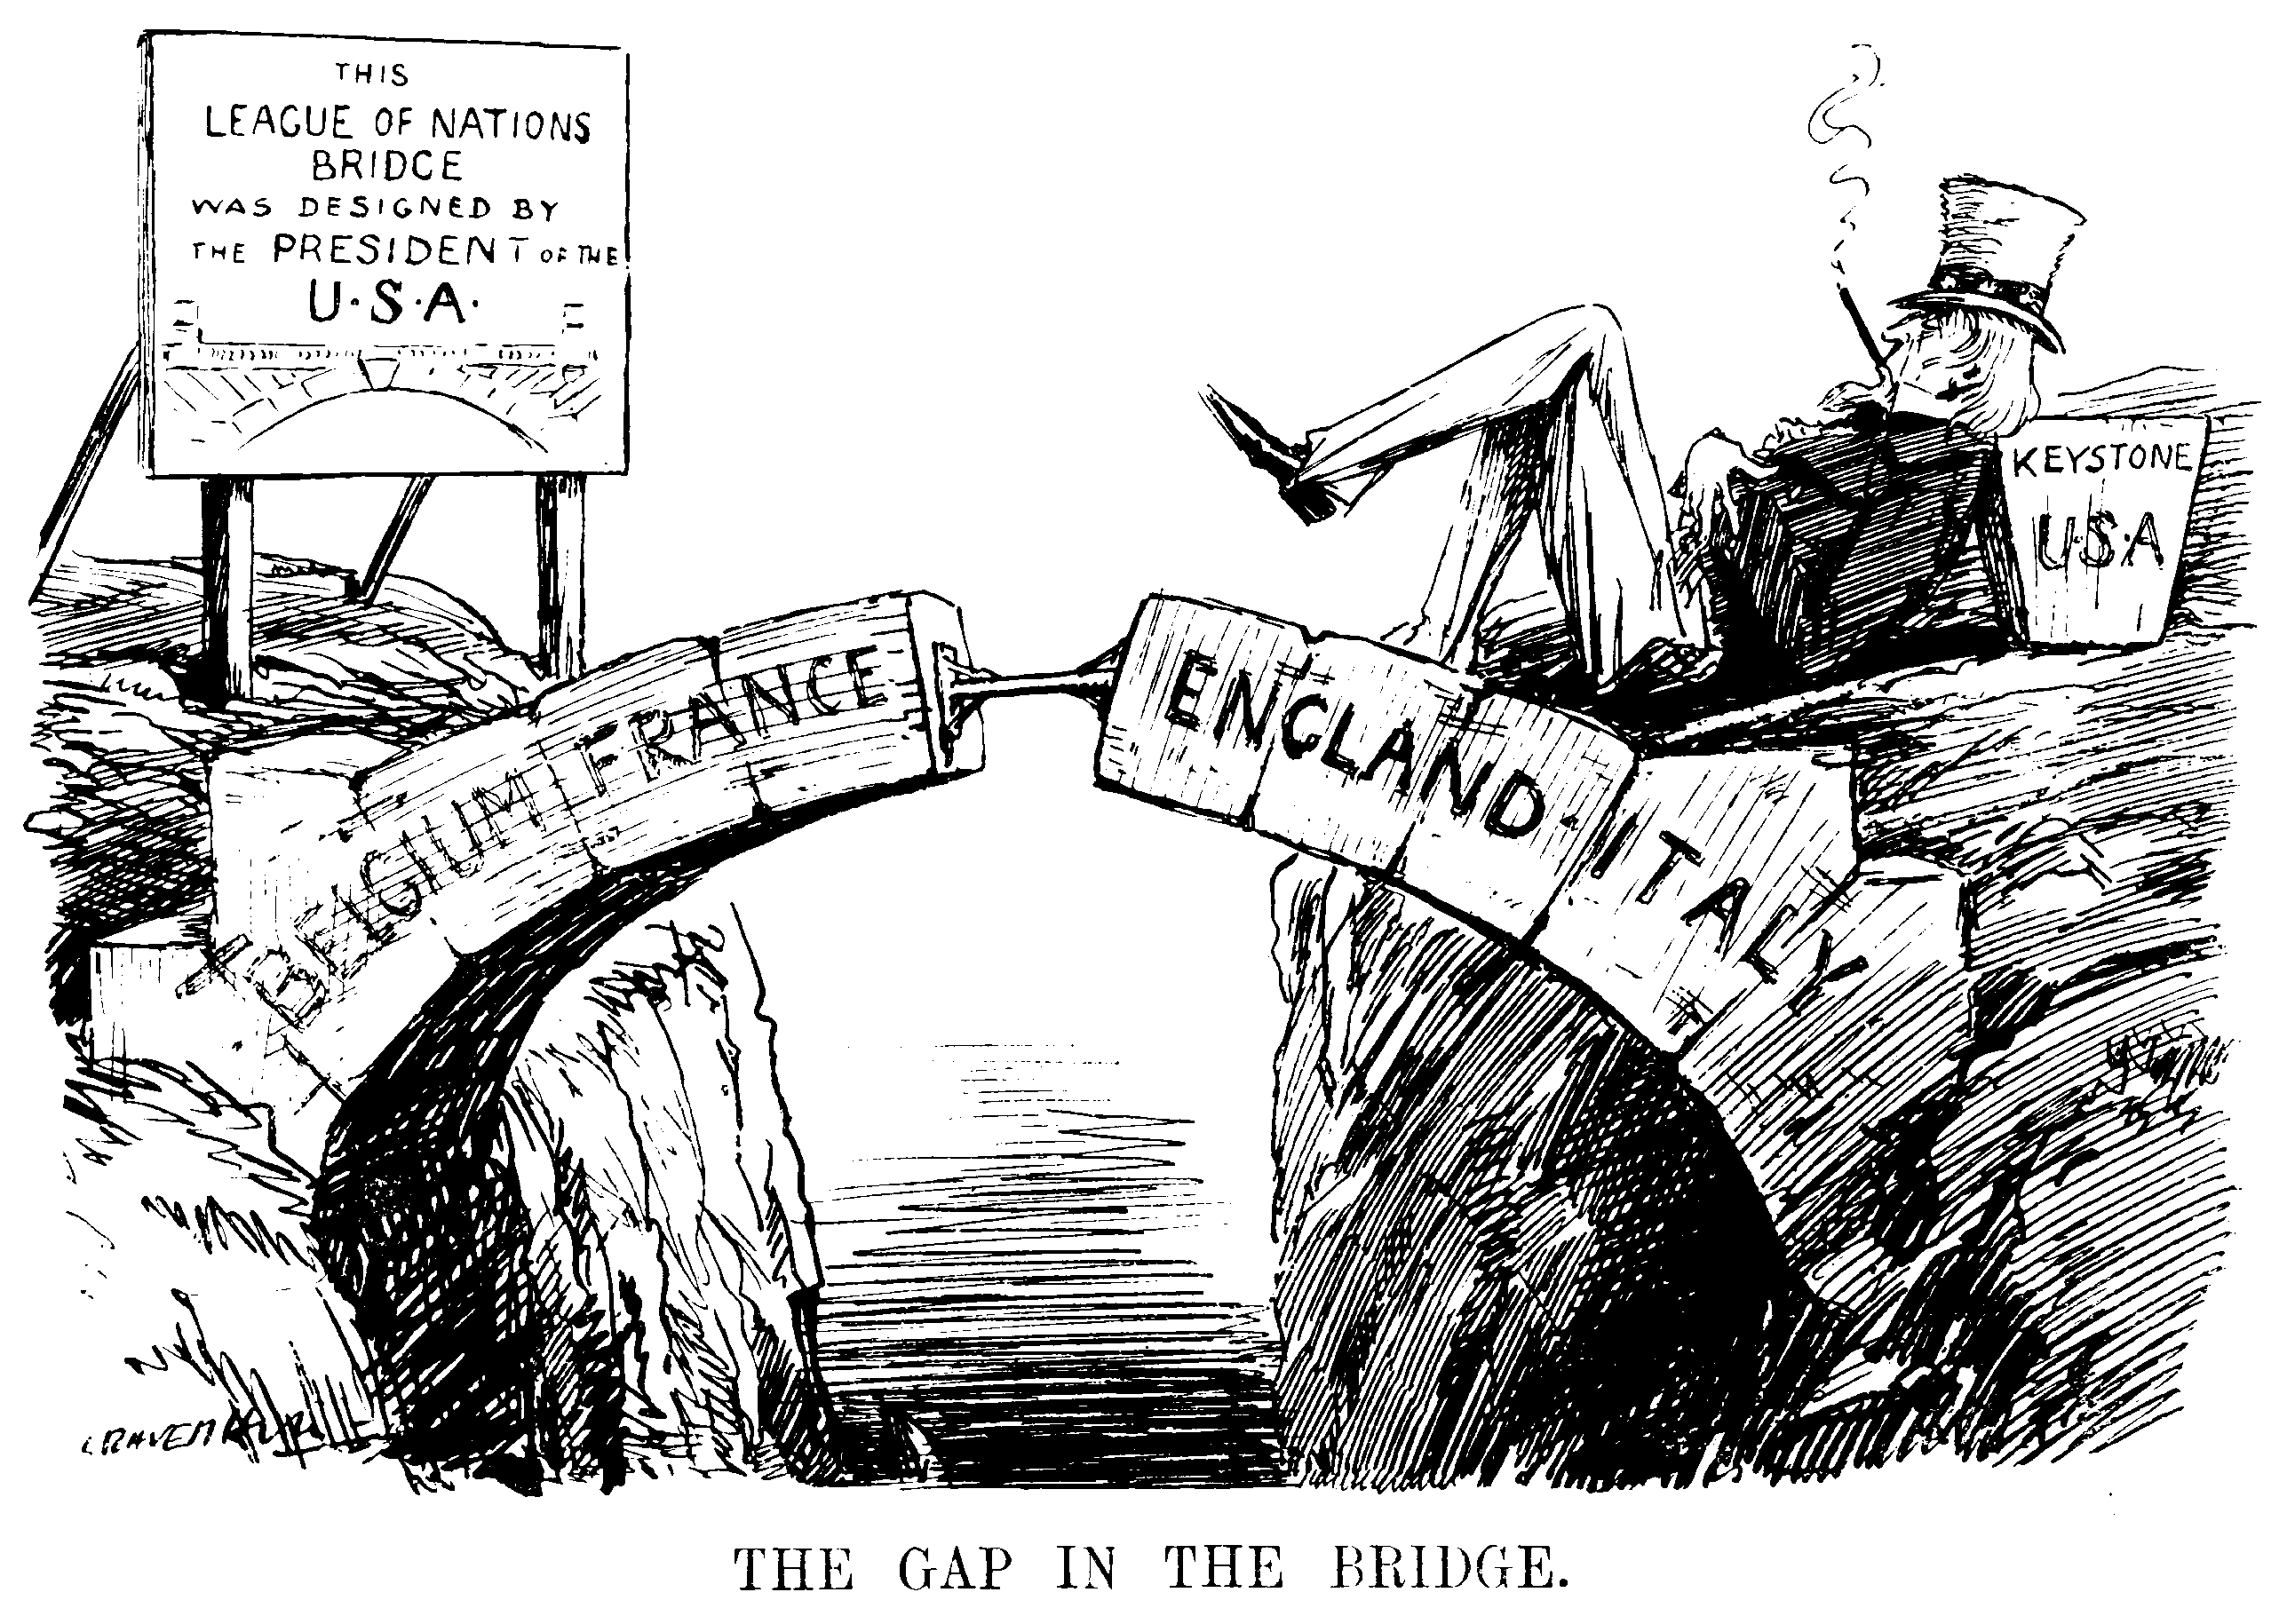
Structure
- Assembly (the main meeting of the League – all members met once a year). Its main problem was that decisions had to be unanimous (agreed by everyone), which was very difficult to achieve.
- Council (a small group of the more important nations – Britain, France, Italy and Japan plus some other countries – met 4–5 times a year).
3. Agencies (committees of the League):
- Court of International Justice (for small disputes).
- Health Committee (to improve world health).
- International Labour Organisation (to try to get fair wages).
- Slavery Committee (to end slavery).
- Refugee Committee (to return people to their homes after wars or disasters).

4. Secretariat (was supposed to organise the League, but failed).
The League and International Agreements

The Dawes Plan – This was designed by America to prevent conflict through lending money to Germany so that they could pay reparations. This helped the League with their aims of enforcing the Treaty of Versailles and stopping wars.

The Locarno Treaties – Germany agreed to accept the boarders laid out in the Treaty of Versailles, that the Rhineland would remain a demilitarised zone and that any future disputes between France and Germany would be settled by the League. This again helped the League with their aim of enforcing the Treaty of Versailles.

Kellogg-Briand Pact – This agreement was signed in 1928 by 63 countries who agreed to try and stop any future conflict through peaceful means. This helped the League with their aim of stopping wars. It was particularly significant that America signed the Pact as they were not members of the League.

The cartoon shows that compared to ‘international strife’
which was a strong and deadly force in the 1920s the League
was like little more than a defenceless rabbit. It was well-meaning
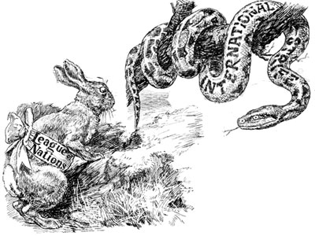
idea, but in practice it would never work.
Failures of the 1920s
Poland (1920) Stopping wars/Enforcing the Treaty of Versailles
Poland took land from Russia, breaking the Treaty of Versailles. The Poles ignored the League’s order to stop
Disarmament (1932) Stopping wars/Enforcing the Treaty of Versailles/ Disaramament
Disarmament talks failed, because Germany demanded as many weapons as everyone else.
Kellogg-Briand Pact (1928) Disaramament/ stopping wars
Sixty-five countries signed the treaty to end war – but just ignored it
Corfu (1923) Stopping wars
Mussolini ignored the League’s orders to pull out of Corfu in 1923, and made Greece pay money to Italy.

Jobs Improving lives and jobs
The International Labour Organisation failed to persuade countries to adopt a 48-hour week.
Invasion of the Rhur Enforcing the Treaty of Versailles
France invaded the Ruhr in 1923 to force the Germans to pay Reparations.

On the whole, the League failed at stopping wars (Corfu) and disarmament (Kellogg-Briand), as well as enforcing the Treaty of Versailles (Poland). These failures were mainly due to the fact that the League had no way of effectively imposing sanctions due to its lack of an army and the fact that the one country that could support the League with the necessary economic and military power, the USA, was not a member. Britain and France were too weak following WWI to really be able to support the League.

Successes of the League in the 1920s
Reparations (1921) Enforcing the Treaty of Versailles
When the Germans refused to pay, France and Britain invaded Germany and made them pay.

Prisoners of War Improving lives and jobs
The League took home half a million WWI prisoners of war.
Aaland Islands (1921) Stopping wars
In this disagreement over control between Sweden and Finland – League acted as arbitrator and said they should go to Finland, Sweden accepted.
Bulgaria (1925) Stopping wars
Greece obeyed the League’s orders to pull out of Bulgaria in 1925.

Slaves Improving lives and jobs
The League attacked slave traders in Africa and Burma and freed 200,000 slaves.

Disease Improving lives and jobs
The League worked to prevent malaria and leprosy.
Refugees (1922) Improving lives and jobs
The League set up camps and fed Turkish refugees.

Economic problems Improving lives and jobs
The League sent economics experts to help Austria and Hungary.

Drugs Improving lives and jobs
The League closed down four big Swiss companies which were selling drugs.

Overall the League was very successful at improving people’s lives and jobs during the 1920s. These activities tended to be carried out by the League’s committees, showing that this area of the structure worked particularly well. The work of the League which successfully highlighted social problems on a global scale and made positive steps towards eradicating diseases such as leprosy and their work in relocating refugees had never been achieved before by any organisation.

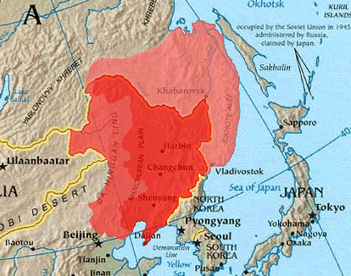
Failures of the 1930s

Manchuria
• The Nationalist government of China led by Chiang Kai-shek was weak, corrupt and busy fighting the Communists.
• Due to the Great Depression, Japan wanted to build an empire to secure supplies of raw materials.
• The Japanese government was controlled by the army
• China ruled Manchuria, but the Japanese army ran the railway there, and ruled in Korea.
• Sept 1931: There was some vandalism on the Manchurian railway; Japan claimed the Chinese had sabotaged the railway.
• Japan invaded Manchuria and set up the 'independent' state of Manchukuo under the former Emperor of China, Henry P'ui.
• China appealed to the League.
• Dec 1931: the League appointed a commission led by Lord Lytton from Britain to investigate.
• April 1932 Lytton goes to Manchuria.
• Oct 1932: Lytton's report published - stated that Japan was the aggressor and should leave.
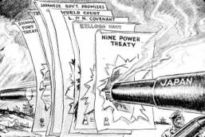
• 24 Feb 1933: The Assembly voted that Japan
should leave Manchuria, Japan walked out of the meeting.
• Japan stayed in Manchuria.
• The League could not agree economic sanctions or an arms sales ban.
• In 1933 Japan resigned from the League, and invaded/ conquered Jehol (next to Manchuria).
• In 1937 Japan invaded the rest of China.
A SPECTACULAR failure:
The League was discredited
Manchuria showed:
• It was slow (the Lytton Report took almost a year)
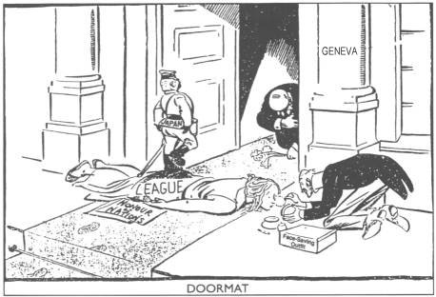
• A country could get its own way if it ignored the League ‘Collective security' was useless against big countries - especially during the Great Depression.
• Even the great powers within the League (Japan was on the Council) were happy to ignore it.

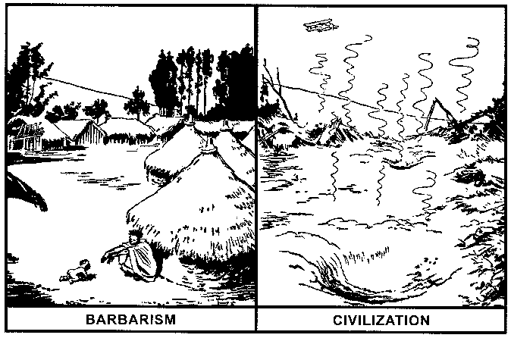
Abyssinia
- Independent African nation, rich in raw materials.
- October 1935 Italy invaded.
- The Abyssinian Emperor Halie Selassie asked the League of Nations for help.
- The League did not want a clash with Mussolini. Britain and France wanted him to be their ally against Hitler.
- The Hoare-Laval Pact (a secret agreement to give the rich areas of Abyssinia to Italy) was drawn up.
- As result of the Pact and the subsequent failure of the League, weaker countries realised they could not depend on the League for Help.
- Hitler invaded the Rhineland.
- It showed that the League could not make collective security work.
- In October 1936 Hitler and Mussolini made the Rome-Berlin Axis Agreement: another world war was looming.

Why did the League fail?
It WAS DUMB!
Weak – the League’s ‘powers’ were virtually useless. Sanctions did not work (Failed to stop the sale of arms to Italy during the Abyssinian crisis). It had no army.
America – the strongest nation in the world never joined. Britain and France were not strong enough to impose peace on their own.
Structure – the League was muddled, so it took ages to do anything. Members couldn’t agree – but decisions had to be unanimous. This paralysed the League. It was very slow to act (Manchuria).
Depression – the world-wide Depression made countries try to get more land and power. They were worried about themselves, not about world peace.
Unsuccessful – the more the League failed, the less people trusted it. (Manchuria led to the invasion of the Rhineland). In the end, everybody just ignored it.
Members – the League’s main members let it down. Italy (Abyssinian Crisis) and Japan (Manchurian Crisis) betrayed the League. France and Britain did nothing to help it.
Big bullies – in the 1920s, the League had dealt with weak countries. In the 1930s, powerful countries like Germany, Italy and Japan attacked weaker countries. They were too strong for the League to stop them.

Road to War and Appeasement Revision Notes
Hitler’s Aims
- Abolish the Treaty of Versailles – Hitler, like many Germans, believed that the Treaty was extremely unfair and unjust. He called the German leaders who had signed it the ‘November Criminals’. By the time Hitler came to power the Germans had already stopped making reparations payments, but he hated other aspects of the Treaty that were still in place.
- Expand German territory – Hitler wanted to get back the German territory that had been lost in WWI. His main priorities were to unite with Austria (Anschluss) and the areas of Czechoslovakia which contained German speaking peoples. Hitler also hoped to expand into eastern Europe – this policy was known as Lebensraum (living space).
- Defeat Communism – Hitler hated communism and hoped to expand the German Empire by taking land from the USSR. He blamed the Bolsheviks (communists) for the defeat of Germany in WWI and believe they wanted to take over the country.
The Road to War – Hitler’s Foreign Policy in the 1930s
Rearmament
As soon as he came to power Hitler began to rearm. In 1936 he introduced conscription. This clearly broke the terms of the Treaty of Versailles which stated that the army could not exceed 100,000 men. He also held a staged a massive military rally in 1935.

Hitler used rearmament and conscription as a means of lowering unemployment. Britain and France did not react as they felt that the Treaty had been too harsh on Germany. Britain even went as far as signing a naval agreement with Germany which allowed the German navy to be increased by up to 35% the size of the British navy.

The Saar Plebiscite
A plebiscite is a vote on a single issue. The Saar (area rich in coal)according to the Treaty of Versailles it was to be ruled by the League of Nations for 15 years. Accordingly, in 1935 a plebiscite was held asking if the area wished to return to German control. This was entirely legal within the terms of Versailles and also gave Hitler a morale boost.
Stresa Front 1935,

A coalition of France, Britain, and Italy formed in April 1935 at Stresa, Italy, to oppose Adolf Hitler’s announced intention to rearm Germany, which violated terms of the Treaty of Versailles. When Italy invaded Ethiopia later that year, France and Britain tried to reconcile the action with the need to remain united against Germany, but the coalition soon dissolved.

Remilitarisation of the Rhineland
In March 1936, Hitler moved troops into the Rhineland. This was clearly against the terms of the Treaty of Verasailles, which stated that the area was to be demilitarised in order to protect France from invasion. Germany had formerly agreed to this in the Lacarno Treaties of 1925.

Following the League of Nation’s failure to act in Abyssinnia, however, Hitler decided to risk invading the Rhineland as he did not believe Britain and France would respond. He order his troops to turn back if they faced any form of resistance at all as he knew he was not strong enough to fight a war at this point. Hitler was correct, France was still to weak after WWI to retaliate and Britain allowed this to happen as they believed the Treaty of Versailles had been too harsh on Germany.

The Spanish Civil War
In 1937 there was a civil war in Spain between the Communists and the Fascists (led by General Franco). Hitler used the war as an opportunity to test out his new weapons (on the side of Franco). German aircraft made devastating air raids on Spanish cities, the likes of which had never been seen before. The world was horrified.

The Anti-Comintern Pact, 1936-37
Hitler made an agreement with Italy and Japan to try to limit communist influence (such as the USSR and China) around the world. The new alliance was called the Axis Alliance. These countries later went on to fight against the allies in WWII.

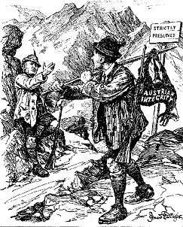
Anschluss with Austria, 1938
This British cartoon from 1938 shows Hitler as a poacher, stealing Austria. Mussolini is shown as a bad game-keeper. ‘I never heard a shot, Adolf’’, he is saying.
Hitler had attempted Anchluss (union with Austria) in 1934, but Mussolini had stopped him. Following the Anti-Comintern Pact, however, Italy did not interfere when Germany tried again in 1938.

Hitler encouraged Nazis in Austria to stir up trouble for the government. He then told the Austrian Chancellor Schuschnigg that only Anschluss could solve the problems. Schuschnigg asked Britain and France for help but they refused, as they did not consider this an invasion but the unification of Germany speaking peoples.

A plebiscite was held to decide what should happen. Hitler was not prepared to risk losing so he sent troops to Austria, the result was then 99.75% in favour. Hitler was now beginning to successfully expand in line with his policy of lebensraum.

The Sudentenland, 1938
After Anchluss Hitler’s next target was an area of Czechoslovakia called the Sudetenland which was mainly populated by Germany speaking people.

First, Hitler encouraged the Sudeten Nazis to demand union with Germany. Then, Hitler made plans to invade Czechoslovakia. The Czech leader, Edward Beneš, asked Britain and France to help. Hitler assured them that he would not invade the whole of the country, he only wanted the Sudetenland.

The Munich Agreement
Neville Chamberlain appeased Hitler. At Munich, on 29 September 1938, Britain and France gave Hitler the Sudetenland.

Czechoslovakia, 1939
After the successful conquest of the Sudetenland, Hitler then took the whole of Czechoslovakia. He hated the country as it had been established through the Treaty of Versailles, also taking over the land would help his policy of lebensraum.

In March 1939 the German troops invade. The Czechs made no resistance, without the essential forts, industries and railways of the Sudetenland they were defenceless. This was clearly an invasion and not simple the unification of German peoples.

Britain and France realised that Poland was likely to be Hitler’s next target and told him that if he attacked they would declare war. After so many years of appeasement, however, Hitler did not believe them.

The Nazi Soviet Pact
In summer 1939, Hitler began to unfold his plan to take over Poland. First, the Germans in Danzig demanded union with Germany. Then, Hitler threatened war.

Chamberlain promised the Poles that Britain would support them if Germany attacked Poland.

In August 1939, Hitler made a secret treaty with Russia. He thought this would stop Britain & France helping Poland.

In August 1939, Hitler sent Ribbentrop, a senior Nazi, to Russia. He offered a Nazi-Soviet alliance – Russia and Germany would not go to war, but would divide Poland between them.

Stalin knew Hitler was lying, but he did not trust the British either – the Munich Agreement had convinced him that Britain and France would never dare to go to war with Hitler.

Stalin had two choices:
If he made an alliance with Britain, he would end up fighting a war with Hitler over Poland.
If he made an alliance with Germany, he would get half of Poland, and time to prepare for the coming war with Germany.

He chose the latter. On 23 August 1939, he signed the Pact with Hitler.

Invasion of Poland, 1939
On 1 September 1939, Hitler invaded Poland.

On 3 September 1939, Chamberlain declared war on Germany.

Appeasement
Reasons for appeasement
- Hitler was standing up to communism.
- The USA would not help stand up to Hitler, Britain and France were worried that they could not succeed without them.
- Many people thought the Treaty of Versailles was unfair on Germany.
- Britain and France were suffering from economic problems and could not afford another war. They had large debts and high unemployment.
- The armed forces were not ready for war.
- Both Britain and France vividly remembered the horrific experiences of the First World War. They wished to avoid another war at any cost.
- Britain could not be certain that they would gain support from their empire

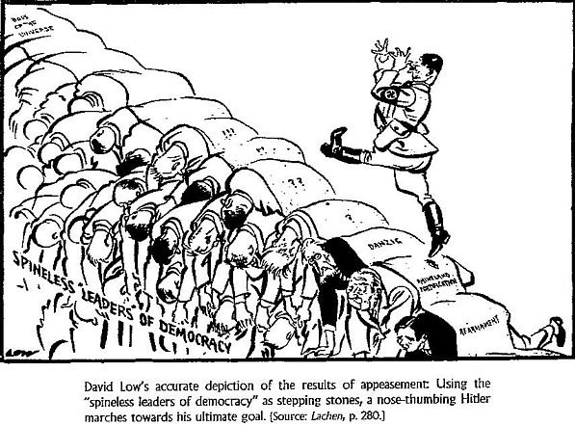

Verdicts on appeasement
Historians have said that appeasement:
- let Hitler grow stronger.

Source A
Give thanks to your God. Your children are safe. Peace is a victory for all mankind. If we must have a victor, let us choose Mr Chamberlain.

The Daily Express, 1938.

- gave Britain time to re-arm.
- humiliated Britain – no country in central Europe ever trusted Britain again, this created tension throughout Europe.
- abandoned millions of people to the Nazis.
- caused the war, by encouraging Hitler to think he could do anything.
- gave Britain the morale high ground – when war came, Britons knew they had done everything possible to keep the peace.
- would never have stopped Hitler, who was determined to go to war.
- was a fine attempt to prevent the deaths of millions of people in a war.
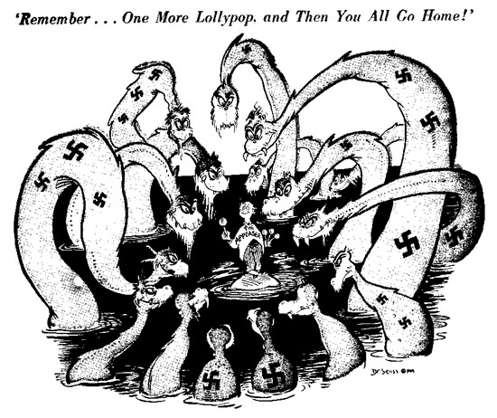

Source B
It is a total defeat. Czechoslovakia will be swallowed up by the Nazis. And do not suppose that this is the end. This is only the beginning.

Churchill, speaking about the Munich Agreement in 1938.

