AQA GCSE History
Paper 2 – British Depth Study
Norman England c1066 – c1100
Revision Booklet
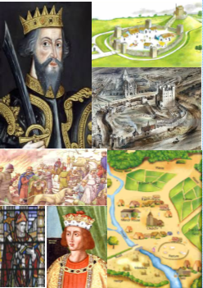
Name: ...........................................................
Teacher: .......................................................
Classroom: ....................................................
Revision group: A / B / C

An introduction to your revision booklet
This booklet is designed to help you to revise the British depth study which focuses on Norman England from around 1066 to around 1100. This part of the course requires in depth knowledge of a short period of time. Therefore, we do not cover many years, but you need to know the information very well. The tasks in this revision booklet are designed to help you to revise the key knowledge that you will need to use in exam questions.
The booklet is divided into four sections:
- Level 1
- Level 2
- Level 3
- Level 4
Each section has a series of tasks in it which will help you to revise the key content on the specification. You are free to choose which level you wish to start at, and once you have completed one level in full, you can move onto the next level. You must complete at least two levels in this booklet.
Our expectations
It is important to challenge yourself in History, and not just to do the bare minimum. As we said to you at the beginning of Year 10, the students who do best in History are the students who work hard and go the extra mile.
Your teacher will check your revision booklets either in lessons or will take them in to ensure that:
- Your historical knowledge is accurate
- You are completing tasks (a record will be kept of this by your teacher)
- You are challenging yourself
Supporting you
You will be completing this booklet outside of lessons in your own time. Revision should be little and often – we would suggest completing 2/3 tasks per week on top of your History home learning.
If at any point you are unsure or are struggling with anything, please see your teacher either during lessons, attend a Tuesday lunchtime revision session or at break/lunch/after school. The History Office door is always open, and being a proactive student in all aspects of your work as well as in finding help will enable you to succeed!

Norman England c1066 – c1100
Level 1 revision tasks
 | Specification content | Revision tasks complete? (Y/N) | RAG your confidence | Checked by teacher?
1 | Anglo-Saxon England before 1066
2 | The death of Edward the Confessor and claims to the English throne
3 | The Battle of Stamford Bridge and the Battle of Hastings
4 | Revolts against the Normans and the Harrying of the North
5 | Norman military innovations, including castles
6 | William I’s control of England
7 | Government in Norman England
8 | Norman justice and the legal system
9 | Domesday Book
10 | Life in Norman England
11 | Similarities and differences between life in Anglo-Saxon and Norman England
12 | Norman reforms to the English Church
13 | Church organisation, reforms made by William Rufus
14 | Norman relations with the Papacy
15 | Monasteries and monastic life
16 | Norman church and education

Task 1 – Anglo-Saxon England before 1066
10 point summary
- England was a wealthy country with around 2 million people living in it. Most of these people lived in the south, with fewer in the north and west.
- Religion was important, everyone followed Catholic Christianity and accepted what the Church said as absolute fact.
- Edward the Confessor had ruled since 1042 and his reign had been largely stable and peaceful. His rule was aided by the Witan.
- Society was ordered by a hierarchy where people were ordered by their level of importance. The king was at the top, followed by the Church. Earls and then peasants at the bottom.
- There were hardly any castles in England and it was not very well defended.
- Most of the southern half of England was covered in forest and there were small villages where the forest had been cleared and land was farmed.
- The king had earls to help him rule England. Each earl helped rule a different part of England.
- The king had earls and housecarls who were professionally trained soldiers – there were around 2500-3000 housecarls in England.
- The most powerful earl in England was Earl Godwin who had a close relationship with King Edward but who had publicly fallen out with him in 1052.
- England had good trade links with other countries such as Norway and France. It had a sophisticated minting system – it made its own coins – and had one of the most advanced economic systems in the known world at this time.
Task: based on the 10 point summary, what were the positives and negatives of Anglo-Saxon England?
Positives of Anglo-Saxon England | Negatives of Anglo-Saxon England
Task 2 – The Death of Edward the Confessor and
Claims to the English Throne
Task: complete the paragraph, using the words in the box below
Confessor 4 1066 Witan Children Godwin 1042

Edward the ______________ had been king of England since _______. He had
reigned England with the support of the __________ which was a council of English
earls and bishops, such as Earl __________. Edward the Confessor died in January
_______ without leaving any ____________. As a result, it was unclear who would
become king. There were ______ powerful men who put their claim forward for the
throne, however these claimants were from different countries and had different
levels of support.
Task: match up the claimants to the English throne in 1066 with the information that explains who they were and what their claim was.
The great nephew of Edward which made him the closest blood relative. He was not named as an heir by Edward, even though he had lived with Edward since he was a child and was treated as though he was Edward’s adopted son. He was an Anglo-Saxon and had the support of many earls.

The King of Norway, he was a powerful Viking with a large and successful army. He was related to King Cnut who had ruled England from 1016-1035 and he claimed that as he was a relative of the previous king, that he should now be king of England.

Was a distant cousin of Edward the Confessor. Had grown up with Edward the Confessor and supported him when Earl Godwin had rebelled against him in 1051. Thought that he had been promised the throne by Edward several years before his death and claimed that he had the support of Harold Godwinson.
Was not a blood relation to the king, but was the brother in law of Edward the Confessor. He was the richest man in England and had helped Edward to rule – especially towards the end of his reign. He was a skilful military leader who had beaten a Welsh invasion and therefore had the support of the English lords. Edward’s dying wish was that this person become king of England.

Harold Godwinson

William of Normandy

Harald Hardrada

Edgar Aetheling

Task 3a – Preparations for the Battle of Hastings
Task: match up the correct features to each army to show the preparations that Harold Godwinson and William of Normandy made for battle in 1066.
 | Harold Godwinson | William of Normandy
Army | Fyrd | Cavalry
Navy
Tactics

Pre-fabricated castles | 3,000 housecarls | 3,000 horses
Thegns | No cavalry | Knights
Archers | Army of several thousand | 7,000 soldiers
Cavalry | fyrd | No archers
Large Navy | Papal Banner | 700 ships

Task 3b – January – September 1066
Task: using the content booklet, fill in the gaps in the timeline of events leading up to the Battle of Hastings.
Edward the Confessor
________ on 5th January
1066. The next day, __________ _____________
is crowned king of England.
Harold Godwinson begins to
_________ for an
___________ from Normandy.
By May 1066 he has several
thousand ___________.

During this time, William’s preparations meant that he had an army of _________ soldiers, ________ horses and _________ ships. His army also contained archers and cavalry.
In ______ 1066, Harold’s brother ___________ raids England, attacking the _______ coast and Lincolnshire. He is fought off by Anglo-Saxon earls __________ and ____________ and flees to Scotland.

Tostig and Harald Hardrada landed near ______ and fought the Battle of __________. Anglo-Saxon earls Edwin and Morcar were ___________ but were not __________. York surrendered.
At the beginning of September, Harold sent his army home to gather in the _________. At the same time, Tostig and _______ ________ started sailing down the coast from Scotland.

Despite defeating and _________ Tostig and Hardrada, 3 days after his victory at Stamford Bridge, Harold heard that William had __________ ___ ____________.
Harold regathered his army and marched _______ - they covered ______ miles in a week. Harold caught Tostig and Hardrada by ________ and defeated them at the Battle of _________ _________.
Task 3c – The Battle of Hastings

Task: illustrate the storyboard with the events of the Battle of Hastings.
7. Saxon shield wall starting to disintegrate – Normans were breaking through
King Harold was killed – the fyrd broke ranks and fled once they saw he was dead.
6. William ordered his cavalry to charge = heavy casualties on both sides. Normans’ pretended to run away again
He ordered his knights to get off their horses and charge at the Saxons with his infantry
5. Fighting paused to let both sides removed their dead/ injured
William moved his archers behind his cavalry, so the arrows wouldn’t fly over the Saxons’ heads – this caught the Saxons by surprise.
4. The fyrd ran after the Norman soldiers BUT got stuck in marshy land at bottom of hill where they were slaughtered by Normans.

3. Feigned retreat – a section of Norman army pretended to run away. This was a well-known Norman tactic which required experienced and well-trained knights.
- Norman infantry then charged up hill BUT was blocked by housecarls using shield wall formation which remained firm.

- The battle starts at 9am. Norman archers fired at Anglo – Saxons BUT arrows flew over their heads.

Task 3d - Why did William win the Battle of Hastings?
Task: complete this mind map using the previous two pages and your content booklet to explain why William won the Battle of Hastings. Annotate around each heading with evidence to support that each factor helped William to win.
Anglo-Saxon mistakes
Support from God
Preparations
Tactics
Why did William win?

Task 4 - Revolts against the Normans 1066 – 1075
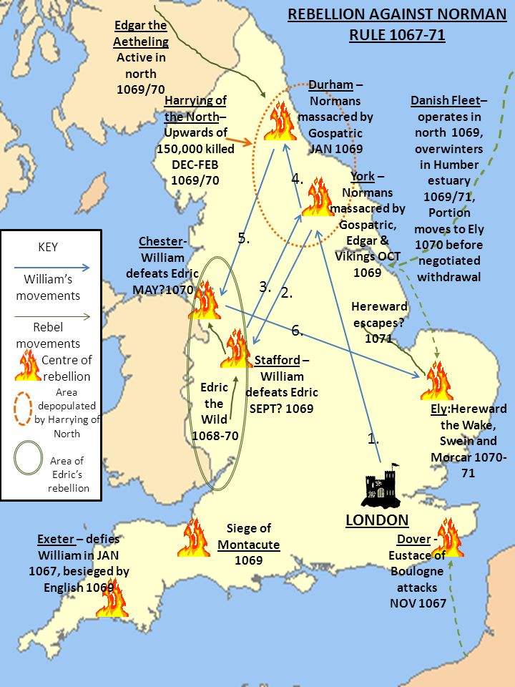
Task: Match the rebellion to the description using the map and your content booklet.

1067 – The Welsh Borders
1067 – Kent
1067 – Northumbria
1068 – Edwin & Morcar
1068 – The South West
1069 – Harrying of the North
1070-71 – East Anglia
1075 – Norman Earls

Which rebellion? | Description
 | William appointed Copsig to rule part of England, which was an odd decision as Copsig had previously worked for Earl Tostig Godwinson. Copsig was soon ambushed by Northumbrians and his head hacked off.
1068 – The South West | The city of Exeter rebelled against William and was put under siege for 18 days. William then lowered taxes and built a castle to increase his control over the city. Despite two attempted rebellions from Harold Godwinson’s sons, Exeter remained loyal thanks to William’s actions.
 | Eadric the Wild was joined by two Welsh kings and attacked Herefordshire.
 | Two Anglo-Saxon earls rebelled for a second time, but submitted to William when he began to build more castles in England.
 | The final challenge that William faced, but this time from the Earl of Hereford and the Earl of East Anglia – with support from Waltheof. William dealt with this rebellion relatively easily, and by the time the Danes arrived the rebellion was over.
 | A difficult to control area of England sought help from King Swein of Denmark, as well as rebelling several times themselves at places such as Durham. Following the rebellion, William laid waste to the land, with mass killings and burnings.
 | People were angry at how they had been treated by the Normans after the Battle of Hastings. They persuaded the French Eustace of Boulogne to attempt to seize Dover Castle but when he did, he didn’t attack with enough force and was soon defeated.
 | William faced a rebellion from the Danes who had remained in England despite agreeing to leave, and an Anglo-Saxon called Hereward. This was not a completely serious rebellion as King Swein had given up on the idea of taking England, however Hereward was a nuisance to William.
Task 5a – Norman military innovations: motte and bailey castles

Task: label the motte and bailey castle diagram using the grid below.
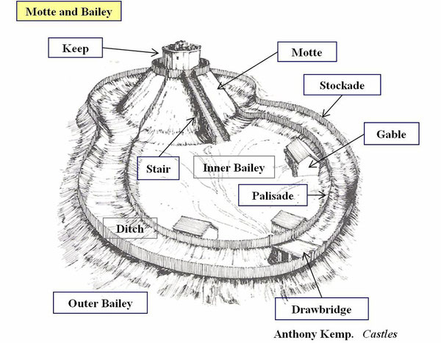

Keep  A wooden or stone fortified tower on top of a motte. | Outer Bailey  An outer ward that protected the inner bailey. | Drawbridge  A bridge, especially one over a castle's moat, which is hinged at one end so that it may be raised to prevent people crossing
Motte  A raised mound or earthwork with a stone or wooden keep (a fortified tower) on top. | Inner Bailey  The bailey is a courtyard enclosed and protected by a ditch | Palisade  A wall made from large wooden stakes.
Stair  The stairs connecting the keep on the motte with the inner bailey. | Stockade  A barrier formed from upright wooden posts or stakes, especially as a defence against attack | Gable  The triangular end of a house.

Task 5b- how and why were castles built?

Task: complete the paragraphs, using the words in the box below
Edward the Confessor control burhs defend central

Castles were ________ to Norman ________ of England. Very few castles had been built by
____________ the _____________ and the defensive fortifications that the Anglo-Saxons
used were called __________. The difference between burhs and castles was that burhs
were built to ___________ the population, whereas castles were built to control the
rebellious English.
The first castles that the Normans built were called ________ and _________ castles. A
troops motte burn keep palisade lookout bailey
motte was an earth mound, and a _______ was built on top of it. The ditches around the
motte made it harder to attack. The bailey was the outer area of the castle which was
defended by a wooden ______________. Norman ___________ were stationed in the bailey
along with their horses. These troops could retreat to the keep if they needed extra
protection, but the keep was also used as a _________________. A motte and bailey castle
could be erected very quickly, but the wooden structure was a weakness because they could
__________.
symbolic reminder soldiers governing rebellions day’s taxes strategic
Castles had two main functions: _____________ and _____________.
- Strategic: they housed Norman ____________ who could help to stop any
_____________. Norman soldiers were never more than a __________ march away
from a Norman castle.
- Symbolic: castles were a permanent _____________ to the English of who was
now ___________________ the country. The Normans charged the English
__________ to help them maintain the castles.

Task 6 – Norman control of England

Task: complete this mind map using the previous pages and your content booklet to explain how the Normans controlled England after 1066.

Task 7a – Government in Norman England
How did the Normans control England?
Castles
Force
Continuing the dynasty
Cooperating with English lords

Task: using the content booklet, annotate each pyramid to explain who each section of society contained.

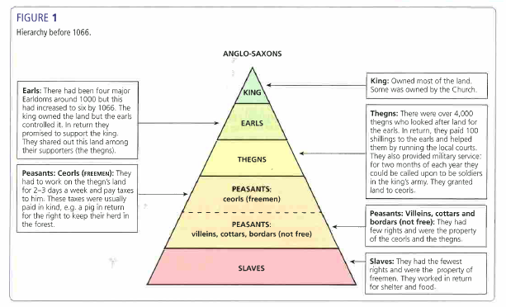

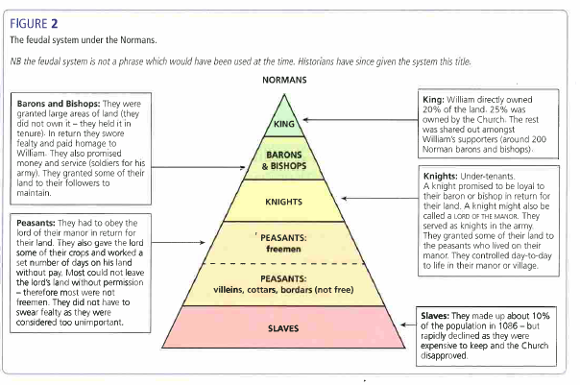

Task 7b – The feudal system under the Normans

Task: in the final column of the table, explain what had changed from the Anglo-Saxons to the Normans.

Feature | Anglo-Saxon | Norman | What changed?
Feudal System | Six major earldoms in 1066  4,000 thegns  King owned most of the land, followed by the Church. | King owned about 20% of the land, with the Church owning around 25% of land.  Remaining land shared between 200 Norman barons and bishops.  By 1086 only 4 thegns owned land.  Royal Forests and Forest Law created. | - More land given to barons and bishops.  - Fewer thegns owned land.  - More Royal Forests created.  - Forest Law created.
Military Control | The main part of the king’s army would be made up from housecarls.  For the rest of the army, the Anglo-Saxons used the fyrd. | Knights made an oath to their lord – it was a religious duty to provide service.  Knights always had to carry out military service.  By 1100 the Norman king had 5,000 knights he could call on.
National government | The king was in charge and the nobility were involved in the process of decision making through the Witan.  Anglo-Saxon government issued orders in writing – these were called writs. This was a short document which gave orders to be sent around the country and he system was known as government by writ. | Norman kings continued to take the advice of their lading subjects through the Great Council.  The Normans continued government by writ but issued far more orders, which allowed William to create a more centralised government.
Local government | Under the Anglo-Saxon, England had been split into 134 shires. A shire-reeve (the original word for sheriff) was in charge of each shire and organised justice, punishment and the collecting of taxes. Each shire was split into smaller areas known as hundreds. | The Normans found the Anglo-Saxon system effective so still used sheriffs. The sheriff acted as second to a baron in an area, and was a vital link between the king and the local area.  Anglo-Saxon sheriffs were replaced with Norman sheriffs.

Task 8a – Norman legal system
Task: complete the missing words in each bullet point, using your content booklet.
- The legal system also kept many features from ____________ - __________ England.
- This was due to the _____________ element, but it was also _____________ – it helped to prove that the Normans were ____________ rulers.
- The one big change that the Normans did make was to _____________ the system and make it more ______________________.
- The most important courts remained the ____________ court, the __________ court and the _____________ court.
- From 1076, _________________ courts to deal with church matters.
- There was no ___________ force in Norman England, therefore the law was enforced by a range of different people.
- The __________ and _________ _________ still had their own laws in the early years of Norman rule.
- In vulnerable areas such as the ____________, the earls effectively had their own royal powers.
- However, the Norman trend was for areas to come increasingly under __________ control as it allowed the Normans to gain more ____________ power and to make ____________.

Task: decide whether each statement is either true or false using your content booklet.
Statement | True or False?
Constables were not paid much, but had the power to arrest people, break up fights and put out fires. They also held the keys to the stocks.
Watchmen were paid to do their job. Their role was to ensure that people abided by curfews, prevent crime and catch criminals.
Hue and cry was the system for raising the alarm after a crime had taken place. If anyone witnessed a crime, they had a duty to report it and could be punished if they did not.
A tithing was a group of 10-12 men who all promised to stop the others committing crimes. If one did, it was the duty of the others to reveal the guilty party, or risk the whole group being fined.
If a Norman was killed and their murderer was not found within 5 days, the whole population of the hundred would be fined. This murdrum fine helped to reduce hostile acts against the Normans, but when these hostile acts did occur, the money from fines proved useful for the king.

Task 8b – Trials in Norman England

Task: using your content book, summarise each form of Norman justice in 30 words for each.

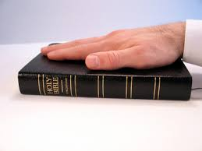
...................................................................
...................................................................
...................................................................
...................................................................
...................................................................
...................................................................

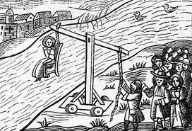
...................................................................
...................................................................
...................................................................
...................................................................
...................................................................
...................................................................

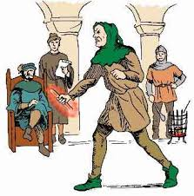
...................................................................
...................................................................
...................................................................
...................................................................
...................................................................
...................................................................

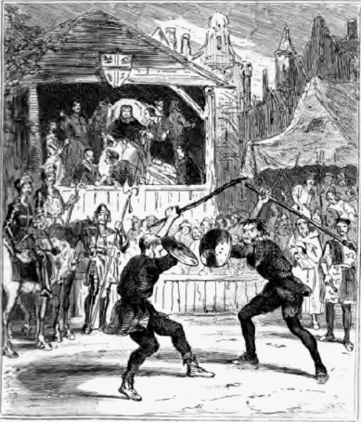
...................................................................
...................................................................
...................................................................
...................................................................
...................................................................
...................................................................

Task 9 – Domesday Book

Task: bullet point information about Domesday under each heading – use your content booklet to help you.


What would Domesday allow William to do?

Which areas did it not cover?
Aim of Domesday Book:

How was information collected?

Task: write a 25 word definition of what Domesday Book was:

.......................................................................................................................................

.......................................................................................................................................

.......................................................................................................................................

Task 10a – Life in a Norman village

Task: annotate the image of a Norman village with 5 facts. Hint: think about:
- Who lived there
- What they did
- What their houses were like
- Who had power
- Hygiene and diet

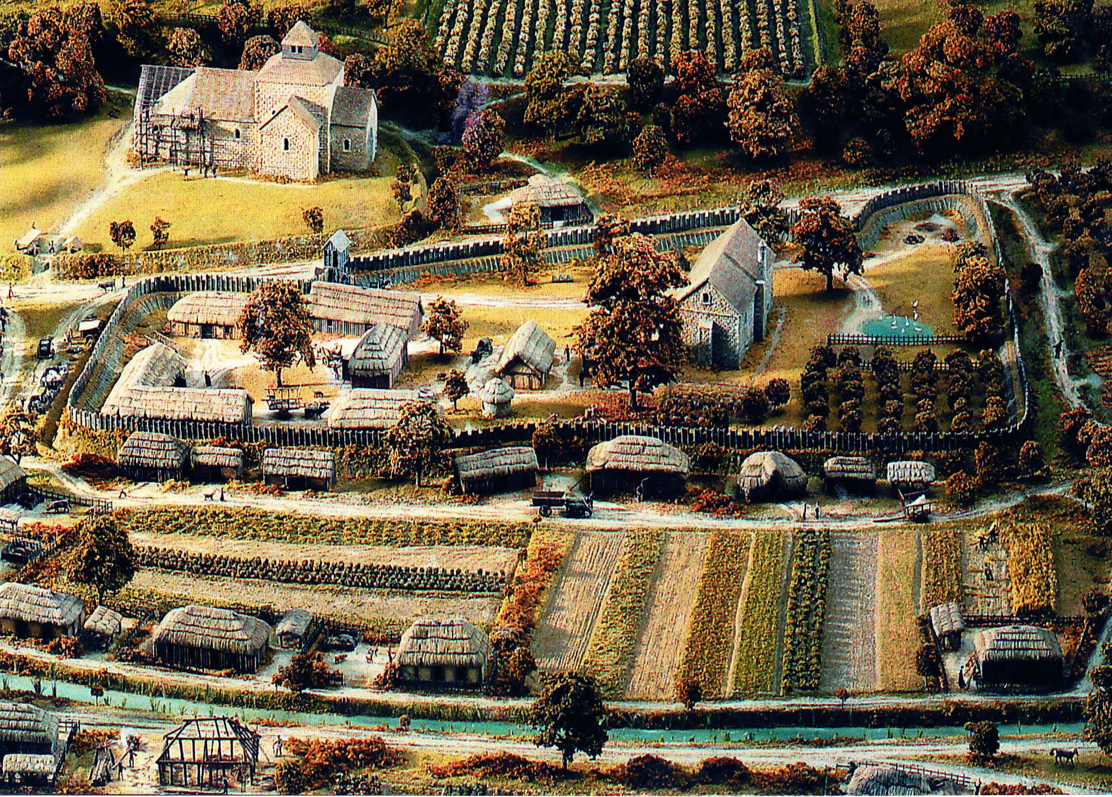

Task 10b – Life in a Norman town

Task: annotate the image of a Norman town with 5 facts. Hint: think about:
- Who lived there
- What they did
- What their houses/businesses were like
- Who had power
- Hygiene and diet

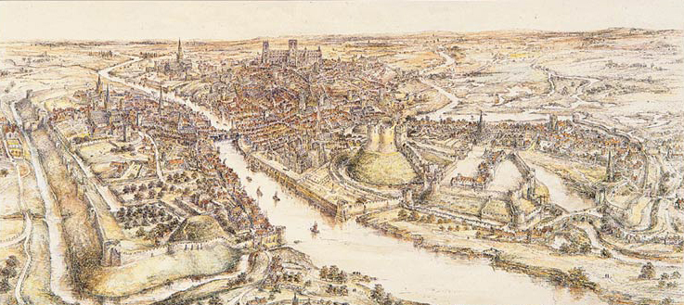

Task 11 – Similarities and differences between Anglo-Saxon and Norman England

Task: Place each bullet point on the spectrum to show how far you think it changed.
- Feudal system
- Military control
- National government
- Local government
- Legal system and trials
- Life in villages
- Life in towns
Small change from Anglo-Saxon England
Big change from Anglo-Saxon England

Task 12a – The English Church
Task: complete the paragraphs, using the words in the box below
Pope heaven powerful Roman Catholic hell

Religion was very important in Norman England and everybody was a ___________ ____________ and believed in God. If you went to church and led a good life, you would go to ____________, however if you were bad and did not go to church, you would go to ________.
The leaders of the Church were very __________________ – sometimes as powerful as kings. The __________ – the overall leader of the Church – was probably the most powerful individual in Europe.
prayers tithe quarter souls landowner Easter Dues

The Church was the largest single ____________________ in Europe – by 1086 it held a ____________ of all land in England. It was given land by rich people who wanted to ensure that they would go to heaven or they instead left money for ____________ for their ________.
Everyone in England had to pay a tax to the Church called a ________ which was one tenth of anything that was produced. Additional taxes were also paid at certain times of year such as ___________ ___________ and surplice fees for ceremonies such as weddings and funerals.
education politics religion health law money

__________: The main role of the church was to ensure that people showed that they believed in God by going to church.
__________: The Church was a major landowner in England. Peasants had to work on Church land for free even though they had their own land to look after. They believed that God would know if they had not done their work on the Church land and that God would punish them. The Church also collected taxes called tithes.
___________: The Church heard court cases for crimes carried out on Church lands. If the Church found somebody guilty of a crime, they would hand down justice in the king’s name.
____________: Leading members of the Church advised the king on important national issues as members of the Witan.
___________: The Church was the only institution that produced books. In this way, the Church could control which books were published.
___________: people in the twelfth century did not understand the cause of diseases and thought that they were a punishment from God. As a result, priests tried to cure the sick by praying for them or recommend they pay a penance in the form of money, pain or prayer.

Task 12b – Norman reforms to the Church
Task: match the change to the description in the table.
Change | Description
 | Archbishop Stigand was replaced by Archbishop Lanfranc. By 1080, there was only one Anglo-Saxon bishop, Wulfstan, left.
 | At first, the Normans stole the treasures of many of the 49 English monasteries and took the Church’s land. However, the Normans soon began rebuilding Anglo-Saxon churches and cathedrals in the Romanesque style (which was already familiar to them and used in France).
 | The Church was separate from all the rest of society and giving it a special role in the legal system through Church courts. In 1076, the Council of Winchester ordered that only Church courts could try clergy for crimes. This meant that people who worked for the church would only be tried for their crimes in Church courts rather than local courts.
 | Dioceses (areas of land served by a church or cathedral e.g. Ripon) were divided into archdeaconries, which were further divided into deaneries. Archdeacons became more common, and had the role of enforcing Church discipline in their area, presiding over Church courts.
 | Anglo-Saxon cathedrals in isolated rural locations were knocked down and moved to more strategic locations such as market towns, so that the bishop was in a more secure location with an overview of his area of control e.g. Thetford was moved to Norwich.

Changes
- The Church was used to help the Normans to control areas of England that may rebel.
- The Church was used to help the Normans to control what people thought.
- The Church had separate legal powers in Norman England.
- The Normans ensured that important people in the Church were loyal.
- The structure of the Church was changed to allow the Normans more control in each diocese.

Task 13a – Changes to Church organisation
Task: rank the changes from ‘biggest change’ to ‘smallest change’ – 1 is the biggest change, 8 is the smallest change.
- What had not changed was the people at the top of the Church hierarchy. The Pope was still head of the Catholic Church and therefore the most powerful Catholic.
- King William was certain that members of the Church in England should not obey the Pope over the king.
- William controlled communication between the leaders of the English Church and the Pope in Rome. This meant that William could influence the information that Church leaders had access to.
- William was also in control of who was appointed to the English Church.
- The Church under the Normans became more centralised – this means that it was answerable to the Archbishop of Canterbury and in turn the king.
- There were also new positions introduced such as archdeacons and deans.
- The new Norman structure allowed bishops to have far greater control of their diocese.
- There were more parish priests under the Normans than there had been previously.

Rank | Summary of change
1
2
3
4
5
6
7
8
Task 13b – William Rufus and the Church
Task: draw a series of images in each box to describe the conflicts that William Rufus had with the Church
Conflict with William of Saint-Calais 1088
1. There was a rebellion against Rufus in 1088. The Bishop of Saint-Calais had informed Rufus about this plot, and promised to bring reinforcements to help him. However, Saint-Calais then changed his mind and never returned with his troops. Rufus put him on trial for treason.
2. Saint-Calais argued that as a member of the clergy, he should be tried in a Church court rather than in a secular court. Rufus refused, arguing that the Bishop had broken his oath of fealty (loyalty) to the king and should be tried by a king’s court.
3. The Bishop of Saint-Calais did eventually return to England in 1091 and served a Bishop of Durham until 1095, but the trial was significant. It showed how determined Rufus was to control the Church rather than be controlled by it.

Conflict between Anselm and Rufus 1093-94
- When Lanfranc died in 1089, he was not replaced. This was a deliberate move by Rufus as he wanted to take the income from the Church lands that Lanfranc had held before his death.
- In 1093, Rufus suffered a serious illness and thought that God was punishing him. To please God, he decided to appoint a new Archbishop of Canterbury – Anselm.
- Relations between Rufus and Anselm were difficult from the beginning and by 1094, Anselm was preaching about the lack of morals at Rufus’ court.
- Rufus was not happy with Anselm’s comments; he felt that he owned the abbeys and that Anselm should not get involved in his affairs.

The Council of Rockingham 1095
- Rufus had stopped Anselm travelling to Rome to get Papal approval for his appointment as archbishop; Rufus argued that this would show that Anselm was really giving his loyalty to the Pope (Rufus wanted to limit the power of the Pope in England). They could not agree, so the Council of Rockingham was called.
- There was much debate and little agreement and so a truce was called. Rufus had been forced to accept Pope Urban II as Pope, but Urban agreed to stay out of English affairs whilst Rufus was king.
- Relations did not stay good for long, and Rufus blocked Anselm’s efforts to reform the Church through Church councils. Anselm also didn’t want to pay Rufus extra taxes or provide the number of knights the king required.
- By 1097, Anselm had fled to Rome – this left Rufus able to profit from the money raised by Anselm’s empty position in the Church.

Simony
- As well as conflict with different people in the Church, Rufus also brought back the practice of simony (selling jobs in the Church). This had been outlawed by Lanfranc in the 1070s. For example, Rufus sold the bishopric of Thetford to Herbert Losinga for 1000 marks.
- One of Rufus’ key allies, Ranulf Flambard, was very good at raising money from the Church – this made him popular with Rufus but unpopular with the clergy. Rufus rewarded him by making him Bishop of Durham – for £1000!

Task 14 – Norman relations with the Papacy
Task: for each Norman king, decide whether or not their relation ship with the Pope was good or bad.
King | What happened? | Good or bad relations?
William I | - Pope Alexander II (1061-1073) gave William the papal banner to fight under at the Battle of Hastings, blessing his invasion. Both Pope Alexander and William wanted to reform the corrupt English Church and bring it into line with Christianity in the rest of Europe.  - Pope Alexander also wanted to get rid of any corrupt or incompetent bishops. William supported this, and also promised to abolish the practices of nepotism and simony, as well as to ban clerical marriage. However, William's main aim was to get rid of untrustworthy Englishmen from powerful roles in the Church and to replace them with Normans.  - Pope Gregory VII wanted bishops to travel to Rome to report to him, but this did not happen - even Lanfranc did not do this. Whilst William did agree to bring back a tax called Peter's Pence which was paid to Rome, he was clear that he did not want the Pope to interfere with his rights has king.
William Rufus | - William Rufus had first damaged his relationship with the Papacy after his trial of William of Saint-Calais in 1088-9 after his came into a lot of conflict with the Pope, particularly after his appointment of Archbishop Anselm.  - Pope Urban II (1088-1099) also had a bad relationship with Rufus. This was due to Rufus' actions in stopping Anselm from travelling to Rome and blocking Anselm's reforms to the English Church. Eventually, Anselm had been exiled and fled to Rome in 1097, further damaging the relationship between Rufus and the papacy.
Henry I | - Archbishop Anselm refused to be made bishop by King Henry. He was exiled in 1103. This led the Pope to threaten Henry with excommunication, the worst punishment that the Church could give.  - Eventually, in 1107, Henry reached an agreement with the Pope. Henry agreed to give up his right to invest bishops. This meant that they would still have to swear loyalty and provide services when required.  - After this, Anselm supported Henry and in return was allowed to bring in Pope Gregory VII’s reforms, for example condemning simony.

Task 15 – Monasteries in Norman England
Task: around the monk, write 10 facts about monasticism in Norman England. You will also need your class notes to help with this task.
Hint – think about the vows monks too, how the Normans built more monasteries, changes that Normans such as Lanfranc made to monasteries.

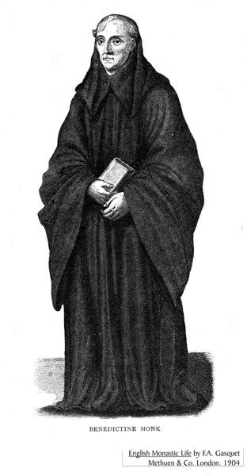

Task 16 – Education in Norman England
Task: complete the paragraphs, using the words in the box below
towns & cities Christianity trade 40 Latin French English

Before 1066, education in monasteries was conducted in __________ rather than __________, and the teachers were monks or nuns.
When the Normans arrived in 1066, education moved out of monasteries and convents and into the _______________. As the size and number of towns increased under the Normans, so did the need for a better education system. People needed better literacy and numeracy skills in order to conduct __________. Furthermore, the Norman barons and knights who lived in England wanted their children educated to the highest possible standards.
Reforms within monasticism meant that children were no longer allowed within monasteries or convents, therefore schools moved out of monasteries and became separate buildings. There was an explosion in the number of schools – by 1100 there were ______ schools and by 1200 there were 75.
In schools, __________ was spoken and began to influence the English language (and vice versa). However, Latin was still used for writing and was seen as the language of ___________.
harvest university clergy 10 Latin questions grammar

At the age of ______, some children moved on to ___________ schools, which were separate from Church schools. Students stayed at grammar school for at least 4 years, learning ___________ grammar as well as how to speak and write the language.
The school year lasted from September to June, which enabled peasant families to bring in the ___________ during the summer months. The school day started as soon as the sun was up and ended late afternoon. During lessons, the teacher sat in the middle of the room and children sat on benches around the outside, answering __________ directed at them by their teachers.
If students were successful at school, they moved on to _____________ where all books and lectures were in Latin. Students who did not go to university could become merchants, parish _________ or secretarial clerks. Subjects such as maths, accountancy and law were not taught in grammar schools and were taught when students started work.

Norman England c1066 – c1100
Level 2 revision tasks
 | Specification content | Revision tasks complete? (Y/N) | RAG your confidence | Checked by teacher?
1 | Anglo-Saxon England before 1066
2 | The death of Edward the Confessor and claims to the English throne
3 | The Battle of Stamford Bridge and the Battle of Hastings
4 | Revolts against the Normans and the Harrying of the North
5 | Norman military innovations, including castles
6 | William I’s control of England
7 | Government in Norman England
8 | Norman justice and the legal system
9 | Domesday Book
10 | Life in Norman England
11 | Similarities and differences between life in Anglo-Saxon and Norman England
12 | Norman reforms to the English Church
13 | Church organisation, reforms made by William Rufus
14 | Norman relations with the Papacy
15 | Monasteries and monastic life
16 | Norman church and education

Task 1 – Anglo-Saxon England before 1066
10 point summary
- England was a wealthy country with around 2 million people living in it. Most of these people lived in the south, with fewer in the north and west.
- Religion was important, everyone followed Catholic Christianity and accepted what the Church said as absolute fact.
- Edward the Confessor had rules since 1042 and his reign had been largely stable and peaceful.
- Society was ordered by a hierarchy where people were ordered by their level of importance. The king was at the top, followed by the Church. Earls and then peasants at the bottom.
- There were hardly any castles in England and it was not very well defended.
- Most of the southern half of England was covered in forest and there were small villages where the forest had been cleared and land was farmed.
- The king had earls to help him rule England. Each earl helped rule a different part of England.
- The king had earls and housecarls who were professionally trained soldiers – there were around 2500-3000 housecarls in England.
- The most powerful earl in England was Earl Godwin who had a close relationship with King Edward but who had publicly fallen out with him in 1052.
- England had good trade links with other countries such as Norway and France. It had a sophisticated minting system – it made its own coins – and had one of the most advanced economic systems in the known world at this time.
Task: based on the 10 point summary, complete the table below.
Reasons to invade England | Problems for the Anglo-Saxons
Task 2 – The Death of Edward the Confessor and
Claims to the English Throne
Task: complete the paragraph, using the words in the box below
Confessor 4 claimants Witan Children Godwin Edward support
1042 earls bishops 1066

_________ the ______________ had been king of England since _______. He had
reigned England with the support of the __________ which was a council of English
_______ and __________, such as Earl __________. Edward the Confessor died in January _______ without leaving any ____________. As a result, it was unclear who would become king. There were ______ powerful men who put their claim forward for the throne, however these ___________ were from different countries and had different levels of _________.
Task: fill in the gaps and then match up the claimants to the English throne in 1066 with the information that explains who they were and what their claim was.
The _______-_______ of Edward which made him the closest __________ relative. He was not named as an ________ by Edward, even though he had lived with Edward since he was a child and was treated as though he was Edward’s adopted son. He was an _______--_______ and had the support of many ________.

The King of __________, he was a powerful _________ with a ________ and _________ army. He was related to King ________ who had ruled England from 1016-1035 and he claimed that as he was a _________ of the previous king, that he should now be king of England.

Was a distant __________ of Edward the Confessor. Had grown up with Edward the Confessor and supported him when Earl _________ had rebelled against him in 1051. Thought that he had been __________ the throne by Edward several years before his death and claimed that he had the support of Harold Godwinson.
Was not a ________ _________ to the king, but was the brother in law of Edward the Confessor. He was the ________man in England and had helped Edward to rule – especially towards the end of his reign. He was a skilful ________ leader who had beaten a Welsh invasion and therefore had the support of the English _____. Edward’s ______ wish was that this person become king of England.

Harold Godwinson

William of Normandy

Harald Hardrada

Edgar Aetheling

Task 3a – Preparations for the Battle of Hastings
Task: fill in the correct information to show the preparations that Harold Godwinson and William of Normandy made for battle in 1066.
For each box, state how it either helped or hindered Harold or William in the battle.
 | Harold Godwinson | William of Normandy
Army
Navy
Tactics

Pre-fabricated castles | ???? housecarls | ???? horses
Thegns | No cavalry | Knights
Archers | Army of several thousand | ???? soldiers
Cavalry | fyrd | No archers
Large Navy | Papal Banner | ??? ships

Task 3b – January – September 1066
Task: using the content booklet, summarise what happened under each heading

Harold builds his army
5th January 1066

Williams’s preparations
Tostig and Hardrada

Battle of Fulford Gate
8th September 1066

William lands at Pevensey
Battle of Stamford Bridge

Task 3c – The Battle of Hastings

Task: illustrate the storyboard and add a caption with the events of the Battle of Hastings.
7.
6.
5. Fighting paused to let both sides removed their dead/ injured
4.

3. Feigned retreat
2.

- The battle starts at 9am.

Task 3d - Why did William win the Battle of Hastings?
Task: complete this mind map using the previous two pages and your content booklet to explain why William won the Battle of Hastings. Annotate around each heading with evidence to support that each factor helped William to win.
Anglo-Saxon mistakes
Support from God

Why did William win?

Task 4 - Revolts against the Normans 1066 – 1075
Task: Fill in the gaps and match the rebellion to the description using the map and your content booklet.

1067 – The Welsh Borders
1067 – Kent
1067 – Northumbria
1068 – Edwin & Morcar
1068 – The South West
1069 – Harrying of the North
1070-71 – East Anglia
1075 – Norman Earls

Which rebellion? | Description
 | William appointed _______ to rule part of England, which was an odd decision as Copsig had previously worked for Earl Tostig Godwinson. Copsig was soon ambushed by ___________ and his head hacked off.
 | The city of ________ rebelled against William and was put under siege for 18 days. William then lowered taxes and built a ________ to increase his control over the city. Despite two attempted rebellions from Harold Godwinson’s ______, Exeter remained _________ thanks to William’s actions.
 | _________ ____ ________ was joined by two Welsh kings and attacked Herefordshire.
 | Two Anglo-Saxon earls rebelled for a second time, but submitted to William when he began to build more castles in England.
 | The _______ challenge that William faced, but this time from the Earl of _________ and the Earl of _______ _________ – with support from Waltheof. William dealt with this rebellion relatively ________, and by the time the _________ arrived the rebellion was over.
 | A difficult to control area of England sought help from King _______ of Denmark, as well as rebelling several times themselves at places such as ______. Following the rebellion, William laid waste to the land, with mass _________ and __________.
 | People were angry at how they had been treated by the Normans after the Battle of Hastings. They persuaded the French _________ of _________ to attempt to seize Dover Castle but when he did, he didn’t attack with enough force and was soon ___________.
 | William faced a rebellion from the Danes who had remained in England despite agreeing to leave, and an Anglo-Saxon called __________. This was not a completely serious rebellion as King Swein had given up on the idea of taking England, however Hereward was a nuisance to William.

Task 5a – Norman military innovations: motte and bailey castles

Task: Add a description to each empty box and then label the motte and bailey castle diagram using the grid below.

Keep | Outer Bailey | Drawbridge
Motte | Inner Bailey | Palisade
Stair  The stairs connecting the keep on the motte with the inner bailey. | Stockade  A barrier formed from upright wooden posts or stakes, especially as a defence against attack | Gable  The triangular end of a house.

Task 5b- how and why were castles built?
Task: complete the paragraphs, using the words in the box below
Edward Confessor castles control difference burhs defend fortifications rebellious central

___________ were ________ to Norman ________ of England. Very few castles had been built by ____________ the _____________ and the defensive ________________ that the Anglo-Saxons used were called __________. The ______________ between burhs and castles was that burhs were built to ___________ the population, whereas castles were built to control the _____________ English.
The first castles that the Normans built were called ________ and _________ castles. A
troops motte burn keep earth mound palisade quickly lookout bailey ditches
motte was an _______ _______, and a _______ was built on top of it. The __________ around the motte made it harder to attack. The ___________ was the outer area of the castle which was defended by a wooden ______________. Norman ___________ were stationed in the ___________ along with their horses. These troops could retreat to the __________ if they needed extra protection, but the keep was also used as a ______________. A motte and bailey castle could be erected very __________, but the wooden structure was a weakness because they could __________.
symbolic reminder soldiers governing rebellions day’s taxes strategic
Castles had two main functions: _____________ and _____________.
- ____________: they housed Norman ____________ who could help to stop any
_____________. Norman soldiers were never more than a __________ march away
from a Norman castle.
- _____________: castles were a permanent _____________ to the English of who

was now ___________________ the country. The Normans charged the English
__________ to help them maintain the castles.

Task 6 – Norman control of England

Task: complete this mind map using the previous pages and your content booklet to explain how the Normans controlled England after 1066.

Task 7a – Government in Norman England
How did the Normans control England?

Continuing the dynasty
Cooperating with English lords

Task: using the content booklet, annotate each pyramid to explain who each section of society contained.

Task 7b – The feudal system under the Normans

Task: fill in the gaps, and in the final column of the table, explain what had changed from the Anglo-Saxons to the Normans.

Feature | Anglo-Saxon | Norman | What changed?
Feudal System | Six major ___________ in 1066  4,000 _____________  ________ owned most of the land, followed by the __________. | _________ owned about 20% of the land, with the _________ owning around 25% of land.  Remaining land shared between _______ Norman __________ and __________.  By 1086 only 4 thegns owned land.  _________ __________ and Forest Law created.
Military Control | The main part of the king’s army would be made up from ________________.  For the rest of the army, the Anglo-Saxons used the _______ | Knights made an ________ to their lord – it was a religious ________ to provide service.  Knights always had to carry out military service.  By 1100 the Norman king had ___________ knights he could call on.
National government | The king was in charge and the nobility were involved in the process of decision making through the _________.  Anglo-Saxon government issued orders in __________ – these were called ________. This was a short document which gave orders to be sent around the __________ and he system was known as government by writ. | Norman kings continued to take the advice of their leading subjects through the Great Council.  The Normans continued government by writ but issued ______ ______ orders, which allowed William to create a more ____________ government.
Local government | Under the Anglo-Saxon, England had been split into 134 _______. A _________-______ (the original word for sheriff) was in charge of each shire and organised justice, _____________ and the collecting of ________. Each shire was split into smaller areas known as ___________. | The Normans found the Anglo-Saxon system __________ so still used sheriffs. The sheriff acted as second to a __________ in an area, and was a vital link between the king and the local area.  Anglo-Saxon sheriffs were ____________ with Norman sheriffs.

Task 8a – Norman legal system
Task: complete the missing words in each bullet point, using your content booklet.
- The legal system also kept many features from ____________ - __________ England.
- This was due to the _____________ element, but it was also _____________ – it helped to prove that the Normans were ____________ rulers.
- The one big change that the Normans did make was to _____________ the system and make it more ______________________.
- The most important courts remained the ____________ court, the __________ court and the _____________ court.
- From 1076, _________________ courts to deal with church matters.
- There was no ___________ force in Norman England, therefore the law was enforced by a range of different people.
- The __________ and _________ _________ still had their own laws in the early years of Norman rule.
- In vulnerable areas such as the ____________, the earls effectively had their own royal powers.
- However, the Norman trend was for areas to come increasingly under __________ control as it allowed the Normans to gain more ____________ power and to make ____________.

Task: match up the different aspects of law enforcement in Norman England.
Were not paid much, but had the power to arrest people, break up fights and put out fires. They also held the keys to the stocks.
Were either volunteers or given the job as a duty. Their role was to ensure that people abided by curfews, prevent crime and catch criminals. As they were not paid, many did not take their role seriously and instead used it as a time to drink with their friends.
The system for raising the alarm after a crime had taken place. If anyone witnessed a crime, they had a duty to report it and could be punished if they did not.
A group of 10-12 men who all promised to stop the others committing crimes. If one did, it was the duty of the others to reveal the guilty party, or risk the whole group being fined.
If a Norman was killed and their murderer was not found within 5 days, the whole population of the hundred would be fined. This fine helped to reduce hostile acts against the Normans, but when these hostile acts did occur, the money from fines proved useful for the king.
Hue and Cry

Constable

Tithing

Murdrum

Watchmen

Task 8b – Trials in Norman England

Task: using your content booklet, explain how each method of trial worked and how it was change or continuity from the Anglo-Saxons

...................................................................
...................................................................
...................................................................
...................................................................
...................................................................
...................................................................

...................................................................
...................................................................
...................................................................
...................................................................
...................................................................
...................................................................

...................................................................
...................................................................
...................................................................
...................................................................
...................................................................
...................................................................

...................................................................
...................................................................
...................................................................
...................................................................
...................................................................
...................................................................

Task 9 – Domesday Book

Task: complete the sentences on Domesday Book – use your content booklet to help you. Hint: think about what Domesday Book would allow the Normans to do in England.

Another reason Domesday Book was important was because..........................
................................................................
................................................................
................................................................
.................................................................
This was a change from Anglo-Saxon England because ....................................
................................................................
................................................................
.................................................................
.................................................................

Domesday Book was important because..................................................
................................................................
................................................................
................................................................
.................................................................
This was a change from Anglo-Saxon England because ....................................
................................................................
................................................................
.................................................................
.................................................................

Task: using your content booklet, find some precise historical evidence that was contained in Domesday Book

Pickering in 1066 | Pickering in 1086

Task 10a – Life in a Norman village

Task: annotate the image of a Norman village with 10 facts.

Task 10b – Life in a Norman town

Task: annotate the image of a Norman town with 10 facts.

Task 11 – Similarities and differences between Anglo-Saxon and Norman England

Task: Place each bullet point on the spectrum to show how far you think it changed. For each point on your spectrum, explain why it changed or stayed the same in 25 words for each.
Small change from Anglo-Saxon England
Big change from Anglo-Saxon England

Task 12a – The English Church
Task: complete the paragraphs, using the words in the box below
Pope Europe heaven important church powerful king Roman Catholic powerful hell

Religion was very _____________ in Norman England and everybody was a ___________ ____________ and believed in God. If you went to ________ and led a good life, you would go to ____________, however if you were bad and did not go to church, you would go to ________.The leaders of the Church were very __________________ – sometimes as powerful as ________. The __________ – the overall leader of the Church – was probably the most ____________ individual in ____________.
prayers tithe largest quarter tax souls surplice landowner tenth Easter Dues 1086

The Church was the __________ single ____________________ in Europe – by ________ it held a ____________ of all land in England. It was given land by rich people who wanted to ensure that they would go to heaven or they instead left money for ____________ for their ________.
Everyone in England had to pay a ______ to the Church called a ________ which was one ________ of anything that was produced. Additional taxes were also paid at certain times of year such as ___________ ___________ and fees for ceremonies such as weddings and funerals.
Task: summarise the different roles of the Church:
Religion:

Money:

Law:

Politics:

Education:

Health:

Task 12b – Norman reforms to the Church
Task: describe and explain the changes made by the Normans to the Church
Change | How?
The Church was used to help the Normans to control areas of England that may rebel.
The Church was used to help the Normans to control what people thought.

The Church had separate legal powers in Norman England.

The Normans ensured that important people in the Church were loyal.

The structure of the Church was changed to allow the Normans more control in each diocese.

Task 13a – Changes to Church organisation
- Rank the changes from ‘biggest change’ to ‘smallest change’ – 1 is the biggest change, 8 is the smallest change.
- Explain why you have ranked it where you have

- What had not changed was the people at the top of the Church hierarchy. The Pope was still head of the Catholic Church and therefore the most powerful Catholic.
- King William was certain that members of the Church in England should not obey the Pope over the king.
- William controlled communication between the leaders of the English Church and the Pope in Rome. This meant that William could influence the information that Church leaders had access to.
- William was also in control of who was appointed to the English Church.
- The Church under the Normans became more centralised – this means that it was answerable to the Archbishop of Canterbury and in turn the king.
- There were also new positions introduced such as archdeacons and deans.
- The new Norman structure allowed bishops to have far greater control of their diocese.
- There were more parish priests under the Normans than there had been previously.
Rank | Summary of change
1
2
3
4
5
6
7
8
Task 13b – William Rufus and the Church
Task: summarise each conflict that William Rufus had with the Church in five key bullet points
Conflict with William of Saint-Calais 1088

Conflict between Anselm and Rufus 1093-94

The Council of Rockingham 1095

Simony

Task 14 – Norman relations with the Papacy
Task: for each Norman king, explain why they had either a good or bad relationship with the Papacy.
King | What happened? | Good or bad relations?
William I |  | Mainly good, but some bad
William Rufus |  | Bad
Henry I |  | Bad to begin with, but got better

Task 15 – Monasteries in Norman England
Task: around the monk, write 10 facts about monasticism in Norman England. You will also need your class notes to help with this task.

Task 16 – Education in Norman England
Task: explain the changes made by the Normans to education
Aspect | What changed?
Church education
Grammar Schools
Language

Norman England c1066 – c1100
Level 3 revision tasks
 | Specification content | Revision tasks complete? (Y/N) | RAG your confidence | Checked by teacher?
1 | Anglo-Saxon England before 1066
2 | The death of Edward the Confessor and claims to the English throne
3 | The Battle of Stamford Bridge and the Battle of Hastings
4 | Revolts against the Normans and the Harrying of the North
5 | Norman military innovations, including castles
6 | William I’s control of England
7 | Government in Norman England
8 | Norman justice and the legal system
9 | Domesday Book
10 | Life in Norman England
11 | Similarities and differences between life in Anglo-Saxon and Norman England
12 | Norman reforms to the English Church
13 | Church organisation, reforms made by William Rufus
14 | Norman relations with the Papacy
15 | Monasteries and monastic life
16 | Norman church and education

Task 1 – Anglo-Saxon England before 1066
10 point summary
Task: Add 5 further points to complete this summary:
- England was a wealthy country with around 2 million people living in it. Most of these people lived in the south, with fewer in the north and west.
- Religion was important, everyone followed Catholic Christianity and accepted what the Church said as absolute fact.
- Edward the Confessor had ruled since 1042 and his reign had been largely stable and peaceful.
- Society was ordered by a hierarchy where people were ordered by their level of importance. The king was at the top, followed by the Church. Earls and then peasants at the bottom.
- There were hardly any castles in England and it was not very well defended.

Task: based on your 10 point summary, complete the spectrum below

Strong country
Weak country

Task 2 – The Death of Edward the Confessor and
Claims to the English Throne
Task: explain why each claim to the throne was important, making sure to include the words in the box.
Harold Godwinson novissima verba Wessex brother in law important sub-regulus
oath military rich

William of Normandy post obitum rebellion Earl Godwin important sub-regulus
oath military cousin

Edgar Aetheling Witan heir Anglo-Saxon important
child blood relative

Harald Hardrada inherit Harthacanute Viking important
army king of Norway Tostig Godwinson

Task 3a – Preparations for the Battle of Hastings
Task: fill in the correct information from memory to show the preparations that Harold Godwinson and William of Normandy made for battle in 1066.
 | Harold Godwinson | William of Normandy
Army
Navy
Tactics
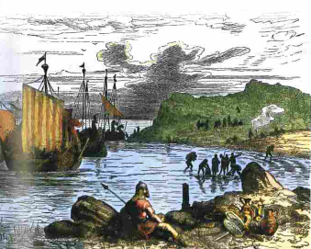
What own knowledge makes this interpretation about William’s landing at Pevensey in 1066 convincing?
…………………………………………………...
……………………………………………………
……………………………………………………
……………………………………………………
……………………………………………………
………………………………………………………………………………………………….
Task 3b – January – September 1066
Task: using the content booklet, summarise what between January and September 1066.

Task 3c – The Battle of Hastings
Task: write an account of how William won the Battle of Hastings.
•Write a chain of events, in order, about the Battle of Hastings
•Include precise historical detail to illustrate each point
•Link back to the question after each event

........................................................................................................................................................................................................................................................................................................................................................................................................................................................................................................................................................................................................................................................................................................................................................................................................................................................................................................................................................................................................................................................................................................................

........................................................................................................................................................................................................................................................................................................................................................................................................................................................................................................................................................................................................................................................................................................................................................................................................................................................................................................................................................................................................................................................................................................................

........................................................................................................................................................................................................................................................................................................................................................................................................................................................................................................................................................................................................................................................................................................................................................................................................................................................................................................................................................................................................................................................................................................................

Task 3d - Why did William win the Battle of Hastings?
Task: complete this mind map using the previous two pages and your content booklet to explain why William won the Battle of Hastings. Annotate around each heading with evidence to support that each factor helped William to win.

Why did William win?

Task 4 - Revolts against the Normans 1066 – 1075
Task: Write a 30 word summary for each rebellion the Normans faced. Explain why each rebellion was important.
Rebellion | Description & why it was important
1067 – Welsh Borders
1067 – Kent

1067 - Northumbria
1068 – Edwin & Morcar

1068 – The South West

1069 – Harrying of the North

1070-71 – East Anglia

1075 – Norman Earls

Task 5a – Norman military innovations: motte and bailey castles

Task: Label the motte and bailey castle diagram.

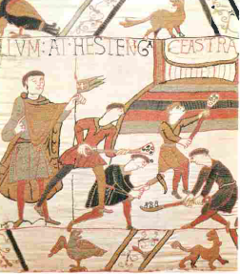
What own knowledge do you have that makes this interpretation of motte and bailey castles convincing?
…………………………………………………………………………
…………………………………………………………………………
…………………………………………………………………………
…………………………………………………………………………
…………………………………………………………………………
…………………………………………………………………………
…………………………………………………………………………
…………………………………………………………………………
…………………………………………………………………………
…………………………………………………………………………
…………………………………………………………………………
…………………………………………………………………………
Task 5b- how and why were castles built?
Task: Write 3 paragraphs on how and why castles were built, using the words in the box below
Edward Confessor castles control difference burhs defend fortifications rebellious central

………………………………………………………………………………………………………………………………………………………………………………………………………………………………………………………………………………………………………………………………………………………………………………………………………………………………………………………………………………………………………………………………………………………………………………………………………………………………………………………………………………………………………………………………………………………………………………………………………………………………………………………………………………………………………………………………………………………………………………………………………………………………………………………………………………………………………………………………………………………………………………………………………………………………………………
troops motte burn keep earth mound palisade quickly lookout bailey ditches
…………………………………………………………………………………………………………………………………………………………………………………………………………………………………………………………………………………………………………………………………………………………………………………………………………………………………………………………………………………………………………………………………………………………………………………………………………………………………………………………………………………………………………………………………………………………………………………………………………………………………………………………………………………………………………………………………………………………………………………………………………………………………………………………………………………………………………
symbolic reminder soldiers governing rebellions day’s taxes strategic

………………………………………………………………………………………………………………………………………………………………………………………………………………………………………………………………………………………………………………………………………………………………………………………………………………………………………………………………………………………………………………………………………………………………………………………………………………………………………………………………………………………………………………………………………………………………………………………………………………………………………………………………………………………………………………………………………………………………………………………………………………………………………………………………………………………………………………………………………………………………………………………………………………………………………………

Task 6 – Norman control of England

Task: complete this mind map using the previous pages and your content booklet to explain how the Normans controlled England after 1066.

Task 7a – Government in Norman England
How did the Normans control England?

Task: explain how the following groups in the feudal system changed from Anglo-Saxon England to Norman England.

King
…………………………………………………………………………………………………………………………………………………………………………………………………………………………………………………………………………………………………………………………………………………………………………………………………………………………………………………………………………………………………………
……………………………………………………………………………………………………………………………………………………………………………………………………………………………………………………

Earls Barons//Bishops
…………………………………………………………………………………………………………………………………………………………………………………………………………………………………………………………………………………………………………………………………………………………………………………………………………………………………………………………………………………………………………
……………………………………………………………………………………………………………………………………………………………………………………………………………………………………………………

Thegns Knights
…………………………………………………………………………………………………………………………………………………………………………………………………………………………………………………………………………………………………………………………………………………………………………………………………………………………………………………………………………………………………………
……………………………………………………………………………………………………………………………………………………………………………………………………………………………………………………

Peasants
…………………………………………………………………………………………………………………………………………………………………………………………………………………………………………………………………………………………………………………………………………………………………………………………………………………………………………………………………………………………………………
……………………………………………………………………………………………………………………………………………………………………………………………………………………………………………………

Slaves
…………………………………………………………………………………………………………………………………………………………………………………………………………………………………………………………………………………………………………………………………………………………………………………………………………………………………………………………………………………………………………

Task 7b – The feudal system under the Normans

Task: complete the first two columns of the table to explain each feature of the government under the Anglo-Saxons and Normans. In the final column, explain what changed between the two.

Feature | Anglo-Saxon | Norman | What changed?
Feudal System
Military Control
National government
Local government

Task 8a – Norman legal system
Task: describe each aspect of the Norman legal system, and explain who the changes to the system affected.
Method of control | Anglo-Saxon | Norman England | People who the change affected
Shire courts
Hundred courts

Primogeniture
Oaths
Murdrum fines
Ordeals

Harrying of the
North

Forest Laws

Task 8b – Justice in Norman England

Task: using your content booklet, explain how convincing each interpretation is about different aspects of the Norman legal system.
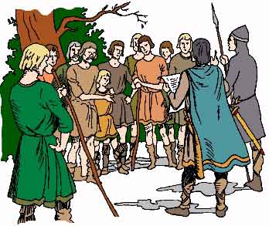
What own knowledge do you have that makes this interpretation of tithings convincing?
..........................................................
……………………………………………………….
……………………………………………………….
……………………………………………………….
……………………………………………………….
……………………………………………………….
……………………………………………………….
……………………………………………………….
……………………………………………………….
………………………………………………………
……………………………………………………….
…………………………………………………………………………………………………………………………………………………………………………………………………………………………………………………………………………
………………………………………………………………………………………………………………………………………………………………………………………………………………………………………………………………………..
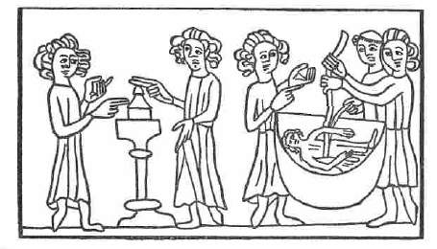
What own knowledge do you have that makes this interpretation of ordeals convincing?
………………………………………….
………………………………………….
………………………………………….
………………………………………….
………………………………………….
………………………………………….
………………………………………….
…………………………………………
……………………………………………………………………………………………………………………………………………………………………………………………………………………………………………………………………………………………………………………………………………………………………………………………………………………………………………………………………………………………………………………………………………………………………………………………………………………………………………………………………………………………………………………………………………………………………………………………………………………………………………………………………………………………………………………………………………………………………………………………………………………………………………………………………………………………………………………………………………………………………………………………………………………………………………………………………………………………………………………………………………………………………………………

Task 9 – Domesday Book

Task: choose 3 things that you think were important about Domesday Book and explain why they are important.
Hint: think about how the land had changed from 1066, what the Normans were trying to do, how the survey was gathered. Use the sources and interpretations to help you. Use historical examples to support your explanation.

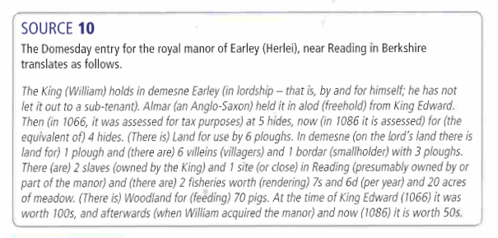

1...............................................................................................................................................................................................................................................................................................................................................................................................................................................................................................................................................................................................................................................................................................................................................................................................................................................................................................................................................................................

2..............................................................................................................................................................................................................................................................................................................................................................................................................................................................................................................................................................................................................................................................................................................................................................................................................................................................................................................................................................................

3..............................................................................................................................................................................................................................................................................................................................................................................................................................................................................................................................................................................................................................................................................................................................................................................................................................................................................................................................................................................

Task 10a – Life in a Norman village

Task: Using your own knowledge, how convincing is this interpretation of life in a Norman village?

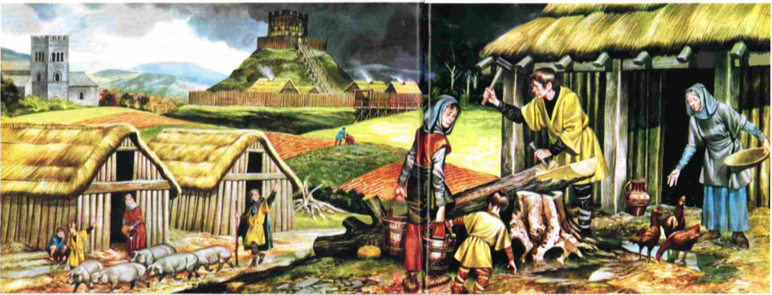

Role of weather .....................................................................................................................................................................................................................................................................................................................................................................................................................
.......................................................................................................................................
Presence of a castle ............................................................................................................................................................................................................................................................................................................................................................................................................................................................................................................................................................
Style of church
............................................................................................................................................................................................................................................................................................................................................................................................................................................................................................................................................................
Style of house .......................................................................................................................................
.....................................................................................................................................................................................................................................................................................................................................................................................................................
Tasks that the peasants are doing ..............................................................................................................................................................................................................................................................................
..............................................................................................................................................................................................................................................................................

Task 10b – Life in a Norman town

Task: write down 5 differences between Norman villages and towns

Task: how did life in Norman towns change? Select and explain 3 changes.

...................................................................................................................................................................................................................................................................................................................................................................................................................................................................................................................................................................................................................................................................................................

...................................................................................................................................................................................................................................................................................................................................................................................................................................................................................................................................................................................................................................................................................................

...................................................................................................................................................................................................................................................................................................................................................................................................................................................................................................................................................................................................................................................................................................

Task 11 – How far did life change in Norman England?

Task: for each aspect of life in Norman England, explain how far it changed from the Anglo-Saxons to the Normans and why.

Aspect | Rich people (aristocracy) | Poor people
Land
Law
Language
Castles
Villages
Towns

Task 12a – The English Church
Task: write two paragraphs about religion in England, using the words in the boxes below
Pope - Europe - heaven - important – church - powerful – king - Roman Catholic - hell

......................................................................................................................................................................................................................................................................................................................................................................................................................................................................................................................................................................................................................................................................................................................................................................................................................................................................................................................................................................................................................................................................................................................................................................................................................................................................................................................................................................................................
prayers - tithe - largest - quarter - tax - souls - surplice - landowner - tenth -
Easter Dues - 1086

......................................................................................................................................................................................................................................................................................................................................................................................................................................................................................................................................................................................................................................................................................................................................................................................................................................................................................................................................................................................................................................................................................................................................................................................................................................................................................................................................................................................................
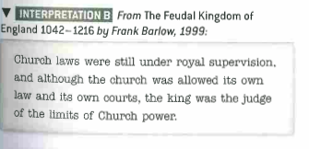
What own knowledge do you have that makes this interpretation of the role of the Church convincing?
....................................................
...................................................
....................................................
....................................................
..............................................................................................................................................................................................................................................................................
..............................................................................................................................................................................................................................................................................
Task 12b – Norman reforms to the Church
Task: for each reform that the Normans made to the Church, explain why it was important.
Reform | Why was it important?
Removal of Anglo-Saxon clergy
Changes to nepotism, pluralism, simony and clerical marriage
Establishing synods
Moving and rebuilding Anglo-Saxon churches and cathedrals
Establishing Church courts

Task 13a – Changes to Church organisation
Task: for each change the Normans made to Church organisation, explain what changed and how this allowed the Normans to increase their control on the Church.
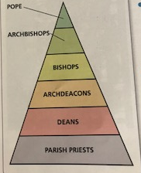
Removing Anglo-Saxon bishops and archbishops
................................................................
................................................................
................................................................
................................................................
................................................................
................................................................
................................................................
................................................................

Creation of archdeacons and deans
...............................................................
................................................................
................................................................
................................................................
................................................................
................................................................
................................................................
.....................................................................................................................................................................................................................................................................................................................................................................................................................
The role of parish priests was developed
........................................................................................................................................................................................................................................................................................................................................................................................................................................................................................................................................................................................................................................................................................................................................................................................................................................................................................................................................................................................................................................................................................................................

Task 13b – William Rufus and the Church
Task: how convincing is this interpretation of William Rufus’ relationship with the Church?
Use your own knowledge of:
- Conflict with William of Saint-Calais 1088
- Conflict between Anselm and Rufus 1093-94
- The Council of Rockingham 1095
- Simony
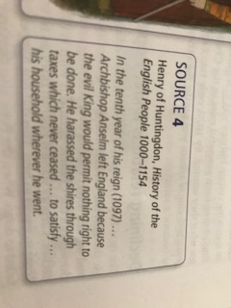
................................................................................................................................................................................................................................................................................................................................................................................................................................................................................................................................................................................................................................................................................................................................................................................................................................................................................................................................................................................................................................................................................................................................................................................................................................................................................................................................................................................................................................................................................................................................................................................................................................................................................................................................................................................................................................................................................................................................................................................................................................................................................................................................................................................................................................................................................................................................................................................................................................................................................................................................................................................................................................................................................................................................................................................................................................................................................................................................................................................................................................................................................................

Task 14 – Norman relations with the Papacy
Task: write an account of Norman monarchs’ relationship with the Papacy
- Write a chain of events, in order, about the Norman relations with the Papacy
- Cover each of the Norman kings
- Include precise historical detail to illustrate each point
- Link back to the question after each event

...............................................................................................................................................................................................................................................................................................................................................................................................................................................................................................................................................................................................................................................................................................................................................................................................................................................................................................................................................................................................................................................................................................................................................................................................................................................................

...............................................................................................................................................................................................................................................................................................................................................................................................................................................................................................................................................................................................................................................................................................................................................................................................................................................................................................................................................................................................................................................................................................................................................................................................................................................................

...............................................................................................................................................................................................................................................................................................................................................................................................................................................................................................................................................................................................................................................................................................................................................................................................................................................................................................................................................................................................................................................................................................................................................................................................................................................................

Task 15 – Monasteries in Norman England
Task: explain 4 reforms that the Normans made to monasteries. For each, explain why the Normans made the change.
Reform | Description | Why was change made?

Task: which reforms were successful, and which were failures? Can you explain why?

Task 16 – Education in Norman England
Task: explain why the changes made by the Normans to education were important

Church education
..........................................................................................................................................................................................................................................................................................................................................................................................................................................................................................................................................................................................................................................................................................................................................................................................................................................

Grammar schools
..........................................................................................................................................................................................................................................................................................................................................................................................................................................................................................................................................................................................................................................................................................................................................................................................................................................

Language- the use of Latin
..........................................................................................................................................................................................................................................................................................................................................................................................................................................................................................................................................................................................................................................................................................................................................................................................................................................
Everyday use of language
..........................................................................................................................................................................................................................................................................................................................................................................................................................................................................................................................................................................................................................................................................................................................................................................................................................................

Norman England c1066 – c1100
Level 4 revision tasks
 | Specification content | Revision tasks complete? (Y/N) | RAG your confidence | Checked by teacher?
1 | Anglo-Saxon England before 1066
2 | The death of Edward the Confessor and claims to the English throne
3 | The Battle of Stamford Bridge and the Battle of Hastings
4 | Revolts against the Normans and the Harrying of the North
5 | Norman military innovations, including castles
6 | William I’s control of England
7 | Government in Norman England
8 | Norman justice and the legal system
9 | Domesday Book
10 | Life in Norman England
11 | Similarities and differences between life in Anglo-Saxon and Norman England
12 | Norman reforms to the English Church
13 | Church organisation, reforms made by William Rufus
14 | Norman relations with the Papacy
15 | Monasteries and monastic life
16 | Norman church and education

Task 1 – Anglo-Saxon England before 1066
Task: From memory, complete a 10 point summary of Anglo-Saxon England

Task: How convincing is this interpretation about Anglo-Saxon England?
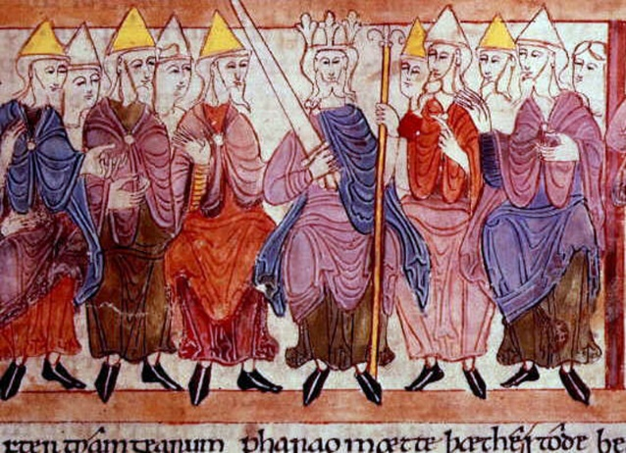
................................................................
................................................................
................................................................
................................................................
................................................................
................................................................
................................................................
................................................................
................................................................
........................................................................................................................................................................................................................................................................................................................................................................................................................................................................................................................................................................................................................................................................................................................................................................

Task 2 – The Death of Edward the Confessor and
Claims to the English Throne
Task: Explain what was important about William of Normandy’s claim to the throne.
....................................................................................................................................................................................................................................................................................................................................................................................................................................................................................................................................................................................................................................................................................................................................................................................................................................................................................................................................................................................................................................................................................................................................................................................................................................................................................................................................................................................................................
....................................................................................................................................................................................................................................................................................................................................................................................................................................................................................................................................................................................................................................................................................................................................................................................................................................................................................................................................................................................................................................................................................................................................................................................................................................................................................................................................................................................................................
....................................................................................................................................................................................................................................................................................................................................................................................................................................................................................................................................................................................................................................................................................................................................................................................................................................................................................................................................................................................................................................................................................................................................................................................................................................................................................................................................................................................................................

Task: Explain what was important about Harold Godwinson’s claim to the throne.
....................................................................................................................................................................................................................................................................................................................................................................................................................................................................................................................................................................................................................................................................................................................................................................................................................................................................................................................................................................................................................................................................................................................................................................................................................................................................................................................................................................................................................
....................................................................................................................................................................................................................................................................................................................................................................................................................................................................................................................................................................................................................................................................................................................................................................................................................................................................................................................................................................................................................................................................................................................................................................................................................................................................................................................................................................................................................
....................................................................................................................................................................................................................................................................................................................................................................................................................................................................................................................................................................................................................................................................................................................................................................................................................................................................................................................................................................................................................................................................................................................................................................................................................................................................................................................................................................................................................

Task 3a – Preparations for the Battle of Hastings
Task: explain what was important about William’s preparations for the Battle of Hastings
Support of France
....................................................................................................................................................................................................................................................................................................................................................................................................................................................................................................................................................................................................................................................................................................................................................................................................................................................................................................................................................................................................................................................................................................................................................................................................................................................................................................................................................................................................................
Military preparations
....................................................................................................................................................................................................................................................................................................................................................................................................................................................................................................................................................................................................................................................................................................................................................................................................................................................................................................................................................................................................................................................................................................................................................................................................................................................................................................................................................................................................................
Support of God
....................................................................................................................................................................................................................................................................................................................................................................................................................................................................................................................................................................................................................................................................................................................................................................................................................................................................................................................................................................................................................................................................................................................................................................................................................................................................................................................................................................................................................
Task 3b – January – September 1066
Task: How convincing is this interpretation of Harold’s actions before the Battle of Hastings?
Harold’s brother Gyrth, as quoted in the Anglo-Saxon Chronicle
You are just returned and worn out after the war against the Norwegians, now you are hastening to move against the Normans.

....................................................................................................................................................................................................................................................................................................................................................................................................................................................................................................................................................................................................................................................................................................................................................................................................................................................................................................................................................................................................................................................................................................................................................................................................................................................................................................................................................................................................................

Task: How convincing is this interpretation about the Battle of Stamford Bridge?
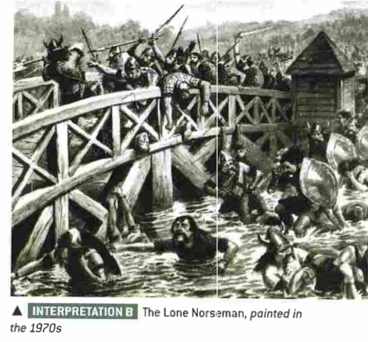
.........................................................
.........................................................
.........................................................
.........................................................
.........................................................
.........................................................
.........................................................
.........................................................
.........................................................
.........................................................
.........................................................
.........................................................
........................................................
........................................................
........................................................................................................................................................................................................................................................................................................................................................................................................................................................................................................................................................................................................................................
Task 3c – The Battle of Hastings
Task: FROM MEMORY - write an account of how William won the Battle of Hastings.
............................................................................................................................................................................................................................................................................................................................................................................................................................................................................................................................................................................................................................................................................................................................................................................................................................................................................................................................................................................................................................................................................................................................................................................................................................................................................................................................................................................................................................................................................................................................................

............................................................................................................................................................................................................................................................................................................................................................................................................................................................................................................................................................................................................................................................................................................................................................................................................................................................................................................................................................................................................................................................................................................................................................................................................................................................................................................................................................................................................................................................................................................................................

.............................................................................................................................................................................................................................................................................................................................................................................................................................................................................................................................................................................................................................................................................................................................................................................................................................................................................................................................................................................................................................................................................................................................................................................................................................................................................................................................................................................................................................................................................................................................................

Task 3d – How did William establish his control?
Task: explain the actions that William took after the Battle of Hastings to make the English submit to his rule.
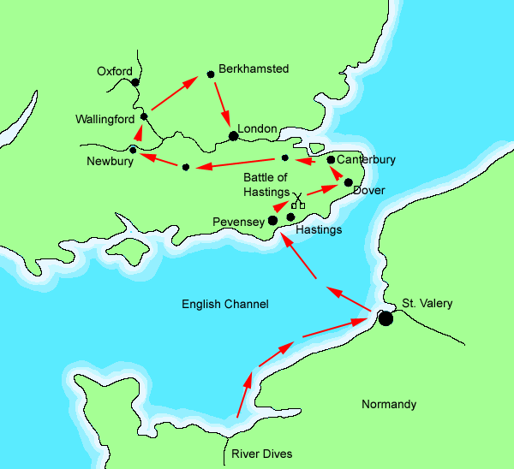
Terror
........................................................
........................................................
........................................................
........................................................
........................................................
........................................................
........................................................
........................................................
........................................................
........................................................
........................................................
........................................................
........................................................
........................................................
........................................................
........................................................
Military presence
........................................................................................................................................................................................................................................................................................................................................................................................................................................................................................................................................................................................................................................................................................................................................................................................................................................................................................................................................................................................................................................................................................................................
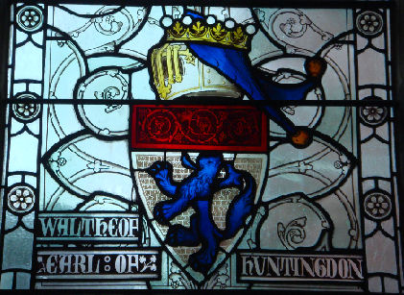
Patronage and concessions
..............................................................
..............................................................
..............................................................
..............................................................
..............................................................
..............................................................
..............................................................
..............................................................
..............................................................
..............................................................
..............................................................
..............................................................................................................................................................................................................................................................................

Task 4 - Revolts against the Normans 1066 – 1075
Task: How convincing is this interpretation about the way in which William dealt with rebellions?
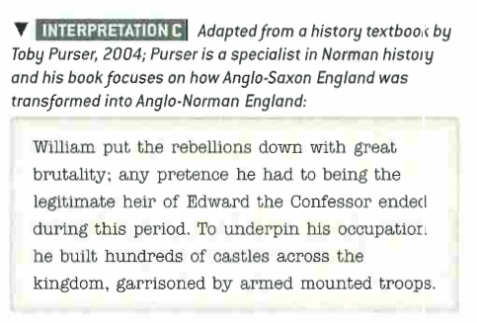
.............................................................................................................................................................................................................................................................................................................................................................................................................................................................................................................................................................................................................................................................................................................................................................................................................................................................................................................................................................................................................................................................................................................................................................................................................................................................................................................................................................................................................................................................................................................................................
.............................................................................................................................................................................................................................................................................................................................................................................................................................................................................................................................................................................................................................................................................................................................................................................................................................................................................................................................................................................................................................................................................................................................................................................................................................................................................................................................................................................................................................................................................................................................................
..........................................................................................................................................................................................................................................................................................................................................................................................................................................................................................................................................................................................................................................................................................................................................................................................................................................
Task 5 – Norman control - Castles
Task: Explain what was important about the building of Norman castles
Location
.............................................................................................................................................................................................................................................................................................................................................................................................................................................................................................................................................................................................................................................................................................................................................................................................................................................................................................................................................................................................................................................................................................................................................................................................................................................................................................................................................................................................................................................................................................................................................

Building
.............................................................................................................................................................................................................................................................................................................................................................................................................................................................................................................................................................................................................................................................................................................................................................................................................................................................................................................................................................................................................................................................................................................................................................................................................................................................................................................................................................................................................................................................................................................................................
Control
.............................................................................................................................................................................................................................................................................................................................................................................................................................................................................................................................................................................................................................................................................................................................................................................................................................................................................................................................................................................................................................................................................................................................................................................................................................................................................................................................................................................................................................................................................................................................................

Task 6 – Norman control of England
Task: create your own historical interpretation of how the Normans secured England following the Battle of Hastings.
Comment on:
- Relations with Anglo-Saxon nobility
- Rebellions
- Castle building

Interpretation C – written by a Year 11 historian

........................................................................................................................................................................................................................................................................................................................................................................................................................................................................................................................................................................................................................................................................................................................................................................................................................................................................................................................................................................................................................................................................................................................................................................................................................................................................................................................................................................................................................................................................................................................................................................................................................................................................................................................................................................................................................................................................................................................................................................................................................................................................................................................................................

Task 7a – Government in Norman England

Task: Write an account of how the feudal system changed from Anglo-Saxon England to Norman England.

…………………………………………………………………………………………………………………………………………………………………………………………………………………………………………………………………………………………………………………………………………………………………………………………………………………………………………………………………………………………………………
………………………………………………………………………………………………………………………………………………………………………………………………………………………………………………………………………………………………………………………………………………………………………………………………………………………………………………………………………………………………………………………………………………………………………………………………………………………………………………………………………………………………………………………………………………………………
……………………………………………………………………………………………………………………………………………………………………………………………………………………………………………………

…………………………………………………………………………………………………………………………………………………………………………………………………………………………………………………………………………………………………………………………………………………………………………………………………………………………………………………………………………………………………………
……………………………………………………………………………………………………………………………………………………………………………………………………………………………………………………
…………………………………………………………………………………………………………………………
…………………………………………………………………………………………………………………………
……………………………………………………………………………………………………………………………………………………………………………………………………………………………………………………

………………………………………………………………………………………………………………………………………………………………………………………………………………………………………………………………………………………………………………………………………………………………………………
……………………………………………………………………………………………………………………………………………………………………………………………………………………………………………………
…………………………………………………………………………………………………………………………………………………………………………………………………………………………………………………………………………………………………………………………………………………………………………………………………………………………………………………………………………………………………………
…………………………………………………………………………………………………………………………
……………………………………………………………………………………………………………………………………………………………………………………………………………………………………………………

Task 7b – The feudal system under the Normans

Task: explain what changes occurred for each aspect of government and make a judgement about the extent of change.

Feature | What changed and how much?
Feudal System
Military Control
National government
Local government

Task 8 – Norman legal system
Task: write an account of the ways in which law and order changed under the Normans.
Hint: think about what changed and what stayed the same – who did changes have the biggest impact on and how far did things stay the same?

…………………………………………………………………………………………………………………………………………………………………………………………………………………………………………………………………………………………………………………………………………………………………………………………………………………………………………………………………………………………………………
………………………………………………………………………………………………………………………………………………………………………………………………………………………………………………………………………………………………………………………………………………………………………………………………………………………………………………………………………………………………………………………………………………………………………………………………………………………………………………………………………………………………………………………………………………………………
……………………………………………………………………………………………………………………………………………………………………………………………………………………………………………………

…………………………………………………………………………………………………………………………………………………………………………………………………………………………………………………………………………………………………………………………………………………………………………………………………………………………………………………………………………………………………………
……………………………………………………………………………………………………………………………………………………………………………………………………………………………………………………
…………………………………………………………………………………………………………………………
…………………………………………………………………………………………………………………………
……………………………………………………………………………………………………………………………………………………………………………………………………………………………………………………

………………………………………………………………………………………………………………………………………………………………………………………………………………………………………………………………………………………………………………………………………………………………………………
……………………………………………………………………………………………………………………………………………………………………………………………………………………………………………………
…………………………………………………………………………………………………………………………………………………………………………………………………………………………………………………………………………………………………………………………………………………………………………………………………………………………………………………………………………………………………………
…………………………………………………………………………………………………………………………
……………………………………………………………………………………………………………………………………………………………………………………………………………………………………………………

Task 9 – Domesday Book

Task: FROM MEMORY – Explain what was important about the Domesday Survey

.................................................................................................................................................................................................................................................................................................................................................................................................................................................................................................................................................................................................................................................................................................................................................................................................................................................................................................................................................................................
..............................................................................................................................................................................................................................................................................

................................................................................................................................................................................................................................................................................................................................................................................................................................................................................................................................................................................................................................................................................................................................................................................................................................................................................................................................................................................
..............................................................................................................................................................................................................................................................................

.................................................................................................................................................................................................................................................................................................................................................................................................................................................................................................................................................................................................................................................................................................................................................................................................................................................................................................................................................................................
..............................................................................................................................................................................................................................................................................

Task 10a – Life in a Norman village

Task: FROM MEMORY - How convincing is this interpretation of life in a Norman village?

.....................................................................................................................................................................................................................................................................................................................................................................................................................
.......................................................................................................................................
............................................................................................................................................................................................................................................................................................................................................................................................................................................................................................................................................................

............................................................................................................................................................................................................................................................................................................................................................................................................................................................................................................................................................
.......................................................................................................................................
.....................................................................................................................................................................................................................................................................................................................................................................................................................

..............................................................................................................................................................................................................................................................................
..............................................................................................................................................................................................................................................................................
.......................................................................................................................................
.....................................................................................................................................................................................................................................................................................................................................................................................................................

Task 10b – Life in a Norman town

Task: Explain what was important about the growth of towns in Norman England

...................................................................................................................................................................................................................................................................................................................................................................................................................................................................................................................................................................................................................................................................................................
...................................................................................................................................................................................................................................................................................................................................................................................................................................................................................................................................................................................................................................................................................................

............................................................................................................................................................................................................................................................................................................................................................................................................................................................................................................................................................
.......................................................................................................................................
...................................................................................................................................................................................................................................................................................................................................................................................................................................................................................................................................................................................................................................................................................................

...................................................................................................................................................................................................................................................................................................................................................................................................................................................................................................................................................................................................................................................................................................
...................................................................................................................................................................................................................................................................................................................................................................................................................................................................................................................................................................................................................................................................................................

Task 11 – How far did life change in Norman England?

Task: for each aspect of life in Norman England, explain how far it changed from the Anglo-Saxons to the Normans and why.
Hint: think about rich and poor people.

Aspect | Explanation
Land
Law
Language
Castles
Villages
Towns

Task 12a – The English Church
Task: how convincing is this interpretation about the role of the Church in England?
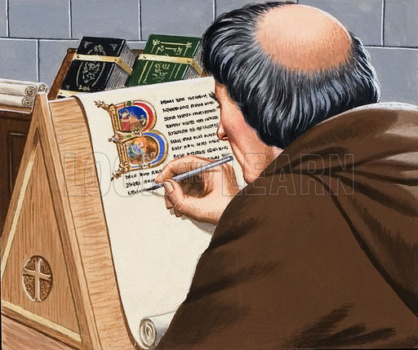
Think about: law/money/education/religion/health
.............................................................................................................................................................................................................................................................................................................................................................................................................................................................................................................................................................................................................................................................................................................................................................................................................................................................................................................................................................................................................................................................................................................................................................................................................................................................................................................................................................................................................................................................................................................................................................................................................................................................................................................................................................................................................................................................................................................................................................................................................................................................................................................................................................................................................................................................................................................................................................................................................................................................................................................................................................................................................................................................................................................................................................................................................................................................................................................................................................................................................................................................................................................................................................................................................................................................................................................................................................................................................................................................................................................................................................................................................................................................................................................................................................................................
Task 12b – Norman reforms to the Church
Task: for each reform that the Normans made to the Church, explain why it was important.
Reform | Why was it important?
Removal of Anglo-Saxon clergy
Changes to nepotism, pluralism, simony and clerical marriage
Establishing synods
Moving and rebuilding Anglo-Saxon churches and cathedrals
Establishing Church courts

Task 13a – Changes to Church organisation
Task: Explain what was important about the changes to the organisation of the Norman Church
...................................................................................................................................................................................................................................................................................................................................................................................................................................................................................................................................................................................................................................................................................................
...................................................................................................................................................................................................................................................................................................................................................................................................................................................................................................................................................................................................................................................................................................

............................................................................................................................................................................................................................................................................................................................................................................................................................................................................................................................................................
.......................................................................................................................................
...................................................................................................................................................................................................................................................................................................................................................................................................................................................................................................................................................................................................................................................................................................

...................................................................................................................................................................................................................................................................................................................................................................................................................................................................................................................................................................................................................................................................................................
...................................................................................................................................................................................................................................................................................................................................................................................................................................................................................................................................................................................................................................................................................................

Task 13b – William Rufus and the Church
Task: create your own historical interpretation of William Rufus’ relationship with the Church
Comment on:
- Relations with the Papacy
- William St Calais and Anselm
- The Council of Rockingham 1095
Interpretation C – written by a Year 11 historian

......................................................................................................................................................................................................................................................................................................................................................................................................................................................................................................................................................................................................................................................................................................................................................................................................................................................................................................................................................................................................................................................................................................................................................................................................................................................................................................................................................................................................................................................................................................................................................................................................................................................................................................................................................................................................................................................................................................................................................................................................................................................................................................................................................................................................................................................................

Task 14 – Norman relations with the Papacy
Task: FROM MEMORY - write an account of Norman monarchs’ relationship with the Papacy

...............................................................................................................................................................................................................................................................................................................................................................................................................................................................................................................................................................................................................................................................................................................................................................................................................................................................................................................................................................................................................................................................................................................................................................................................................................................................

...............................................................................................................................................................................................................................................................................................................................................................................................................................................................................................................................................................................................................................................................................................................................................................................................................................................................................................................................................................................................................................................................................................................................................................................................................................................................

...............................................................................................................................................................................................................................................................................................................................................................................................................................................................................................................................................................................................................................................................................................................................................................................................................................................................................................................................................................................................................................................................................................................................................................................................................................................................

Task 15a – Monasteries in Norman England
Task: Explain what was important about the reform of the monasteries for Norman England.
Hint: think about what was changed, why and how successful it was.
...............................................................................................................................................................................................................................................................................................................................................................................................................................................................................................................................................................................................................................................................................................................................................................................................................................................................................................................................................................................................................................................................................................................................................................................................................................................................

...............................................................................................................................................................................................................................................................................................................................................................................................................................................................................................................................................................................................................................................................................................................................................................................................................................................................................................................................................................................................................................................................................................................................................................................................................................................................

...............................................................................................................................................................................................................................................................................................................................................................................................................................................................................................................................................................................................................................................................................................................................................................................................................................................................................................................................................................................................................................................................................................................................................................................................................................................................

Task 15b – Monks and Norman monasticism
Task: how convincing is this interpretation about Norman monasticism?
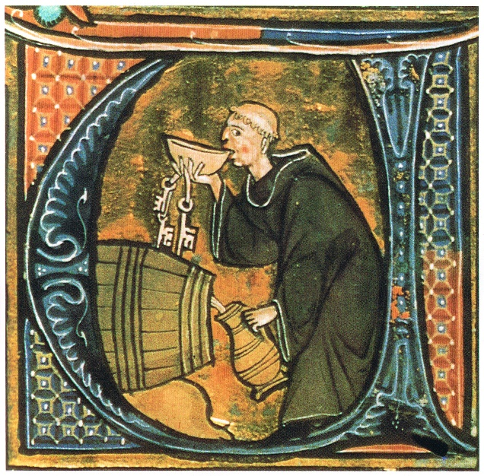
Think about: reforms to monasticism, the monastic revival, Lanfranc’s reforms, the Benedictine order, Cluniac reforms to monasteries.
...............................................................................................................................................................................................................................................................................................................................................................................................................................................................................................................................................................................................................................................................................................................................................................................................................................................................................................................................................................................................................................................................................................................................................................................................................................................................
...............................................................................................................................................................................................................................................................................................................................................................................................................................................................................................................................................................................................................................................................................................................................................................................................................................................................................................................................................................................................................................................................................................................................................................................................................................................................
.................................................................................................................................................................................................................................................................................................................................................................................................................................................................................................................................................................................................................................................................................................................................................................................................................................................................................................................................................................................

Task 16 – Education in Norman England
Task: Explain the importance of changes made by the Normans to education.

...............................................................................................................................................................................................................................................................................................................................................................................................................................................................................................................................................................................................................................................................................................................................................................................................................................................................................................................................................................................................................................................................................................................................................................................................................................................................
...............................................................................................................................................................................................................................................................................................................................................................................................................................................................................................................................................................................................................................................................................................................................................................................................................................................................................................................................................................................................................................................................................................................................................................................................................................................................
...............................................................................................................................................................................................................................................................................................................................................................................................................................................................................................................................................................................................................................................................................................................................................................................................................................................................................................................................................................................................................................................................................................................................................................................................................................................................

