GCSE Independent Study Guide Historic Environment
Pevensey Castle
Name:
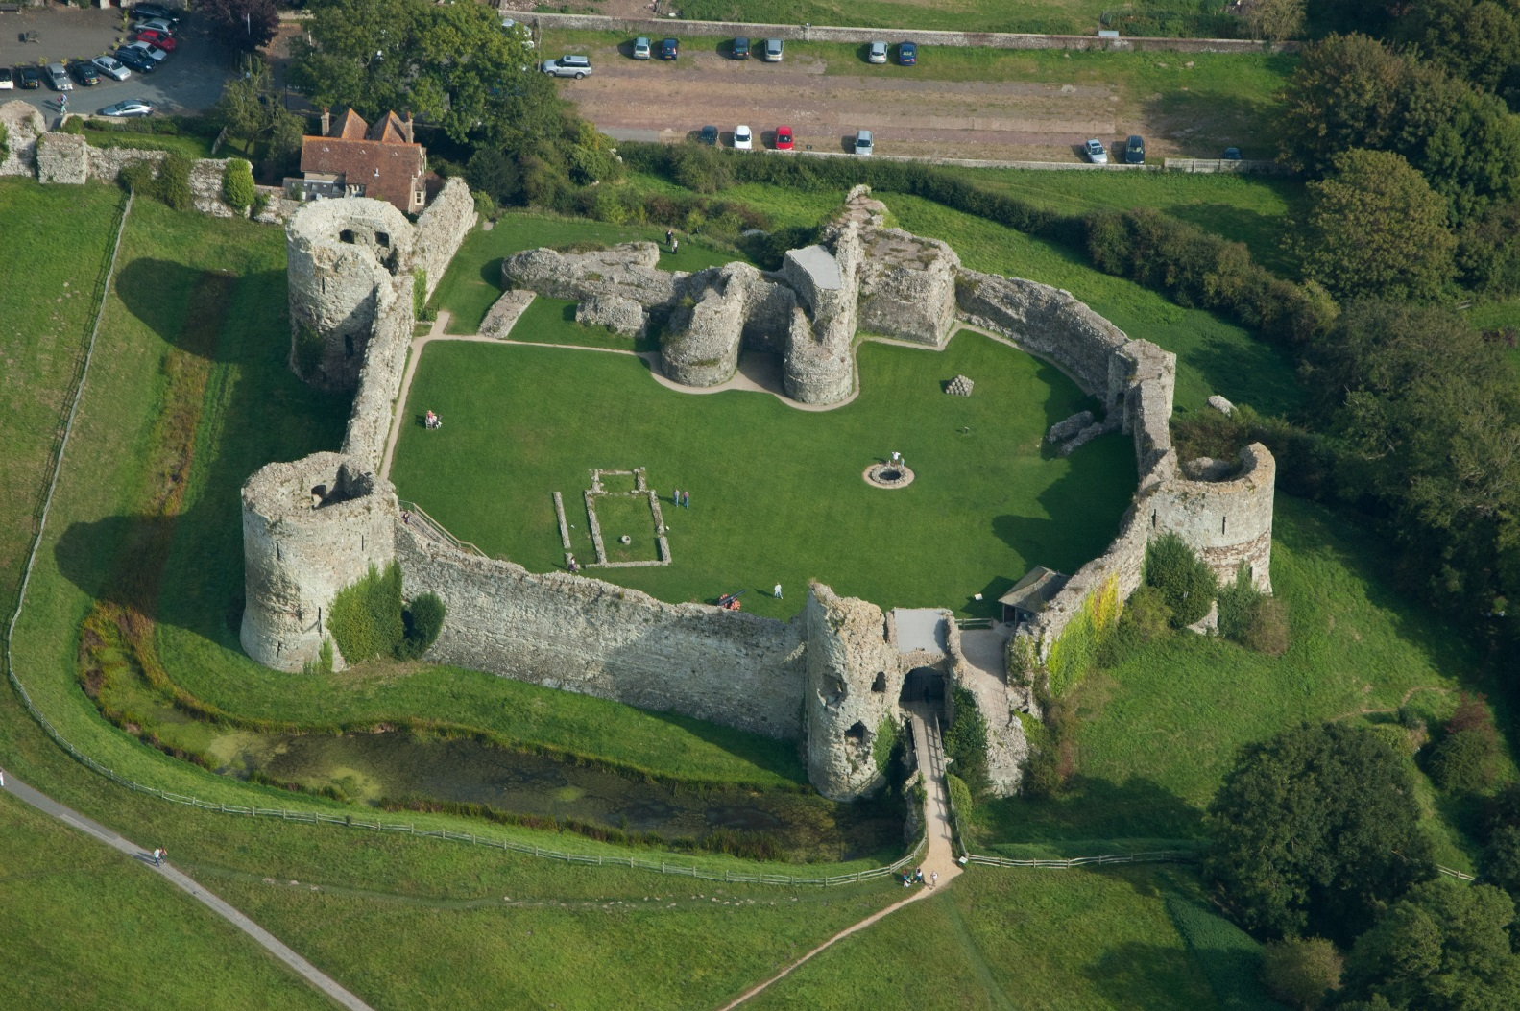
History Teacher:

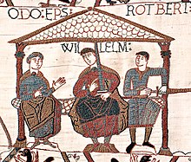

A plan of Pevensey Castle.

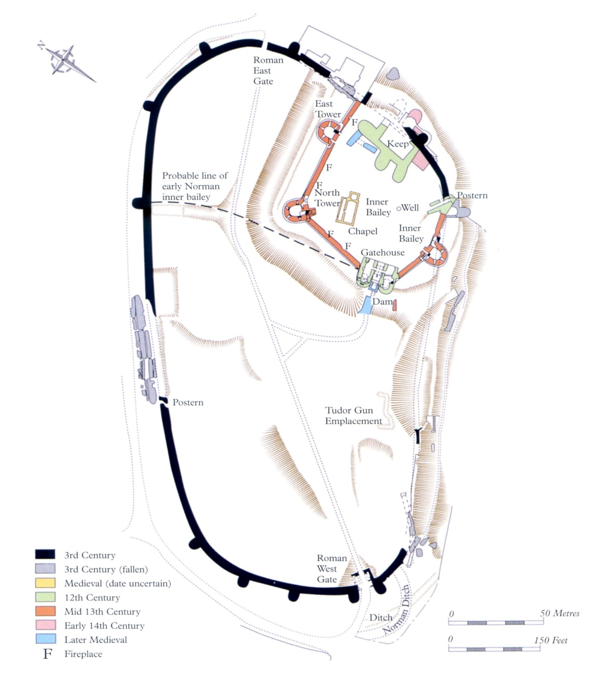

Information about this STUDY GUIDE
The historic environment for the summer 2019 exam focuses on Pevensey Castle and its links to the Normans. You will need to be clear about the castle and the site around it in its historical context i.e. what events were happening in Norman England between 1066 and 1100. You will also look at the links between Pevensey Castle and the key events, features or developments of the period e.g. what was William I and his son William II doing at key points during the Norman Conquest.
You will need to use any resources available to you, including written information in this study guide, along with researching information using ICT facilities at school and available to you elsewhere.
There will be a specific exam question on your paper next year based on Pevensey Castle which requires you to think about and focus on showing skills such as change, continuity, causation and/or consequence. You will need to be able to identify key features of the castle, and understand its connection to the wider historical context of the Normans. The site will also slink to how people lived at the time, how they were governed and their beliefs and values.
Central to dealing with this topic will be to study:
- the location of the castle, and other castles in England
- the function the castle performed in Norman society
- the structure of the castle and how it was designed
- people connected with the site e.g. the original Saxon earls and then the new Norman barons
- how the design reflects the culture and values of the people at the time
- how important events/developments from studying the Normans are connected to the site.
+++

The geographical location of Pevensey Castle

Pevensey is situated on a spur of sand and clay, about 10 metres (33 ft) above sea level. In Roman times this spur was a peninsula that stuck outwards into a tidal lagoon and marshes. A small river, Pevensey Haven, runs along the north side of the peninsula and would originally have gone into the lagoon, but is now largely silted up. The lagoon extended inland as far north as Hailsham and eastwards to Hooe. With the effect of longshore drift this large bay was gradually cut off from the sea by shingle, so that today's marshes are all that remain behind the shingle beach.
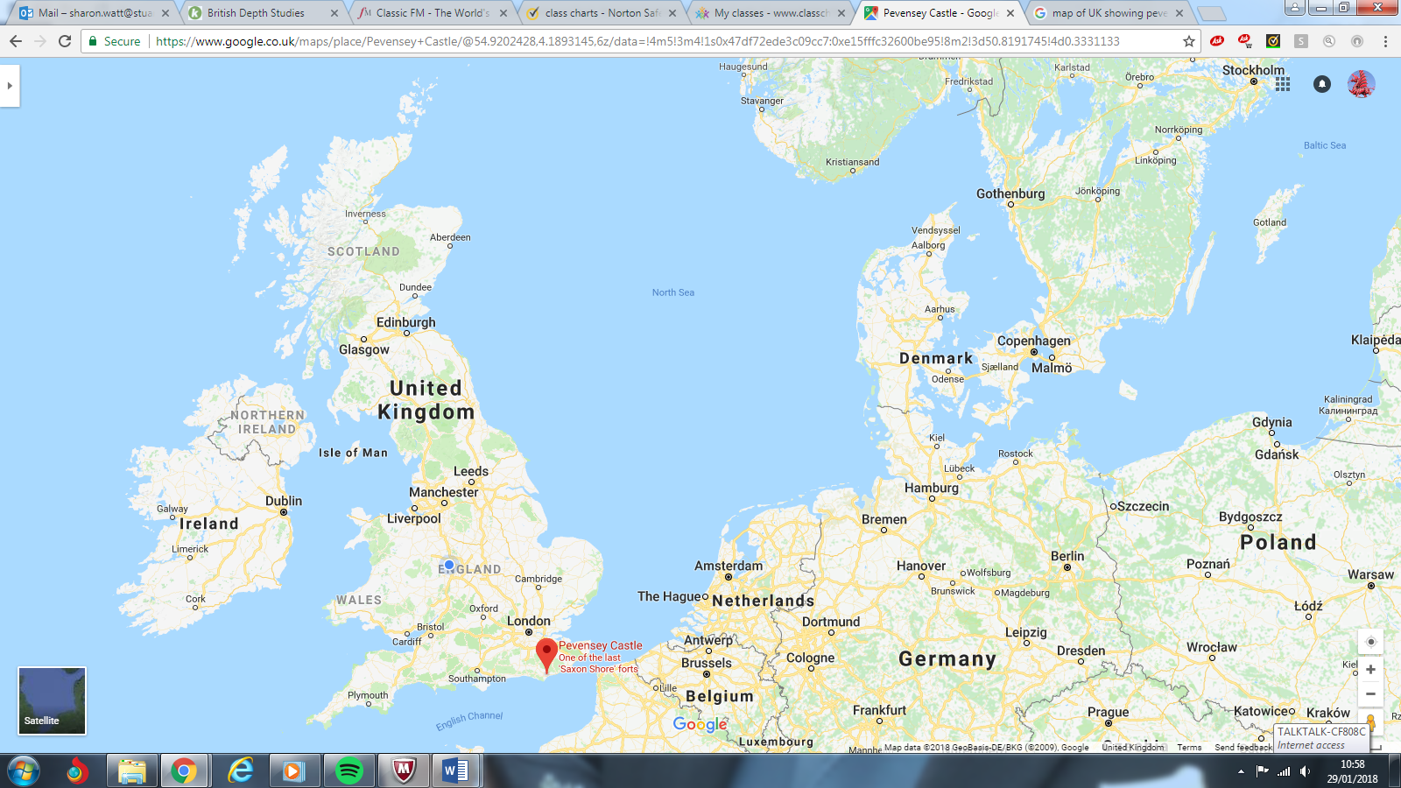
The marshes, known as the Pevensey Levels, cover an area of around 47 miles² (120 km²). They are a Site of Special Scientific Interest and a large nature reserve, jointly owned by Natural England and the Sussex Wildlife Trust. There are many nationally rare plants and invertebrates, including the fen raft spider. The site is very fragile and general access is not permitted.

Pevensey Bay

The settlement of Pevensey Bay lies behind and on the shingle beach. Although small, it is nevertheless a small seaside resort and has lots of facilities. It is a clay bay, making it susceptible to erosion over time.

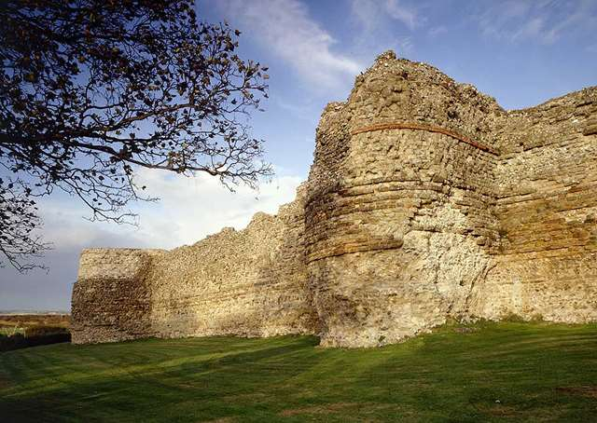
Pevensey Bay and the Romans
The Romans built a fort there in about AD 290 as one in a chain of nine forts along the south and east coasts which defended the ‘Saxon Shore’, a coastal frontier facing attack by barbarian Saxon pirates. All these forts shared architectural features, particularly the D-shaped wall towers which were a new feature of Roman forts at this time.
The image shows the Roman wall at Pevensey to the left of the west gate, showing two D-shaped bastions (the parts of the building which stick out).

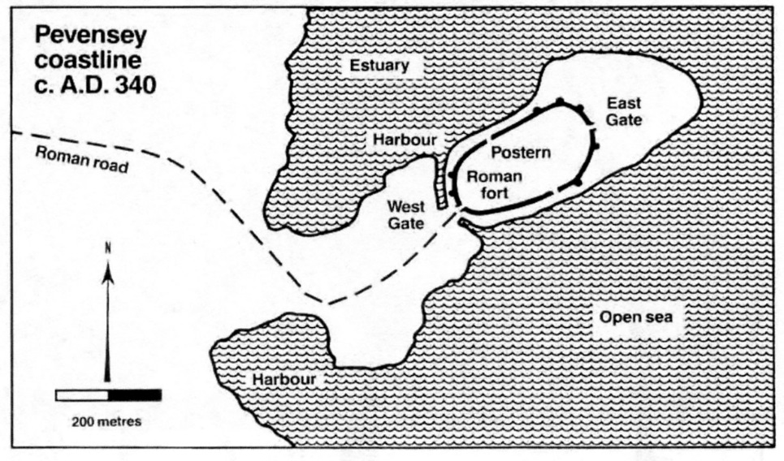
In those days, Pevensey was on a peninsula which jutted out into the sea, with Pevensey itself joined to the mainland by a narrow neck of dry land. This area around the coast must have been marshland but was sheltered from the prevailing south-westerly winds by the South Downs and Beachy Head. Today, however, the remains of the fort stand on dry land about a mile from the Channel coastline which has changed considerably since Roman times.

Saxon Pevensey
After the Romans withdrew troops from Britain in the early 5th century, Pevensey’s walls continued to shelter a community. The Anglo-Saxon Chronicle records that in AD 491 the fort was besieged and its population slaughtered by Saxon raiders. After this, although the fort may still have housed a settlement, it probably gradually fell to ruins.
Norman Pevensey
The Normans used Pevensey as a landing base for their invasion in 1066. It provided a safe site to land, and one the Normans could defend themselves on, if they were attacked by the Saxons who they believed were awaiting their arrival. After landing, William immediately built a temporary fortification, almost certainly inside the walls of the Roman fort, to shelter his troops. He cut a ditch across the peninsula to isolate the ruins from the mainland and repaired the walls to create a castle.
In 1088, the castle became an area of importance for William the Conqueror’s son, William Rufus as there was an attempt to take the throne by his brother Robert, who was in Normandy, and Count Odo, who was William the conqueror’s half- brother. There was a siege at Pevensey Castle by William Rufus who was successful in forcing the rebels to back down when they surrendered after running out of food. To make the castle stronger, the new design of a stone keep was built at Pevensey in 1100, making it the central feature which can still be seen today.

Tasks:
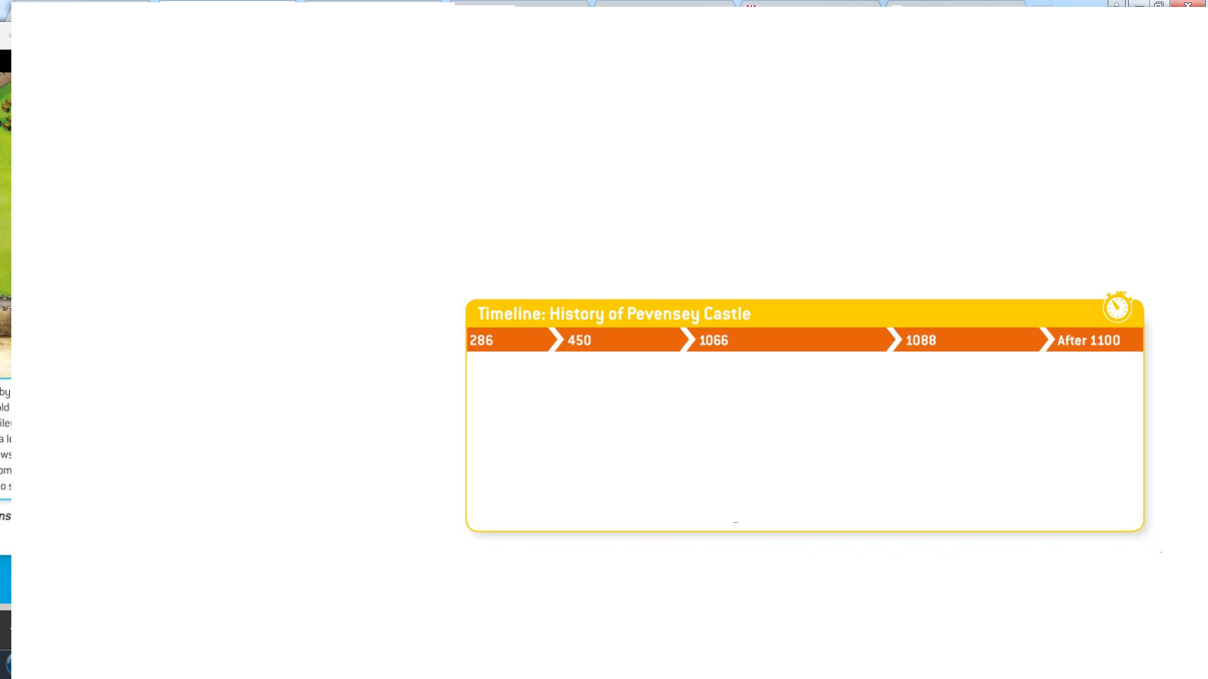
- Using the information in the booklet that you have read so far, complete the timeline below which gives you an overview of the key events that took place at Pevensey Castle.
- List 3 different ways that Pevensey Castle was a good defensive area for anyone who controlled it.
____________________________________________________________________________________________________________________________________________________________________________________________________________________________________________________________________________________________________________________
- Why do you think that the castle was made stronger by both William the Conqueror in 1066, and then his son in 1100?
______________________________________________________________________________________________________________________________________________________________________________________________________________________________________________________________________________________________________________________________________________________________________________________________________________________________________________________________________________
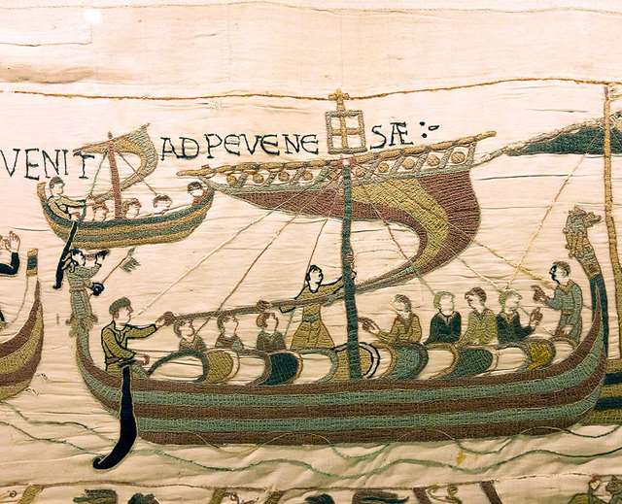
Pevensey Castle and the Norman Invasion of 1066

William the Conqueror’s fleet assembled at the mouth of the River Dives and after setting off was blown north to St Valery where he was kept in port by difficult weather conditions. Before dawn on 28 September 1066 – three days after King Harold’s victory at Stamford Bridge – William, Duke of Normandy, sailed his invading fleet into Pevensey Bay. William’s landing site was well chosen. Firstly, it offered a shallow beach and natural harbour to disembark his troops and resources. Secondly, he must have known about the Roman fortification at Pevensey that would serve as a temporary base for his army.
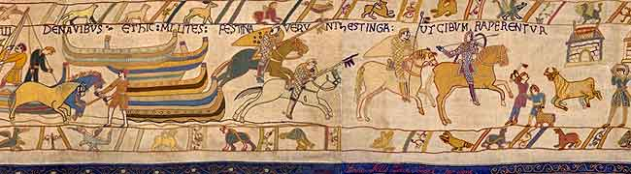
The ships beached, the sailors, the sergeants, and squires unloaded the ships; carried out shields and saddles, landed the war-horses and the palfreys. Of the army, the archers came ashore first, each with his bow strung, and a quiver full of arrows at his side. All were shaven and shorn; and dressed in short garments, ready to attack, to shoot, to wheel about and skirmish. All stood well equipped and ready for the fight; and they scoured the whole shore, but found not a single armed man!

Tasks:
- Using the image from the Bayeux Tapestry on this page, label the features on the scene using the arrows as guidance to help you identify what is happening. The sentences are on the next page. Use a ruler and pencil to draw the label, and then write the information in pen.

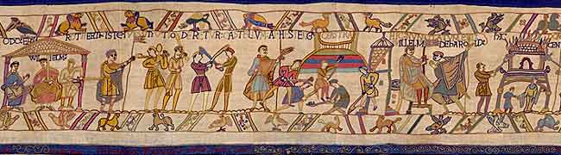

Beachead scene three – William makes plans

Label the following features on the picture of the Bayeux Tapestry on the previous page, using the arrows as guidance to help you identify the points:

- A motte is being built by Norman soldiers
- William is in discussion with his half- brothers, Odo and Robert, count of Mortain
- A messenger brings news of Harold’s whereabouts
- A woman and child flee from a burning house
- Soldiers with weapons practice, ready for battle

- Complete the literacy task using the information in the text below
SKIM the text: what is the general outline of the information?
SCAN the text more closely: what key facts are you able to find out?
HIGHLIGHT: 5 key pieces of information which show William using Pevensey as a DEFENSIVE area

In a different colour, highlight the information which shows William’s army threatening the Saxons

Pevensey played a crucial role in the Norman invasion of 1066 because it provided a defensible site. After landing, William immediately built a temporary timber fort, almost certainly inside the walls of the Roman fort, to shelter his troops. It is likely that it took him less than a day to build this fort from pre-cut and prepared sections that he brought with him in the invasion fleet. William ordered a ditch cut across the peninsula to isolate the ruins from the mainland, and repaired the Roman walls. The Roman tower in the north-west corner of the new inner Bailey was raised in height to provide an observation point as the Normans were worried about a counter-attack from the North. The next day William marched his army to Hastings, and waited for Harold to arrive from the north – in the meantime pillaging and burning the surrounding countryside. To keep the army active in medieval times meant treating the enemy this way. This gave the army chance to supply itself with food from nearby villages, prevented the enemy from having food and weapons, and at the same time allowed the soldiers to steal anything they wanted as payment for fighting.

What exactly was the FUNCTION of castles in Norman England?
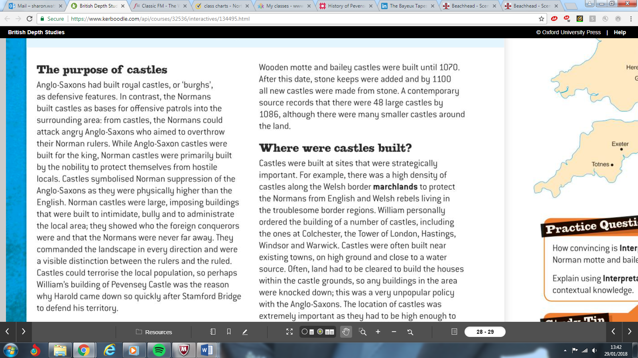
(Highlight key facts in the text as you go through)

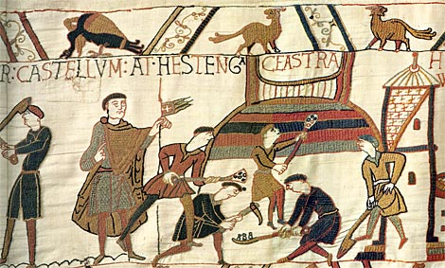

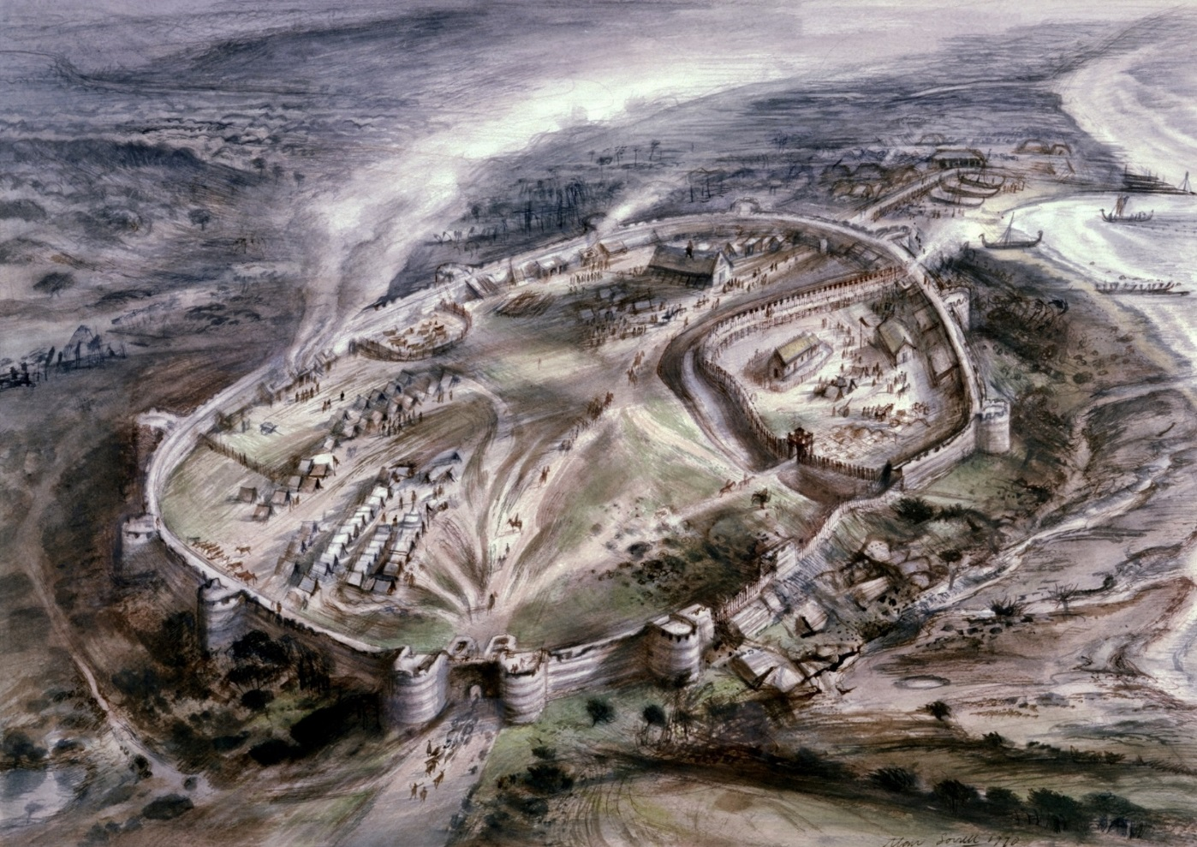

An artist’s reconstruction of how the Roman fort at Pevensey might have looked in 1066 when used by the Normans

Why were Motte and Bailey Castles Important?

After researching motte and bailey castles using the computers, label the diagram below and then match each label to its description.

…………………….
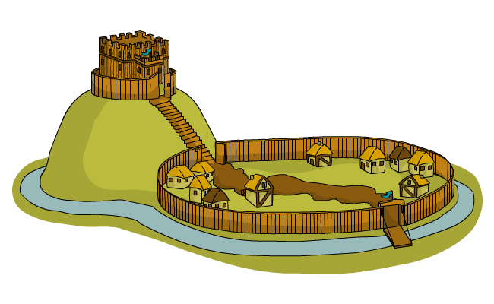
…………………….
…………………….
…………………….
…………………….
…………………….
…………………….

…………………… – defensive mound of earth.

…………………… – living area for soldiers and animals.

…………………… – the safest part of the castle.

…………………… – made it harder to reach the castle walls.

…………………… – fence which protected the bailey.

…………………… – connected the motte and the bailey.

…………………… – exposed terrain surrounding the castle.

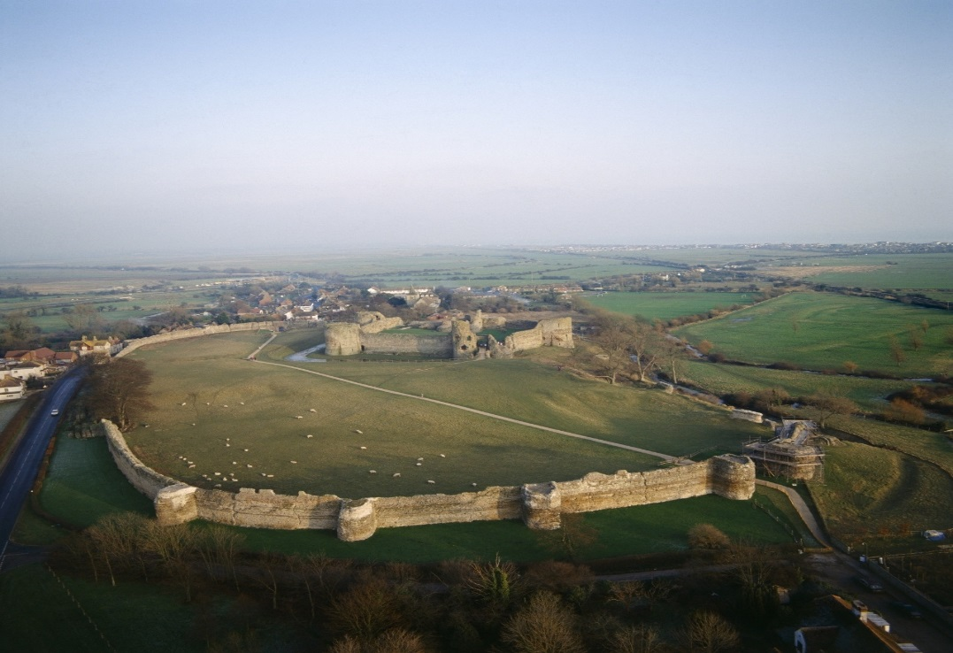
What did Pevensey Castle look like?
How did castle design change?
Although quick and simple to build, the motte and bailey had its weaknesses.

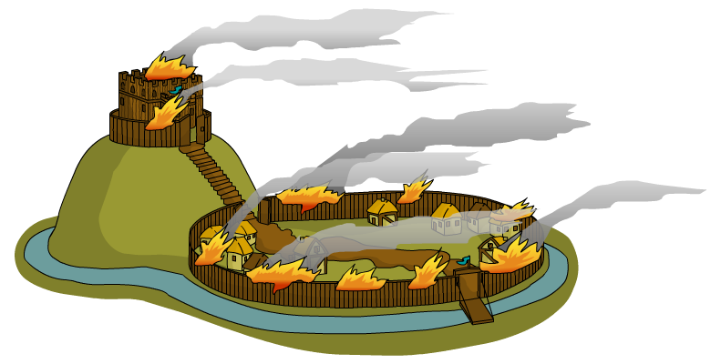
Because this type of castle was built from wood it could easily be set on fire and would rot over time.

Motte and bailey castles were not a permanent solution.
A stronger, more substantial type of castle was needed.

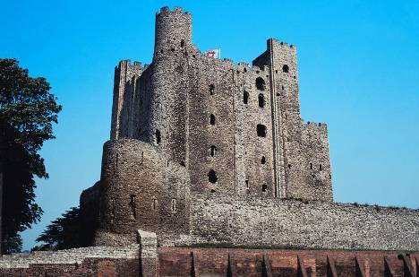
The Normans quickly set about building castles made of stone. Castles of this type were called square keep castles.

Stone castles were extremely heavy. This meant that they couldn't be built on the old motte and bailey castle sites, because the man-made mottes would not support the weight of all the stone.

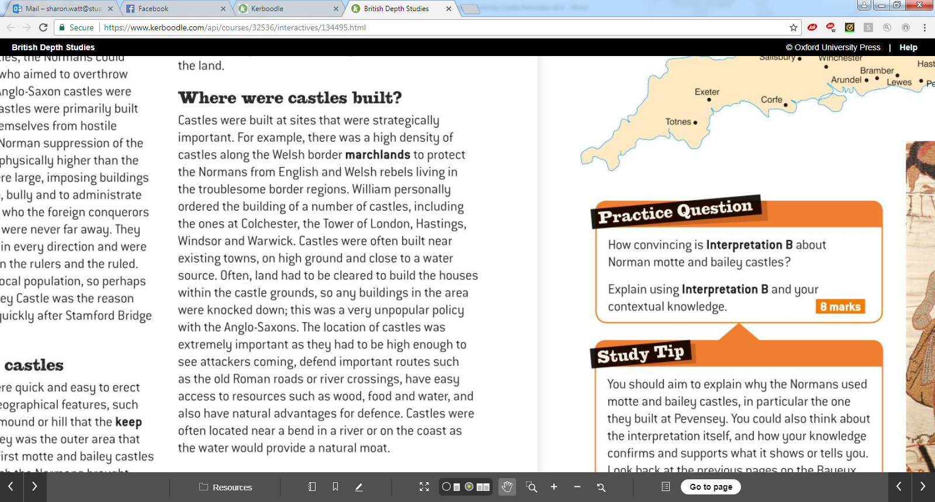
Explain why the FIVE KEY WORDS below were important for Norman Castle building:

LOCATION

WATER

MARCHLANDS

NATURAL RESOURCES

STONE
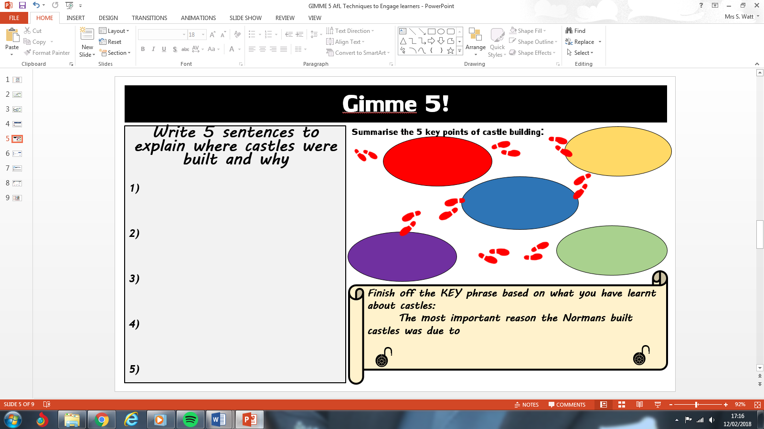
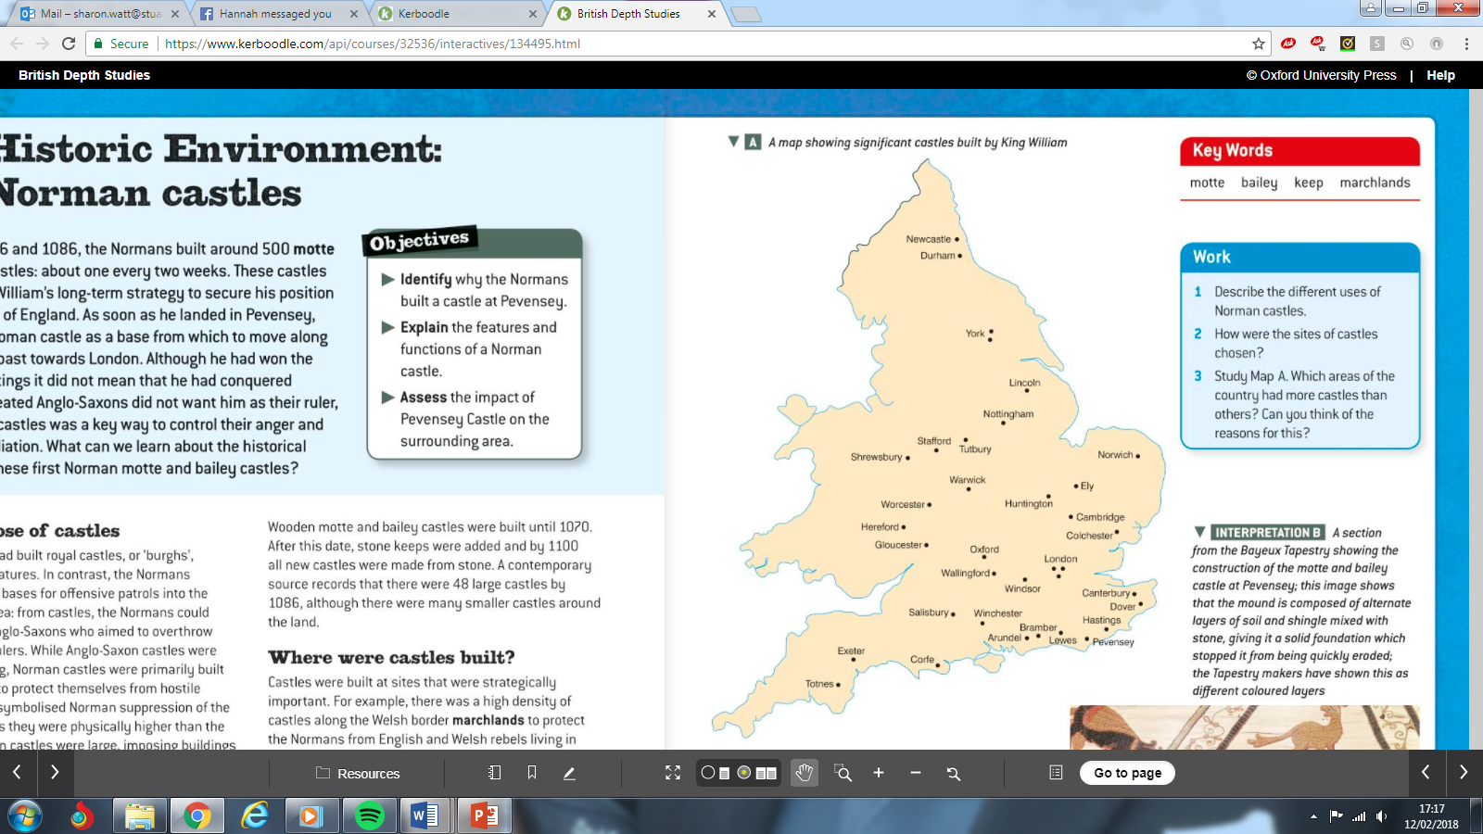

Exam question practice:

Look carefully at Source A above.

- What does Source A show you as the reader?

- What do you notice about where Norman castles have been built?

- Which areas of the country had more castles than others? Explain your reasons for this using key factual knowledge.

Different parts of Pevensey Castle
Using pages 30-31 of the textbook, label the diagram showing how Pevensey Castle looked and the different sections of it.

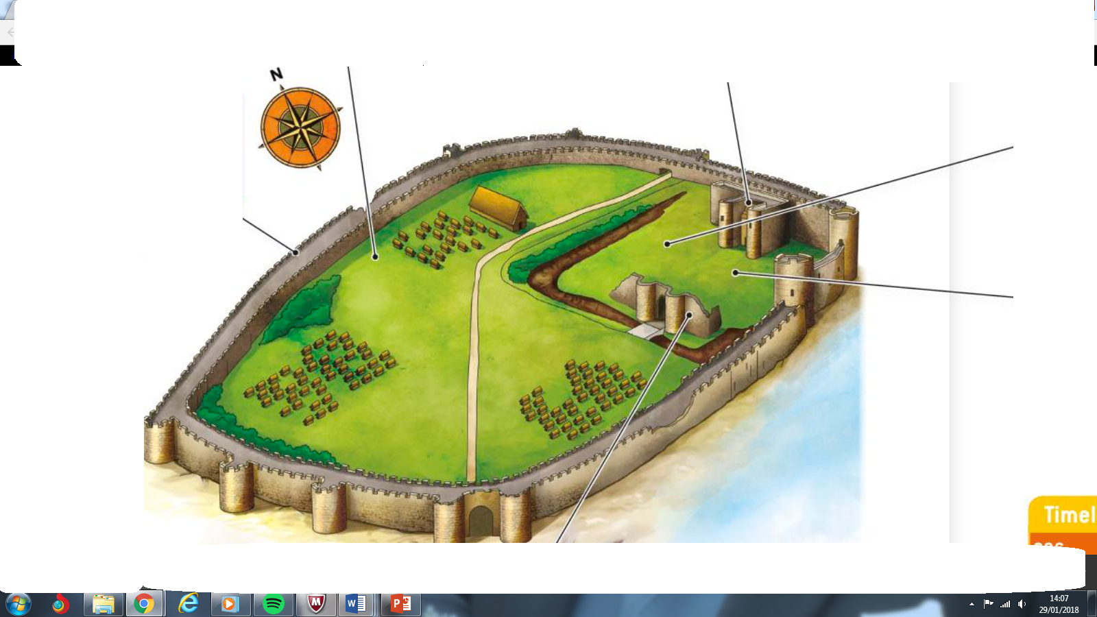

How did castle design change under the Normans?
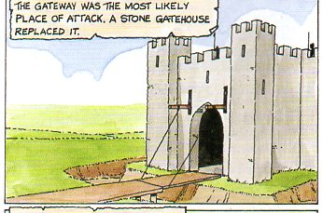
Using the three diagrams on the page, complete the mindmap below to give as many reasons as possible why Norman castle design changed.
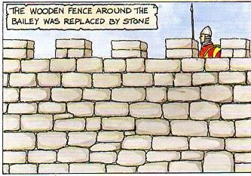

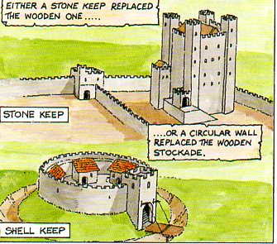

Why did Norman castle designs change over time?

How did castle design change under the Normans?

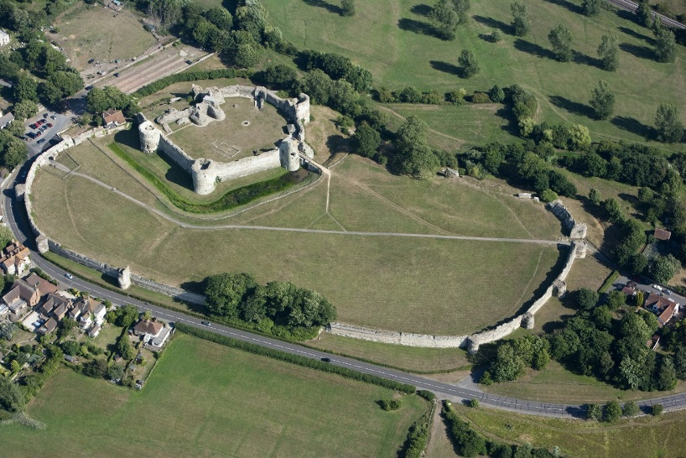
A photograph of the outer Bailey of Pevensey Castle viewed from the north-west.

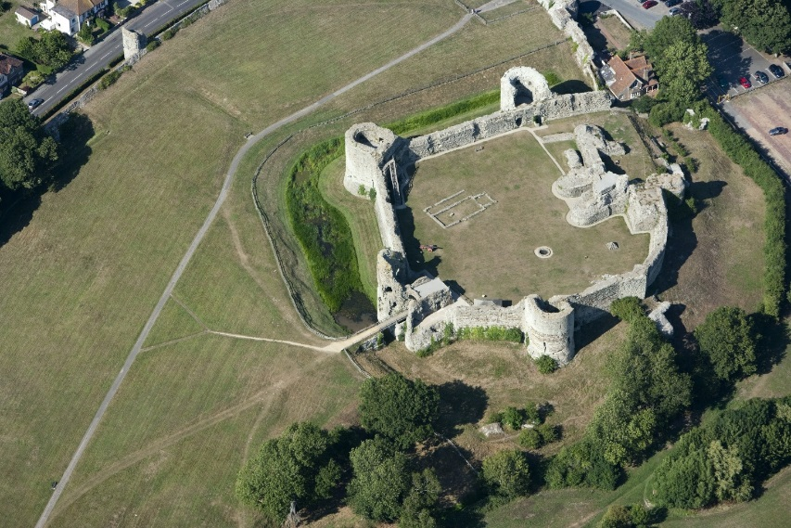

A photograph of the outer Bailey of Pevensey Castle viewed from the south-west.

Task

Look carefully at both of the pictures of Pevensey Castle above.
Using the computers, research the following key terms and write down what they mean.

Concentric Castles

Ramparts

Crenellations

Gatehouse

Bailey

Postern

The Siege of Pevensey Castle
Read through the account of the siege and complete the tasks on the following page.

After the death of William the Conqueror in 1087 there was a problem about who would succeed him. Despite a preference for his second son, William Rufus, William I divided his enormous empire between the elder two of his three sons. He gave the throne of England to William Rufus, who became William II. He bequeathed Normandy to Robert his eldest son, and made a large settlement of treasure on his youngest son, Henry.

As most important barons held land on both sides of the channel they now owed feudal service to William Rufus for the lands in England, and to Robert for those in Normandy. The division of William the Conqueror’s empire was a recipe for conflict and a serious mistake.

To make things worse, the dying William, making his peace with God, had also ordered the release from prison of a number of his political opponents including his half-brother, Odo, held since 1082 for conspiracy. Odo, Bishop of Bayeux in Normandy, was also Earl of Kent, and lord of the very importantly placed castle of Rochester. He was a dangerous man and quickly became central to a revolt of the Anglo-Norman barons against the new King of England, William II. The aim of their revolt was to replace William with Robert on the English throne. Fighting occurred in several parts of England during 1088, but the real threat was in Kent and Sussex where Odo and other rebels held lands.

Pevensey had a strategic importance in the conflict as there was a real danger that Robert would invade England from Normandy as his father had done. Pevensey lay in the Rape given to Robert, Count of Mortain, also a half-brother to Odo, and another one of the rebels against the new English King, William II. After taking the great motte and bailey castle at Tonbridge in Kent by siege, William spent 6 gruelling weeks besieging Pevensey Castle from land and sea. He was supported by his father’s friend, William de Warenne, who had been created Earl of Surrey early in 1088. Warenne, had fought with William the Conqueror at Hastings, and controlled the adjacent Rape of Lewes. In 1088 the rebels in Pevensey Castle were finally forced to seek a truce when they ran out of food.

Despite this rebellion the Count of Mortain was allowed to keep Pevensey but his son then lost it, along with the other family estates in England, as a result of his opposition to William Rufus’ successor and younger brother, Henry I.

Henry granted most of the confiscated lands of the Pevensey Rape to a Norman lord, Gilbert Laigle. However Henry recognised the importance of Pevensey Castle for his security and kept it under his own direct control. In 1101, when Duke Robert again threatened to invade England, Henry I spent the summer at Pevensey in anticipation of an attack.

*The word, ‘Rape’ in this context probably comes from Normandy and an old Norse word for ‘rope’ as there are cases of the Normans measuring and allocating land ‘by the rope’

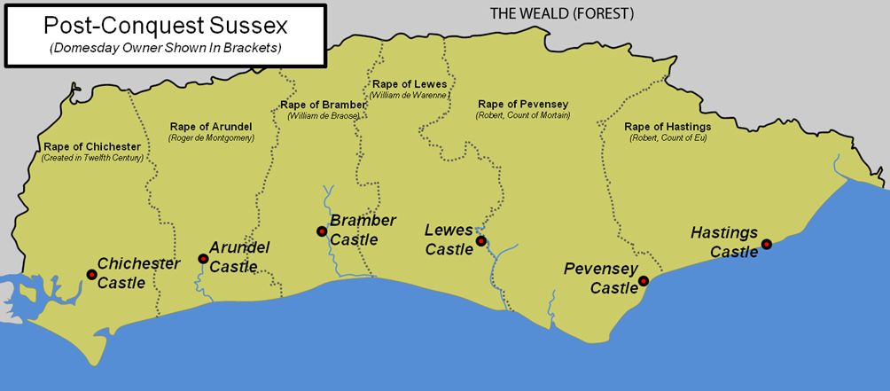
A map showing the division of Sussex into Rapes or territorial strips
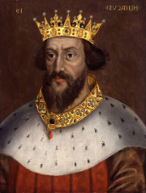
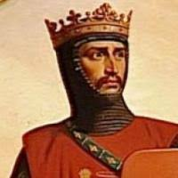
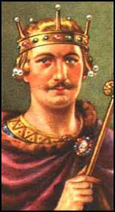
Henry I

GREEN
Robert of Normandy – Robert Curthose
BLUE

William Rufus – William II
RED

Task
- In the story about the Siege of Pevensey Castle, using three coloured pencils, highlight anything linked to William II in RED. Colour in anything to do with Robert of Normandy in BLUE, and finally any information about Henry II in GREEN.
- Why do you think the death of William the Conqueror caused such problems in England?

- Look at the map of the south coast of England. Explain why there was a castle in every rape there, based on what you have found out so far.

- Using the diagram on the next page, draw, or write a brief description of what happened at every stage of the Siege of Pevensey and why it was important.

How did Pevensey Castle affect the people who lived nearby?
Read through the story of William the conqueror’s son, Robert of Mortain, to understand why Pevensey became so important.
The link between castle and town was important when the Normans took over England and this can clearly be seen at Pevensey where Robert of Mortain, who was one of William’s half-brothers, or his officials, wanted to make it a really important area in terms of buying, selling and trading. Pevensey was a small centre in 1066, which began in Anglo-Saxon times. In 1066 there were 24 burgesses and they and the borough belonged to the King. Edward I received £1 per year from them, and almost another £3 from tolls and from taxes on boats coming into the harbour. In addition there were a further 28 burgesses who were the men of other Lords. When Robert took over the town only 27 were left as, most of them had run away because they were worried about what would happen when the Normans invaded.

By 1086 the situation in Pevensey had drastically changed. Robert had 60 burgesses and from them he received nearly £3 in rent, £4 came from tolls, and a further £1 from the mint. There were another 51 burgesses who held their land from the men who paid homage to Robert. Eight of these were the men who belonged to Robert’s own religious group that were from Mortain. These men paid rent totalling more than £2 10s. This was not all, as Robert also received £1 from the town mill. The Domesday Book shows Pevensey to have been a flourishing local centre which, though not as large as nearby Lewes, dominated the land around it.

The town served as a market for the thriving local industry of salt making, which Robert had control over, again something that was making him a lot of money! There were 24 salt works on Robert’s property, and together they brought him over £5 per year. Robert’s vassals were important for making sure his land and money were being looked after well in England, especially since he didn’t really spend much time here, and most of it travelling around Europe. Walter de Ricarville, who came from near Dieppe in northern Normandy, was important enough to be made Sheriff of Pevensey. Men like Walter were rewarded with large estates and were, in some cases, able to establish English baronies of their own.

Like many Anglo-Norman magnates Robert took control of English monastic lands but was generous to Norman monasteries. He gave large gifts of land to the Benedictine monastery at Grestain in Normandy, along with houses, pannage and pasture rights in Pevensey Forest with the use of building materials for the monks’ churches and houses included. The Priory of Mortain also owned English estates concentrated in the Rape of Pevensey and in Dorset. However, Robert made sure that none of the English manors given as a gift to the religious orders were better, or more expensive than the manors he kept for himself so they were often isolated and at a distance from the main areas of Robert`s interest and control.

When Robert died he chose to be buried with his father and first wife in the family monastery at Grestain. He may have been amongst the great magnates of England, but he was a Norman not an Anglo-Norman. He came with his Norman vassals to help with his brother’s conquest of England. He stayed to help consolidate the victory and was duly rewarded, but probably spent little time in his new possessions. Robert was essentially an absentee landlord.
How did Pevensey Castle affect the people who lived nearby?
TASKS:
- Read through the story of Robert of Mortain again.
- You will need THREE different coloured highlighters
- Use ONE colour to highlight anything about Pevensey which was focused on the importance of the LAND and keeping control of it.
- In a SECOND colour, highlight anything about Pevensey which was linked to RELIGION
- In a THIRD colour, highlight anything about Pevensey which showed Robert’s opportunities to make MONEY.

- Now, in order to help you with revision and the essay question, put the points into the table below in the correct column. Use bullet point to help you, and use different colours to make the three headings stand out.
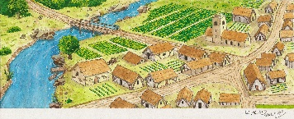  LAND | 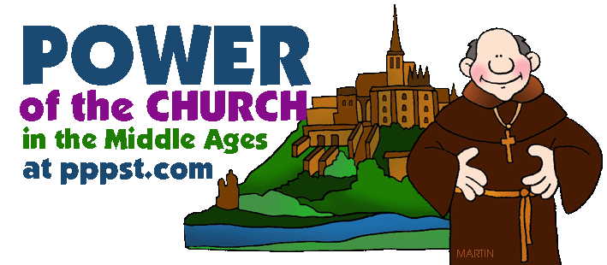  RELIGION | 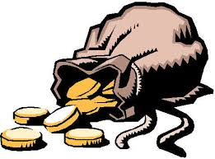  MONEY

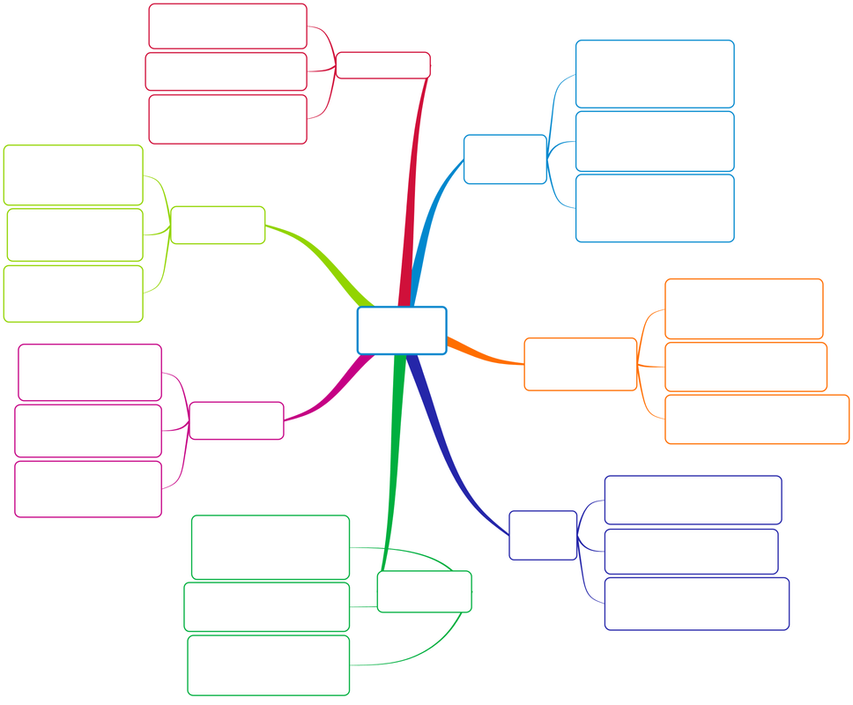
Sum up your learning about Pevensey Castle!
Why was Pevensey important in 1066?
How did the design of Pevensey Castle change?
Why was the geography of Pevensey so important?
Key facts during the siege of Pevensey
Pevensey Castle defence features
Who controlled the area post-1066?
How did the area make money?
PEVENSEY CASTLE
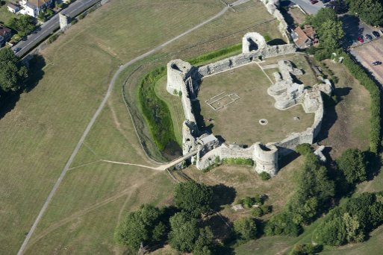
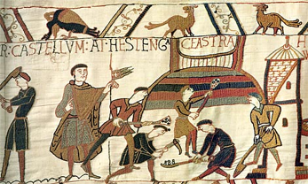

GCSE Historical Environment Study:
Pevensey Castle

 | 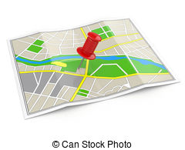 | 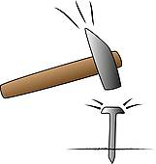 | 
MOTIVE:  Why did an individual, or group of people want to build this building in the first place? | LOCATION:  Why was the building constructed in this particular location?  What is important or significant about the location? | FUNCTION:  Why was the building constructed with this design? What are the main features of the building and what job does each one do? | PURPOSE:  What was the building going to be used for?  Who was going to use it the most?  Who lived or worked there?
You need to be clear on each of the sections for Pevensey Castle and you must apply each of the points to the question which will be worth 16 marks in your final exam
MoLoFuPu

1.’The main reason for so many Norman castles being constructed after 1066 was that they allowed the Normans to control the population without the need to use force.’ How far does the study of Pevensey Castle support this statement? Explain your answer. You must refer to Pevensey Castle. [16 marks]
MoLoFuPu
 |  |  | 
MOTIVE:  ~A fort had existed there since Roman times in 290 AD a part of a chain of forts along the south coast for defence at that time where the Romans could control the Channel.  ~ The Normans used this area to build on the existing castle ruins and make it a strong base for the south coast. | LOCATION:  ~Massively strategic! It was on a peninsula which jutted out into the sea and so provided a good advanced lookout for the south coast area.  ~ Normans used it as a landing base in 1066 for invasion as it was safe and could be defended if the Saxons attacked them quickly.  ~ There was a shallow beach and a natural harbour for the Normans to disembark with their troops, weapons and horses in 1066.  ~ Key area in 1086 when Robert of Martain attacked it as laid siege because it is a key area of one of the 5 territorial strips in Sussex which was a powerful county in England at the time. | FUNCTION:  ~ Ruins were used by William the Conqueror to build a motte and bailey fort in 1066 so it was easy to defend and quick to construct.  ~ The Roman tower in the NW corner was made higher by William as an observation point.  ~ A keep was made stronger later with stone. Hard, straight walls made it difficult for attackers to scale. Three guard towers were added to the keep along with step, narrow staircases for defence.  ~ Postern gate was added.  ~ Strong outer bailey and wall constructed to make it more difficult for attackers. | PURPOSE:  ~ A strong, but small town grew after the Romans left so was good for trade. Saxon raiders attacked the town in 491 AD but the town regrew in the Middle Ages.  ~ Burgesses were in the town paying Edward the Confessor money each year for holding land, and also through tolls, so William carried this on when he conquered England.  ~ 60 burgesses were in the town by 1086 showing it was growing, and very profitable, Additional money went to the king from the money which other landowners held from the original burgesses.  ~ The mill in the town was very profitable and doing well. Mentioned as a strong town in the Domesday Book.  ~ Main money and jobs came from salt making  ~ Monastic land was also there so monks and churches will have been built, supporting the townspeople.

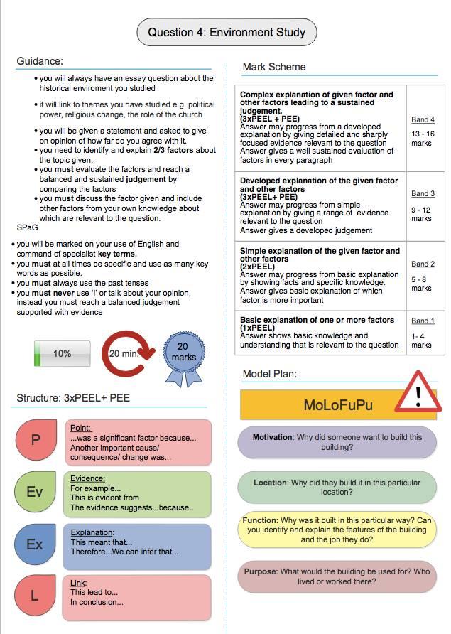
How does what you have been studying link to the exam…?
The exam board will ask you 16 mark essay questions about Pevensey Castle. The questions below are some of the things which could be asked. Now is your time to use the planning grid above, to start to write and plan out some answers to these questions.

- ‘The main change Normans brought about was that they increased the building of castles to prevent rebellion and being overthrown’. How far does the study of Pevensey Castle support this statement? Explain your answer.
You should refer to Pevensey Castle. [16 marks]

- ’The main change Normans brought about was that castles were key to controlling the population in England’. How far does the study of Pevensey Castle support this statement? Explain your answer.
You should refer to Pevensey Castle. [16 marks]

- ’The main change Normans brought about through their development of castle building was to ensure that barons made English towns profitable for the king’. How far does the study of Pevensey Castle support this statement? Explain your answer.
You should refer to Pevensey Castle. [16 marks]

Burgess = a freeman of the town or borough
Toll = an amount of money which is paid for services given to someone to allow them to do something e.g. hold land
Mint = the place where coins are made in England
Vassal = a servant, or someone who works in your service
Magnate = a wealthy and influential person in business
Consolidate = to become secure and strong

