Causation Model Answer

Explain why there were challenges to the Weimar Republic in the years 1919-1923. [12 marks]

|  |
| --- |
| You may use the following in your answer:   * Treaty of Versailles * Kapp Putsch   You must also use information of your own. |

|  |  |
| --- | --- |
| Reason One  *[Introduce and fully explain your first reason]*  *[Use your own knowledge to explain the reason giving examples where possible]* | Useful phrases  *The first reason for… This meant that…*  *This was important because… For example…*  *This led to…. As a result of… This is shown by…* |
| The first reason the Weimar Republic faced challenges in the years 1919 to 1923 is the growing support for a Communist revolution in Germany. As a result of the British naval blockade, many citizens were starving and drawn to the appeal of extreme left wing policies. In Russia there had been a communist revolution in 1917 and inspired many to try and achieve the same in Germany. As a result of this the new democratic government in Germany faced left wing opposition from the start including a significant uprising by the Spartacists led by Rosa Luxemburg and Karl Liebknecht in 1918. The fact that the government only survived this uprising through the support of right wing extremists demonstrated the weakness and vulnerability of the Weimar Government to challenges from opponents. | |
| Reason Two  *[Introduce and fully explain your second reason]*  *[Use your own knowledge to explain the reason giving examples where possible]* | Useful phrases  *Another reason for… This meant that…*  *This was important because… For example…*  *This led to…. As a result of… This is shown by…* |
| Another reason the Weimar Republic faced challenges was the opposition of the conservative elite and armed forces to the establishment of a democratic government in Germany. The Freikorps were key to the defeat of the Spartacist Uprising in 1918 yet as a result of this right wing supporters viewed the new regime as vulnerable and sought to replace it with their own authoritarian leadership. This is shown by the Kapp putsch in 1920 in response to the Weimar government acceptance of the terms of the Treaty of Versailles. As a result of the regime surviving due to the support of the Freikorps it was unsurprising that these same groups felt confident that their own uprising against the Weimar government would be successful. It could be argued that the Weimar government invited a future challenge from the right wing when they relied upon them to defeat the Spartacists. The fact that the new regime was viewed negatively by groups on the left and right wing made challenges to their authority inevitable. | |
| Reason Three  *[Introduce and fully explain your third reason]*  *[Use your own knowledge to explain the reason giving examples where possible]* | *A final reason for… This meant that…*  *This was important because… For example…*  *This led to…. As a result of… This is shown by…* |
| A final reason for the challenges to the Weimar government is their acceptance of the terms of the Treaty of Versailles. Although the government had little choice but to sign the controversial treaty it encouraged opponents of the peace terms to view the Weimar regime as complicit in the weakening of Germany. As a result, politicians on the left and right wing sought to challenge their authority. In addition to this, the economic consequences of the treaty such as hyperinflation meant the government were viewed as unable to solve the hardships facing the German people and went as far as to convince many that the government was responsible for the difficulties they were experiencing. | |

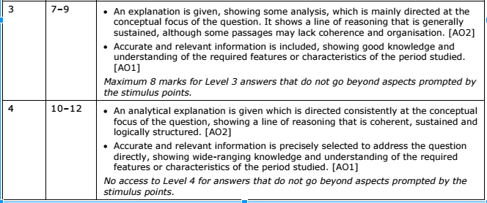

**TASKS:** Read back through your own answer, and the model answer.

Identify THREE features that the two answers share e.g. Both answers use examples of challenges faced by the Weimar Government.

1. …………………………………………………………………………………………………………………………………………………………….

…………………………………………………………………………………………………………………………………………………………….

2. …………………………………………………………………………………………………………………………………………………………….

…………………………………………………………………………………………………………………………………………………………….

3. …………………………………………………………………………………………………………………………………………………………….

…………………………………………………………………………………………………………………………………………………………….

Identify THREE features of the model answer which could have improved your answer. e.g. The model answer is clearly structured into three distinct reasons.

1. …………………………………………………………………………………………………………………………………………………………….

…………………………………………………………………………………………………………………………………………………………….

2. …………………………………………………………………………………………………………………………………………………………….

…………………………………………………………………………………………………………………………………………………………….

3. …………………………………………………………………………………………………………………………………………………………….

…………………………………………………………………………………………………………………………………………………………….

Rewrite ONE of your paragraphs/reasons in light of these reflections. [if not enough space, write in your book]

…………………………………………………………………………………………………………………………………………………………….

…………………………………………………………………………………………………………………………………………………………….

…………………………………………………………………………………………………………………………………………………………….

…………………………………………………………………………………………………………………………………………………………….

…………………………………………………………………………………………………………………………………………………………….

…………………………………………………………………………………………………………………………………………………………….

…………………………………………………………………………………………………………………………………………………………….