The American West 1835-1895

Paper 2: Period Study

**What do you need to know?**

The history of the Native Americans and the American West has long fascinated people of all ages – from the romantic view of the Indian and tribal life to the dusty and bandana-wearing image of the cowboy that has been portrayed in literature and the media. In this option, students will have the opportunity to explore what the ‘real’ American West was like and examine the impact of government-sponsored expansion in the American outback, which had far-reaching consequences for both the Indians and the many settlers of the time. This was a defining period in the history of the USA, as a huge number of people moved west to settle on the Plains and the frontier of settlement was pushed westwards – driven by the belief in Manifest Destiny to expand the United States from coast to coast. The lives of the Plains Indians changed dramatically over these 60 years, as railroads, the cattle industry and gold prospecting impacted on their previous ways of life and means of survival, and they were moved onto reservations. To aid this story of the American West, the unit has been divided into three sequential Key topics that help tell this fascinating and interesting story. Firstly, students look at the lives of the Plains Indians, early migration and settlement and problems of lawlessness in early settlements, as well as the tensions between the settlers and Plains Indians. They then move on to how settlement on the Plains developed, ranching and the cattle industry, and the impact on the Plains Indians’ lives of events and developments between c1862 and c1876. Finally, students look at further changes in farming, the cattle industry and settlement, conflict and tension between different groups living on the Plains, and the destruction of the Plains Indians’ way of life. All three Key topics are interconnected, however, with threads of settlement, conflict and tensions, and the changing lives of the Plains Indians running throughout. Consequently, students should be encouraged to see the period study as a whole rather than three separate topics.

**Name:**

**Class:**

**Teacher:**

j0280920

**How will you be assessed?**

Students answer three compulsory questions for the period study.

Question 1 is worth 8 marks. This focuses on consequence.

Question 2 is worth 8 marks. This focuses on analytical narrative. Students write an account that not only describes what happened, but also finds connections and make sense of events and their impact to explain why events unfolded in the way that they did.

Question 3 is worth 16 marks. Students select two from a choice of three parts. Each focuses on the importance of an event/person/development in terms of what difference they made in relation to situations and unfolding developments (i.e. their consequence and significance)

These are the key dates to learn for the American West. These should form the basis of independent revision. Why not make timelines? Test each other? Can you describe what happened in each of these events?

* **1834** Permanent Indian Frontier set up
* **1843** First settlers arrive in Oregon encouraged by government legislation
* **1844** Mormon persecution in Nauvoo
* **1846** Donner Party head west but meet with disaster and death
* Mormons travel to the Great Salt Lake having been driven out of Nauvoo
* **1848** Gold discovered in California
* **1850s** First homesteaders move to the Plains
* **1851** Fort Laramie Treaty (1)
* **1858–59** Gold discovered in the Pikes Peak region of the Rocky Mountains
* **1859** Gold mines opened in Colorado and Nevada
* **1861** Start of the American Civil War between North and South America
* **1862** Homestead Act
* Little Crow’s War
* Pacific Railway Act passed and work begins on the transcontinental railway
* **1864** Sand Creek Massacre
* **1865** End of the American Civil War
* Slavery abolished in the US
* **1866** Group of US army soldiers wiped out at Fetterman’s Trap by Plains Indians
* Red Cloud’s War on the US Government in their attempt to build forts in Montana
* Goodnight and Loving reach Fort Sumner with 1,700 cattle
* **1867** Medicine Lodge Creek
* Abilene becomes the first cow town
* ‘The Beef Bonanza’
* **1868** ‘The Winter Campaign’
* Fort Laramie Treaty (2)
* **1869** Railroad completed despite opposition from some Americans
* **1870** Cattle Ranching begins on the Plains which led to the ‘Open Range’
* **1873** Timber and Culture Act
* **1874** Barbed wire begins to be mass-produced
* Wind-powered water pump introduced
* Custer leads expedition to the Black Hills ignoring the Treaty of Fort Laramie
* **1876** The Great Sioux War begins between the US Army and the Sioux Indians
* Battle of the Little Big Horn
* **1881** Sitting Bull and followers surrender to the American government
* **1885** All Plains Indians are resettled on to reservations
* Northern herd of buffalo is completely destroyed
* **1886** Severe winter leads to smaller ranches with barbed fences and wind pumps that eventually lead to the end of the cowboy era
* **1887** Dawes Act
* **1890** Battle of Wounded Knee
* US government closes frontier in which the Plains Indians had lost their land
* **1892** Johnson County War

**American West key dates**

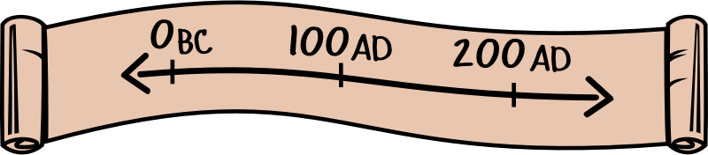

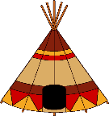

Many different **tribes** lived on the Great Plains. Each tribe was made up of different **bands**, usually families who were related to each other. Bands could be several hundred people or just 20 or 30 people. In order to survive, it was essential that the different bands within a tribe worked together, especially in times of trouble. All the different bands in a tribe would usually meet together in the summer for a great tribal camp. As well as being social and religious occasions, these were times when a tribe could co-operate to ensure their survival on the Plains.

Different tribes had different ways of organising their bands. For some tribes, like the Comanche’s, bands came together frequently and people often moved between bands. For others, like the Pawnee, each band had a separate village. The Sioux village was one of the biggest nations. It was made up of the Lakota, Dakota and Nakota tribes. The Lakota was then made up of seven tribes, including the Oglala and Hunkpapa.

**Chiefs and councils:** Chiefs were the leaders of Indian society. They were always men. Each tribe could have many chiefs; a war chief, a spiritual chief and a chief who led negotiations with other tribes. White Americans found it difficult to understand the way in which chiefs provided leadership for their tribes. This was important because it led to problems in the relationships between the US government and the Plains Indians.

* There was no single system for choosing chiefs. Chiefs were valued because of their wisdom, leadership and spiritual powers or because of their skills as warriors or hunters. Chiefs were rarely chiefs for life. They came and went as their skills emerged or faded away.
* Each band had a band chief, who was chosen as someone who could guide the band in finding enough to eat, and was successful in protecting them from danger.
* Band chiefs and elders made up the tribe’s council when the tribe came together. In some tribes, the councils could declare war on another tribe, or negotiate a peace treaty with another tribe.
* Everyone could give their opinion in the council and was listened to with respect the tribe’s spiritual chief would often be consulted on important decisions. No decision could be made until everyone on the council agreed with it.
* In tribes like the Dakota Sioux, chiefs had no power to command their people. Bands made their own decisions. Some bands might follow one chief and others would choose a different leader.

**Famous Chiefs:**

**Red Cloud:** Lakota Sioux chief who brought Sioux and Cheyenne tribes together in ‘Red Clouds War’ against white Americans. This forced the US government to move the US army out of Sioux lands.

**Sitting Bull**: Chief of the Hunkpapa sub tribe of the Lakota Sioux. An experienced warrior, Sitting Bull was also a famous holy man.

**Crazy Horse:** He was a war leader of the Oglala Sioux. He was a respected warrior. He was also famous for his ability to enter the spirit world through his visions.

**Warrior brotherhoods:** There were several different brotherhoods within a tribe and young men became part of one after proving their bravery and skill in fighting in tribes. Within the Lakota Sioux, some of the brotherhoods included the White Horse Riders, the Strong Hearts and the Crow Owners. These brotherhoods trained men in fighting skills and taught them about the tribe’s belief and values. They were not under the command of the tribal council and so did not always respect treaties. Finally, they were invited to join a guard unit for the whole tribe which organised the yearly buffalo hunt and chose where the tribe should make camp.

**Who were the Plains Indians?**

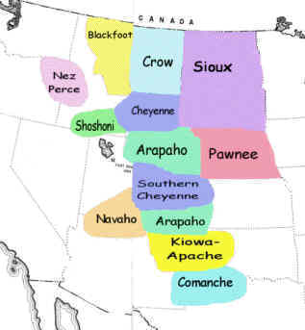

|  |
| --- |
| Bands  Description:  Specific facts: |
| Chiefs  Description:  Specific facts: |
| Councils  Description:  Specific facts: |
| Brotherhoods  Description:  Specific facts: |

|  |
| --- |
| **Other groups within tribal society** |
| **Women**  Women could not be chiefs and a man could have more than one wife- known as polygamy. Women were responsible for feeding and clothing their families; and for the family’s possessions, including the tipi which belonged to the women. Women were responsible for processing buffalo hides and meat, turning them into products that could be traded. |
| **Children**  They were highly valued by the tribe as they were the future of the band. They did not go to school so therefore could not read or write but they learned skills from family and other tribe members. They were taught to ride horses at an early age. Boys were taught how to hunt whereas girls were taught all the domestic skills needed for running a household. Children were rarely punished by their parents. Children tended to behave as it was seen as shameful to disrespect their elders. In extreme cases of misbehaviour, cold water was thrown on the children. |
| **The Elderly**  The Indians had a strong tradition of respect and they respected the advice of their elders. The elderly acted as a link to the past and they preserved the history of the tribe by passing down stories and songs. They attended council meetings and also helped the women raise the children. When the elderly were ready to die they would be left behind by the Indian tribe. This was called exposure. The person was left to die in the open. The rationale behind this was the elderly person had become a burden to the tribe who had to move from place to place to hunt buffalo for survival. |

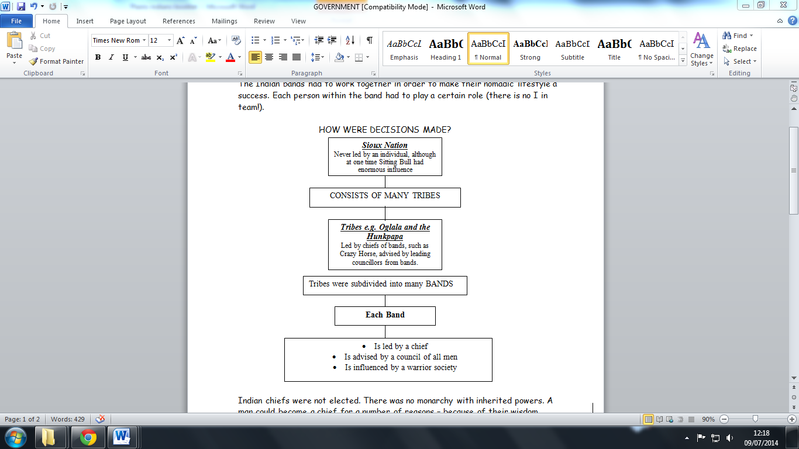

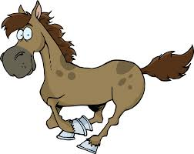

The Plains Indians were *nomads*- meaning they did not settle in one place- who hunted buffalo. This required an ability to change their locations quickly and have a shelter that was portable, durable and water resistant. The **tipi** offered these characteristics.

They made tipis out of 10-20 buffalo skins. It was the job of the woman to put it up and take it down. So the tipi belonged to the women in the tribe. A fire was made in the middle of the tipi so the smoke would go out a hole at the top of the tipi. The door always faced east. The tipi is made in a circle. This was the best shape to combat the severe winds on the Plains.

The fire pit inside the centre of the tipi served to provide warmth. Beds were placed against the tipi walls and buffalo furs served as rugs. The tipi was lined in the winter for warmth and privacy. In the summer the flaps could be lifted making the home cooler. The structure lasted an average of 10 years. When the tipi was replaced, the old one was made into clothing or patching material for other tipis.

In the harsh winters of the Great Plains though, most tribes moved into lodges; these were circular buildings made of earth and timber logs. First, a framework of strong logs was made, and then earth was piled on top to create a well insulated living space. A fire pit was made in the middle with beds on platforms around the walls. Some were so large they could accommodate 60 people.

**How did the Indians survive on the Plains?**

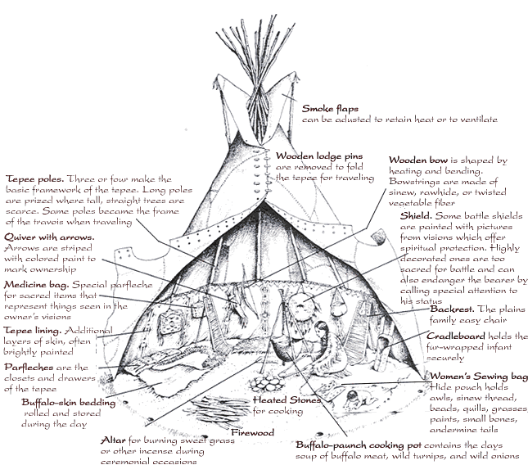

**Buffalo**: Plains Indians organised their life around the buffalo. They moved wherever they could be, and they made sure they never exhausted the supply of buffalo in one place.

In a buffalo hunt warriors would creep up on grazing buffalo dressed in animal skins (to hide their human scent) and shoot them with arrows. The wolf was not a predator of the buffalo so Indians usually wore wolf skins as the buffalo did not mind wolves near them. Alternatively they would create a stampede – forcing the buffalo into ‘jumps’. They would get trapped in ravines and could be shot at with arrows or they could be driven off cliffs and some would die due to the fall.

Buffalo hide could be made into clothes, covers or tipis. In this way the buffalo provided coverings to keep them warm and was also used to make their homes. Dried buffalo dung could be picked up and used as fuel for a fire. This meant they could have a fire to cook with and keep warm in winter even if they couldn't find wood. The bladder and intestines of buffalo could be used as food bags, buckets and cooking vessels. These were more suitable than pots which might get broken as they travelled around, and also meant they did not need wood or metal for buckets and cooking vessels. Buffalo sinews were used as bow strings. This was important since the Indians relied on hunting to provide their food.

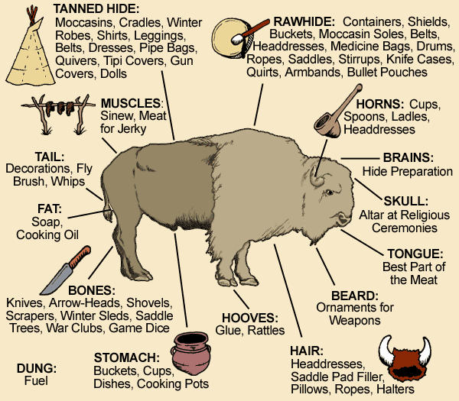

**The horse**: It was a means of transport for home and family, it was used in hunting and it played an important role in warfare. It allowed warriors to raid over much longer distances and it gave a new reason for warfare- stealing horses. It also changed the way that individuals actually fought. It led to war skills and horsemanship becoming an important measure of bravery and status in Plains society. The horse was so vital to life on the Plains that both individuals and tribes counted their wealth by the number of horses they owned. In the 1870s the Hunkpapa Sioux sub tribe had 3500 horses and 2900 Indians whilst the Comanche had nearly 8000 horses and 3000 Indians. The horse increased tribal mobility, enlarged hunting ranges, provided competitive advantage with other tribes. They could also be used to carry heavy loads (travois) making many tribes able to live a NOMADIC lifestyle.

The Sioux Indians believed in the Great Spirit. The Great Spirit was called ‘Wakan Tanka.’ They believed the Great Spirit had created them and every living thing around them. They believed that the sun, the earth, the sky, the mountains, the animals and all the things around them possessed a spirit. This meant that they treated humans, animals, birds, fish, insects and plants with the same sort of respect. The Sioux would only kill animals for food and believed that killing for sport or pleasure was more than just wasteful – it was an insult to the Great Spirit.

Plains Indians believed that they could contact the spirit world through ‘vision quests’, guided by spirit animals like spirit hawks or spirit foxes. Plains Indians also danced special ritual dances like the Sun Dance, to enter the spirit world. It was also possible to work with spirits to charge up magical items, which Indians would wear to bring them luck in hunting or protection from weapons.

The Plains Indians lived close to nature and they believed that the events of the universe were governed by the sun (most important), the earth, moon, sky and rocks, wind and water. **They also believed the land was sacred and no one could own it.**  All objects came from the earth and would return to the earth (hence why the Buffalo heart was buried). Some land was more sacred than other parts to the Indian tribes. Mountains were sacred as they were high up and closer to the spirits. For the Sioux the Black Hills were sacred.

Some tribes’ farmed land as well as living by hunting, fishing and gathering wild plant resources. In these cases, a farming plot belonged to a family rather than all of the tribe using the land together. However much of the land was difficult to farm and no person or family owned this as their property.

Farming and mining were seen as disrespectful to the land. These activities in sacred places would be likely to disrupt the sacred link between the tribe and the spirits.

The Sioux also believed that the power of the earth worked in circles. Circles were all around them - the sun was round, the wind whirled in circles, birds built their nests in a circle, the seasons were one big circle and the lives of people. Tipis were built in circles with their entrances facing east. Medicine circles were also built. Life was one big cycle (birth, childhood, adulthood, second childhood or old age and death) controlled by the Great Spirit.

**What were the Indians beliefs about nature and land?**

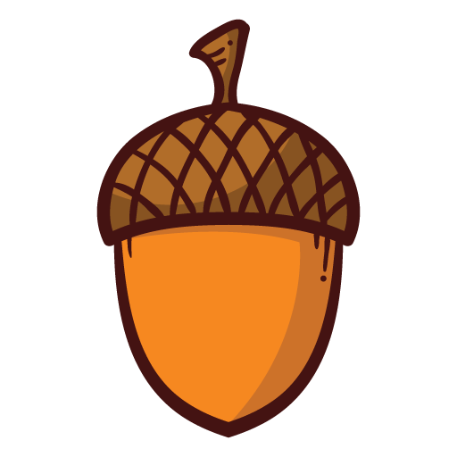 **How did the Indians survive on the Plains?**

A

T

S

|  |  |  |
| --- | --- | --- |
| Read through the information you have been given and complete the note-taking activity. You must give 4 specific facts about each topic. This includes completing the speech bubbles summarising each of the Indian beliefs. Once you have done this complete one of these Acorn challenges: | | |
| Why was the Tipi well suited to the lives of the Plains Indians and the problems of the Plains? | How did the buffalo and horse allow the Indians to survive on the Plains? | Which of these items (tipi, buffalo or horse) would the Indians think was the most important to their survival and why? |

R

Return by:

|  |  |  |
| --- | --- | --- |
| **Correct level of challenge completed?** | **Yes** | **Too low** |

|  |  |  |
| --- | --- | --- |
| **Effort grade for your homework:** | | |
| Exceptional effort going above and beyond expectations. | 10 APs |  |
| Good homework completed with additional effort/information. | 3 APs |  |
| Homework completed to expected standard. |  |  |
| Poor effort or incomplete homework. | Redo/complete |  |

|  |
| --- |
| **Teacher Comment:** |

|  |
| --- |
| **Spellings:** |

|  |
| --- |
| Tipis  Description of importance:  Specific facts: |
| Buffalo  Description of importance:  Specific facts: |
| Horse  Description of importance:  Specific facts: |

Beliefs about spirits:

Beliefs about circles:

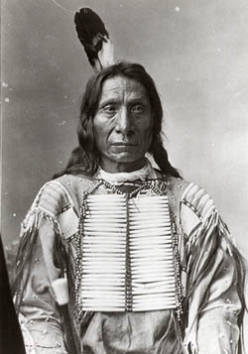

Beliefs about farming and mining:

Beliefs about land:

|  |
| --- |
| Acorn Challenge |
|  |
|  |
|  |
|  |
|  |
|  |
|  |
|  |
|  |
|  |
|  |
|  |
|  |
|  |
|  |
|  |
|  |
|  |
|  |
|  |
|  |
|  |
|  |
|  |
|  |
|  |
|  |
|  |
|  |
|  |
|  |
|  |
|  |
|  |
|  |
|  |
|  |

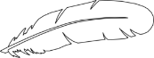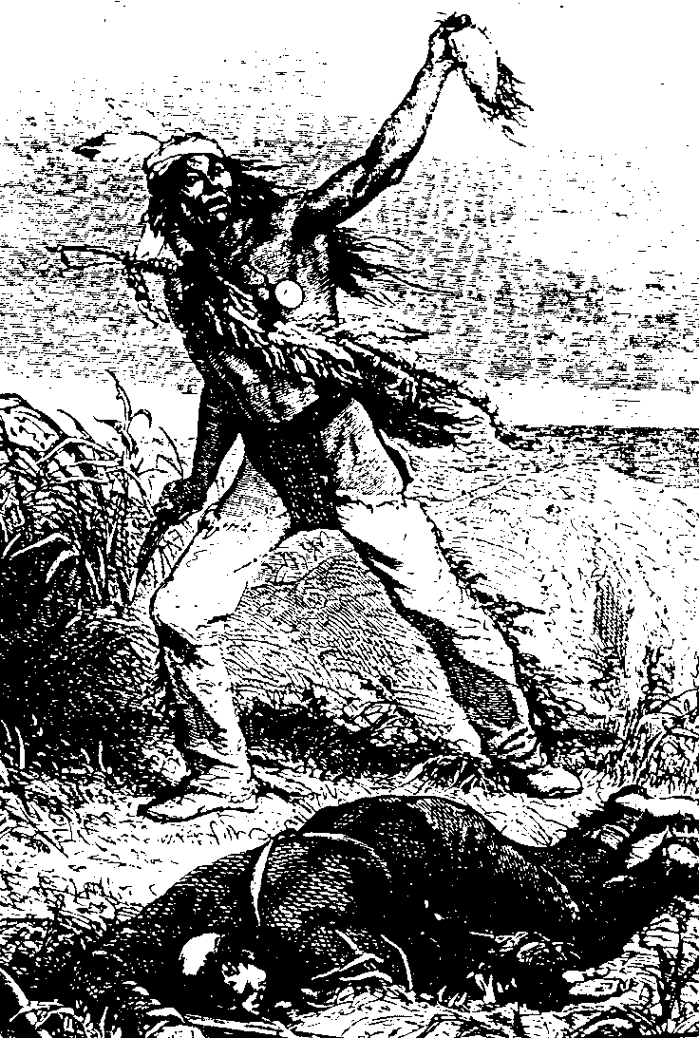

Indians were mainly peaceful tribes. When wars did occur it was usually in order to:

1. Prove bravery and achieve personal glory
2. Be allowed to enter a warrior society or gain a wife
3. Become a man
4. Become wealthy (by capturing horses, weapons and slaves)
5. Test their spiritual power and standing within the tribe

**What were the Indians attitudes towards war?**

War campaigns did not involve large numbers of men. They were carried out by small raiding parties (hit and run tactics). Raiding parties would typically set out from the village three or four times a year. There was rivalry for hunting and living space but the Indians would not conquer land as they believed it belonged to no one. Wars were always fought in the summer. Tribes did not declare war or sign peace treaties however some tribes did have traditional enemies and allies. With the introduction of the horse, tribal warfare increased as tribes strived to steal horses.

Indian warriors would always carry a coup stick, lance and a bow and arrow quiver. It was also common to carry a TOMAHAWK, dagger and increasingly a rifle. The coup stick was extremely important. Indians did not believe dying in battle was brave as you would no longer be able to provide for and protect your tribe. War was a ritual where bravery was tested by touching your enemy rather than killing them- ‘**counting coup’**. Stealing horses also counted as counting coup. Each warrior would be decorated with feathers to show the coup he had achieved. Marking of the feathers showed many different braveries in battle.

**Scalping** was seen as a token of success. They were dried and hung as trophies outside the tipis and could also be used to decorate war gear. It was also done for religious reasons. A warrior could not go into the afterlife if he lost his scalp-therefore could not fight you in the afterlife. Mutilation meant enemy would be disabled in the afterlife. Despite Hollywood movies, the majority of Indians did not scalp their enemies. The Plains Indians scalped their enemies when they were dead and mutilated bodies. To celebrate scalping, scalps were worn on the warriors’ shirts as were the victims’ hair as a sign of bravery and great skill



**Reasons for conflict:** White Americans recognised that the Indians had some rights to American land because they had lived there a long time. However, most White Americans also believed that Indians were savages who did nothing to improve the land: they just lived off the resources the land produced naturally. That meant, they thought, that white Americans had better rights to own land than Indians because they were trying to improve the land: ploughing it for farming, digging up its minerals for manufacturing and developing America into a civilised country. As a result it seemed wrong to most White Americans that the Indians should have good land that they were not doing anything with.

**Government policy:** All through the 19th century, the US federal government struggled for a solution to the Indian problem as the number of white Americans grew and conflict between whites and Indians over land increased.

US government policy had two main approaches to tackling this conflict:

* Keep white settlers and Indians apart
* Encourage Indians to become like white setters.

It was very hard to follow both approaches at the same time, since keeping Indians away from white Americans meant that they continued to follow their traditional ways of life.

**How did US government policy effect the Plains Indians?**

|  |
| --- |
| **A ‘permanent’ Indian frontier**  In 1830, US President Jackson signed the Indian Removal Act, which pressured 46,000 Indians living in the east of America into giving up their lands in return for new lands west of the Mississippi river. Jackson promised that the Indians would never have to give up this new land, known as Indian Territory, and that they would be protected from other Indian tribes and from white settlers.  Then, in 1834, the US government passed the Indian Trade and Intercourse Act that said that the Indian Territory was: ‘all that part of the United States west of the Mississippi river and not within the states of Missouri and Louisiana or the territory of Arkansas’. To keep Indians and whites apart, the government established a ‘permanent’ Indian frontier, which divided Indian territory from the states of Arkansas, Missouri and Iowa.  The 1834 Act also prohibited whites from settling on Indian lands, prevented any sale of guns or alcohol to Indians by white traders and gave the US army the role of policing the frontier to keep these laws. The US Army also had to protect the new Indian arrivals from attacks by the Indians already living there and prevent the Indians launching raids across the frontier onto white farms. The frontier was guarded by a chain of US army forts connected by a military road along the frontier, |
| **Westward expansion**  In the 1830s, a few white Americans thought that the land behind the Indian Frontier was worth having. The Great Plains were not suitable for farming using the methods then available and it was known as the Great American Desert because of its tough climate. Although the US army could not hope to control the whole of the vast frontier, there were not enough whites wanting to cross the frontier to cause major problems in the 1830s.  However in the late 1840s the situation changed. The USA won a war with Mexico in 1848 and, as a result, the USA gained huge new territories in the West including California. In 1846, the USA also gained control of its territory in Oregon Country and in 1845 Texas officially became part of the USA. This expansion of the USA had major consequences for Indian policy. Instead of the Indian Frontier dividing the Indians in the West from the white Americans in the East, Indian lands were now in the middle of the USA. |
| **Government support for westward expansion**  The US government knew that if it wanted to hold onto its new territories in the West, it needed US citizens to go and live there. Although settlers could travel by sea to the west coast, it was a very long and expensive journey. People needed to be able to travel safely across Indian lands.  People travelling from east to west followed trails across Indian lands. The US government used its army to force Indians to move away from the trails to stop Indians attacking the travellers. This meant that US policy started to change. The permanent Indian frontier still marked the boundary with Indian lands, but it was no longer the case that whites could not cross the frontier. |
| **The Indians Appropriations Act 1851**  In 1851 the US government passed the Indian Appropriations Act. This provided government money to pay for moving Indians in Indian territory onto reservations: the same Indians who had been forced to move from the Eastern states. Hunting lands were also allocated to some reservations, so the Indians could continue to hunt buffalo and other animals. Reservations were a continuation of the government policy of moving Indians away from land that the white people wanted to use, but the reservations were something new too. By reducing the amount of land Indians had available for hunting, the government hoped to encourage the Indians to take up farming. The idea was that once the Indians settled down to a farming lifestyle, they could begin to live like white Americans.  Reservations reduced Indians independence and undermined their traditional ways of life:   * Although reservations were supposed to encourage agriculture the land was sometimes very poor and not suitable for farming, and some tribes had to depend on food from the government. * Reservations were often far from tribes sacred places and the burial places of their ancestors. This cut the tribes off from important sources of their tribal identify and culture. * Indians were supposed to stay on their reservations, which was not compatible with the traditional way of life of nomadic hunters, who needed to follow buffalo herds.   Indians were not given the same legal protection as US citizens. They could be moved off their land if the federal government decided the whites needed it. |

 **How did US government policy effect the Plains Indians?**

A

T

S

|  |  |  |
| --- | --- | --- |
| Read through the information on pages 13-14 and complete the note-taking activity. You must give 4 specific facts about each topic. Once you have done this complete one of these Acorn challenges: | | |
| Why do you think the government made these policy decisions? What did they want to do to the Indians? | How would the Indians have reacted to these policy decisions? Why? | Which of the these policies would have had the biggest impact on the Indian way of life? Explain your answer by comparing to the other decisions. |

R

Return by:

|  |  |  |
| --- | --- | --- |
| **Correct level of challenge completed?** | **Yes** | **Too low** |

|  |  |  |
| --- | --- | --- |
| **Effort grade for your homework:** | | |
| Exceptional effort going above and beyond expectations. | 10 APs |  |
| Good homework completed with additional effort/information. | 3 APs |  |
| Homework completed to expected standard. |  |  |
| Poor effort or incomplete homework. | Redo/complete |  |

|  |
| --- |
| **Teacher Comment:** |

|  |
| --- |
| **Spellings:** |

|  |
| --- |
| A permanent Indian frontier  Description of impact on Indians:  Specific facts: |
| Westward expansion  Description of impact on Indians:  Specific facts: |
| The Indians Appropriations Act 1851  Description of impact on Indians:  Specific facts: |

|  |
| --- |
| Acorn Challenge |
|  |
|  |
|  |
|  |
|  |
|  |
|  |
|  |
|  |
|  |
|  |
|  |
|  |
|  |
|  |
|  |
|  |
|  |
|  |
|  |
|  |
|  |
|  |
|  |
|  |
|  |
|  |
|  |
|  |
|  |
|  |
|  |
|  |
|  |
|  |
|  |
|  |

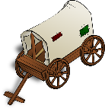

Manifest Destiny was a term first used by John O’Sullivan a newspaper editor from New York. He said   
‘It is our manifest destiny to overspread and to possess the whole of the continent which providence has given us for the development of the great experiment of liberty’.

**Why did settlers move west?**

There were many different factors involved in people’s decision to make the long and dangerous journey west. Some factors pushed migrants away from the East, while others pulled them west.

**Push**- Something negative that makes you want to leave. **Pull**- something positive that makes you want to move somewhere.

|  |  |
| --- | --- |
| Push Factors | Pull Factors |
| 1. In 1837 there was an economic crisis in the East and the South of the USA. Many banks collapsed, people lost their savings, businesses failed and thousands lost their jobs. In some areas, unemployment was as high as 25% and those who still had a job faced wage cuts of up to 40%. 2. Jews, Amish, Mormons and other religious groups wanted to live their lives free from persecution. 3. Land in the east was expensive, especially for Irish immigrants who had begun to arrive in the 1840s. In the West there was plenty of land that could be free, cheap or bought at a low rate (although could be pull as well). | 1. The promise of free farming land in the west was appealing. However, the sea-route to Oregon was very expensive. The first land pass, the Oregon Trail, was publicised in 1825 by Jedidiah Smith. 2. In 1869 the Oregon Trail was replaced by the first transcontinental railroad. By this time, 400,000 people had migrated along the Oregon Trail. 3. In 1848 and 1849, gold was discovered in the Sierra Nevada and California. Thousands of men travelled to find gold meaning that California’s population reached 300,000 by 1855. 4. Manifest destiny led to the belief that the white Americans had the right to populate all areas of America as it was fulfilling God’s will. 5. In 1841 the US government provided $30,000 for an expedition to map the Oregon Trail and publish reports that would help migrants. John Fremont published these and made the journey sound exciting and achievable. |

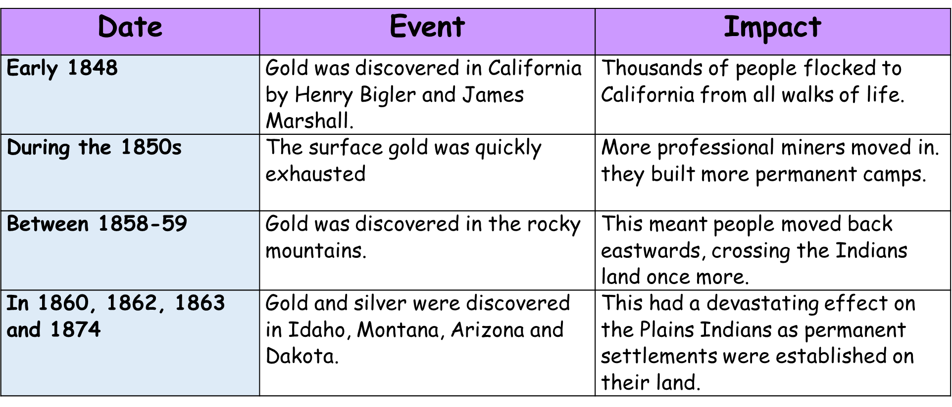

**What were the events of the gold rush?**

The gold rush happened in several stages, each one of them changed the lives not only of the miners but of those in the places where the discoveries were made.

|  |  |
| --- | --- |
| **Positive consequences** | **Negative consequences** |
| * Improved transportation between California and the east coast led to development of new settled communities – cities like San Francisco went from sleepy villages to major city-ports. * Other industries were stimulated like shipbuilding and later railroads. * Many people made money out of the miners by charging extortionate amounts for equipment and supplies – entrepreneurs like Levi Straus made his fortune from selling hardwearing denim to the miners. * Towns and cities were charted. Roads, schools, and churches were formed. California’s population reached 300,000 by 1855. * New states were created as a result of the expansion of the west caused by the gold rush. California was declared on September 9th, 1850 as the 31st state. * The gold rush made the USA a world trader and California a very rich state – it forced the East to forge links with the West. | * Racial Violence: - Gold rush attracted people from across the world- Europe, China, Mexico, black Americans, Indians – the mining towns saw terrible racial riots- Mexicans and Chinese were targets and the Indians were almost wiped out. * One in twelve Forty-Niners lost his or her life, as the death and crime rates during the Gold Rush were extraordinarily high. * There was increased lawlessness as a result of the gold rush as gold attracted the ‘dregs of society’ there was no law and order and people has to abide by their own rules. Prostitution and gambling was rife. * Claim – jumping was a common complaint when miners would try to steal the best land leading to fights and often murder. * Vigilantism where people governed themselves was common – they often lynched those they suspected of committing crimes. * For the early miners there was a very poor quality of life with people living in dirty tents or cabin with fever and cholera killing many. |



**Why was the journey west a difficult experience?**

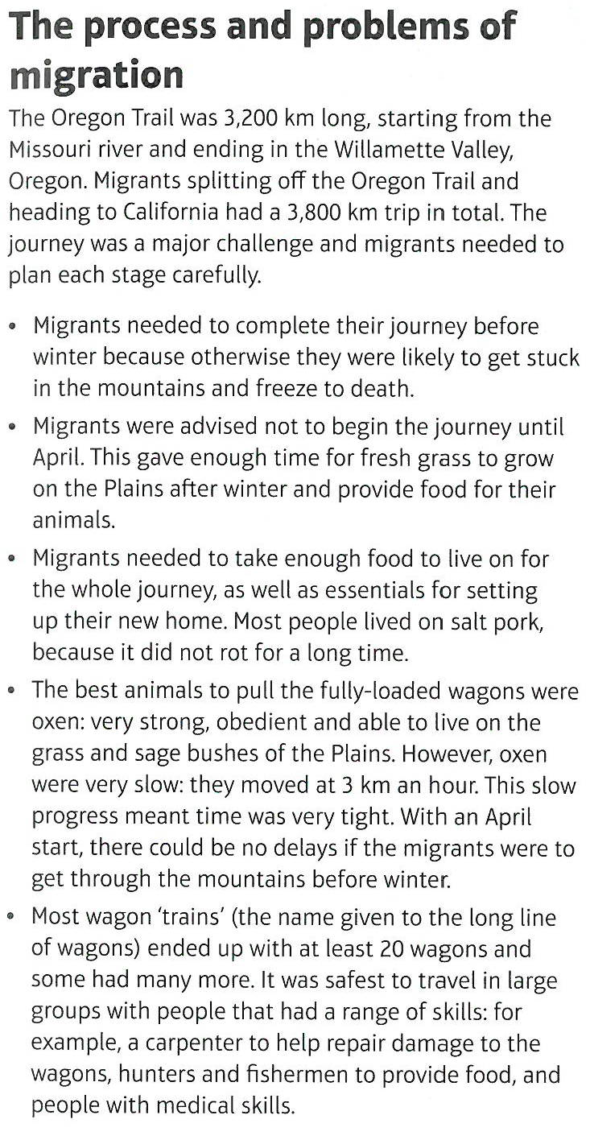

|  |  |
| --- | --- |
| **How did they travel?** | Specially made wagon. Tires fastened with bolts. Oxen and mules pulled wagons. Well suited to trail. Canvas tops good for weather. Called prairie scooters. |
| **What did they take with them?** | Supplies- spare wagon parts, tools, cooking utensils, bedding, clothing, food.  Half a ton of provisions. Very heavy. |
| **Where and when did they start?** | Nearest river port, booked on steam boat. Down the Ohio and up the Mississippi. Reached settlements on Missouri river. Independence Missouri was the last town.  When? Mid-April to May. Earlier meant no food for animals, later meant snow. 6 months to travel 2000 miles. |
| **What were the main problems they might encounter?** | Weather extremes  Wives pregnant or with small children scared.  Altogether unprepared. Wagons overloaded with personal treasures, wilderness skills lacking, and no cash reserves to restock.  Rifles discharged in weapons, wander off and get lost, animals crushed travellers, drowned in river crossings. Cholera epidemics. Killed thousands. Poor sanitary conditions at campsites. |
| **How successful?** | http://1.bp.blogspot.com/-OxXWmN7GMOY/Uf913VN-yqI/AAAAAAAAAgM/R5dVW2TpDbs/s1600/handcarts.jpgHuman bones scattered along the trail. 1 grave for every 80 yards of the trail. 80,000 died. |

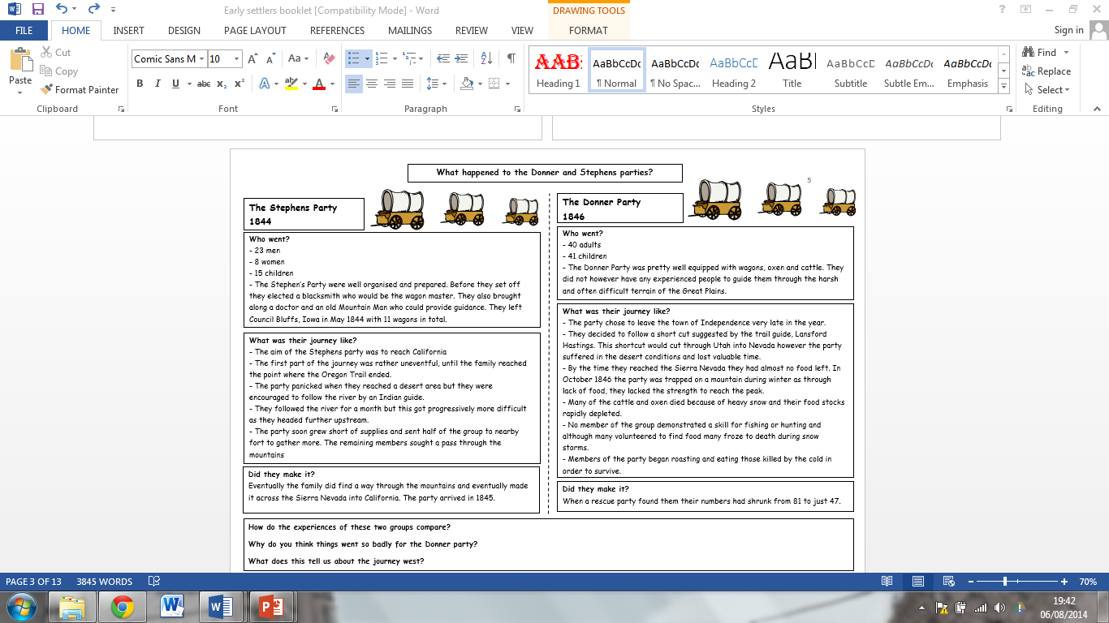

 **Why was the journey west a difficult experience?**

A

T

S

|  |  |  |
| --- | --- | --- |
| Read through the information on page 20 and complete the note-taking activity. You must give 4 specific facts about each topic. Once you have done this complete one of these Acorn challenges: | | |
| 1. What preparation did people need for the journey west? 2. What dangers could be faced on the event? | 1. Why were the Stephens party successful? 2. Why were the Donner party so unsuccessful? | To what extent do you think the journey west was a difficult experience? |

R

Return by:

|  |  |  |
| --- | --- | --- |
| **Correct level of challenge completed?** | **Yes** | **Too low** |

|  |  |  |
| --- | --- | --- |
| **Effort grade for your homework:** | | |
| Exceptional effort going above and beyond expectations. | 10 APs |  |
| Good homework completed with additional effort/information. | 3 APs |  |
| Homework completed to expected standard. |  |  |
| Poor effort or incomplete homework. | Redo/complete |  |

|  |
| --- |
| **Teacher Comment:** |

|  |
| --- |
| **Spellings:** |

|  |
| --- |
| The Oregon Trail  Description:  Specific facts: |
| The Stephens Party  Summary of their journey:  Specific facts: |
| The Donner Party  Summary of their journey:  Specific facts: |

|  |
| --- |
| Acorn Challenge |
|  |
|  |
|  |
|  |
|  |
|  |
|  |
|  |
|  |
|  |
|  |
|  |
|  |
|  |
|  |
|  |
|  |
|  |
|  |
|  |
|  |
|  |
|  |
|  |
|  |
|  |
|  |
|  |
|  |
|  |
|  |
|  |
|  |
|  |
|  |
|  |
|  |

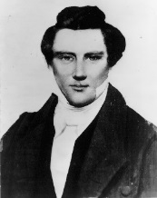

**What was the experience of the Mormons?**

***Mormon beliefs- the 5 p’s***

**Polygamy** –A man could have more than one wife

**Proselytisation** – Mormons should try to convert other people to their faith.

**Politics** - Church leaders should try to find political power over Mormons and non-Mormons, known as gentiles.

**Property** – The Church held property. There were no rights to Individual ownership.

**People of god**. - Obedience would make Mormon’s God’s chosen people in Heaven and on Earth.

**What was the story of the Mormons?**

From the age of 14 onwards Joseph Smith had regular visions including one from an Angel Moroni who told him where to find the true story of Christ. Smith translated these plates and published the Book of Mormon in 1830. He soon had several hundred people following him. Other religious groups believed Smith was a fraud and blasphemous. Smith and his followers were driven out of New York by an angry mob.

The Mormons moved to Kirtland (1831-1837) where they became very successful. They owned mills, shops, a bank and a printing press. Their followers increased to 1000 members. In 1837 an economic crisis hit America, the Mormon bank collapsed and many Mormons and Gentiles lost all their life savings. The Gentiles blamed the Mormons for the financial collapse and they were driven out of Kirtland.

The Mormons moved to colonies in Missouri. Again they built successful businesses and farms. They angered local people by announcing any freedmen (ex-slaves) were welcome to join them in Missouri. Rumours ran wild that the Mormons were stirring up the Indians, with whom they shared a belief in polygamy, and freed slaves. Many gentiles believed the Mormons were trying to rise up against them. Days of rioting resulted when the local people tried to stop Mormons from voting into elections. The army had to be sent in to Missouri. The Governor of Missouri declared the Mormons to be public enemies and they should be killed or driven out. Smith was arrested and only released as he promised he would move on. The Mormons agreed to leave in 1838.

Smith did not want to lead his followers into the Great American Desert so they settled in a little town called Commerce in Illinois. In 1839 Smith renamed it Nauvoo. By 1844 he had built a successful city with a large temple. It became the biggest city in Illinois. The Mormons sent missionaries to Europe to encourage people to settle in Nauvoo. The Mormons governed themselves and created their own private army called the Danites.

By 1844 the Mormon numbers were 35,000 and growing. Smith had a vision that split the Mormons in two. He believed he had a revelation from God which allowed Mormons to practice polygamy. Some Mormons did not believe Smith and criticised him for being a false prophet in the press. He had the press office destroyed. He appeared to be acting like a dictator and many Mormons left. People were also angry he was planning to run for President.

Smith and other Mormon leaders were arrested for their part in destroying the press office. On 27th June 1845 an angry mob of 200 people broke into the prison and killed Smith.

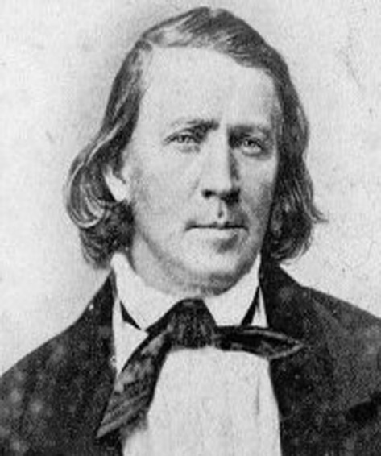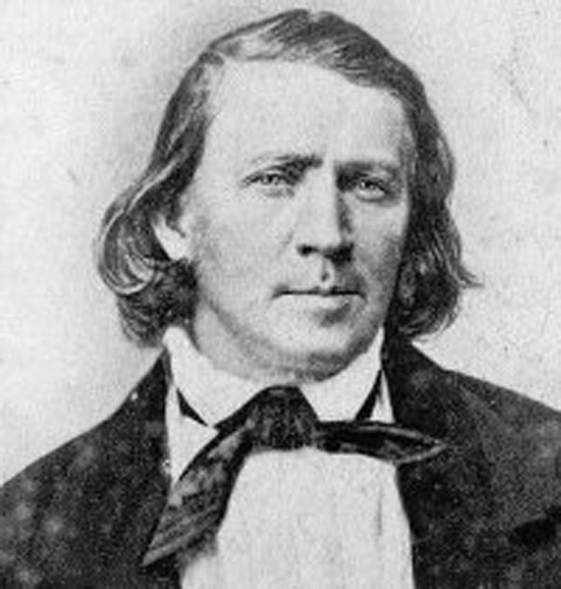

After the death of Joseph Smith, the decision of what to do next rested with Brigham Young, the new leader of the Mormons. He decided that he needed to take the Mormons to a place that they could call their own, a place that nobody else wanted, that was the place that God had decided was for them.



When the Mormons arrived in Salt Lake City this was not the end of their story. In many ways their problems were just beginning. Brigham Young was going to need all his powers of leadership and organisation if they were going to survive and flourish. First the land on which they had settled had to be shared fairly between the Mormon families. The Mormons had to grow crops if they were going to survive. The soil, although it looked rich, was very very dry, water was desperately needed and the lake was far too salty to be used. They also needed to find a way to get their supplies without contacting the hostile outside world!

**Mormons and Salt Lake City**

|  |  |  |
| --- | --- | --- |
| The US government passed an anti-polygamy law in 1862 but it was ignored in Utah. When the Mormons applied for Utah to become a state for the first time, the US government demanded a ban on polygamy. This time the Mormons agreed and in 1896 Utah became a state. | In 1848 the United States defeated Mexico in war and gained the land at the Salt Lake. Young decided to form a Mormon sate called Deseret and apply to join the United States. But the US government refused to recognise Deseret. | Farming was a success, with wheat production increasing by 300% between 1850 and 1860. |
| Water was essential. The Mormons worked together to build a main irrigation ditch through the farming land. Side ditches were then dug so that all the land could be irrigated. Each person was given an exact time when they were allowed to draw water from the main ditch. | In 1857 a group of non-Mormons were passing through Utah. They had not time for the Indians. They abused the Indians who had become converts to the Mormon faith. Their actions caused the Indians to respond and they killed 7 of them. They sought out help from the Mormons who joined them and killed the rest of the non-Mormons. They tried to cover it up but failed. This was known as the mountain meadow massacre. | The city was laid out like a dartboard, with the temple in the middle. Each family was given a plot of the land around it. Farms between 10 and 80 acres were given to larger families. 10 acre plots went to those with small families. 5 acre plots went to artisans who had little time to work on the land. |
| Settlers were carefully selected with a balanced number of farmers, shopkeepers and craftsmen. | The church would be in control of land. It would assign farm land to people according to their needs. This helped prevent resentment between the Mormons. | The Mormons believed that Young was inspired by God and so they accepted his decisions without question. |
| To develop further, the Mormons needed more people. Young sent missionaries to Europe, the Far East and South America to win convents. In England alone nearly 33,000 converts were ready to depart by the end of 1851. | Following the mountain meadow massacre the US government offered the Mormons a full pardon if they accepted the authority of the US government. A gentile governor was elected and the Mormons were allowed to develop in peace. | Young managed to compromise with the US government and the territory of Utah was created. It was smaller than Deseret but Young was named as the first governor. Although some gentiles were appointed to the government along with him, his word was law. |
| They achieved little in education. The schools were badly equipped and the parents resisted attempts to expand the school year beyond three months, insisting the children were needed on the farms. | In order to continue the flow of new settlers, a perpetual emigrating fund was set up to help pay for their passage to the Salt Lake. Money was lent to the emigrants that they repaid after reaching Utah. | The Mormons charged gentiles to cross their lands. This was particularly helpful when the Gold rush crossed their land. However the gentiles complained that the Mormons were charging high prices |

 **What was the experience of the Mormons?**

A

T

S

|  |  |  |
| --- | --- | --- |
| Read through the information on pages 24-26 and complete the note-taking activity. You must give 4 specific facts about each topic. Once you have done this complete one of these Acorn challenges: | | |
| Read through the boxes about Mormon attempts to settle in Salt Lake City. Identify which are successes and which are failures. | Read through the boxes about Mormon attempts to settle in Salt Lake City. Identify which are successes and which are failures. What was their biggest success and what was their biggest failure. Explain your decisions. | Read through the boxes about Mormon attempts to settle in Salt Lake City. Identify which are successes and which are failures. Overall, was their move to Salt Lake City a failure or a success? Explain your decision. |

R

Return by:

|  |  |  |
| --- | --- | --- |
| **Correct level of challenge completed?** | **Yes** | **Too low** |

|  |  |  |
| --- | --- | --- |
| **Effort grade for your homework:** | | |
| Exceptional effort going above and beyond expectations. | 10 APs |  |
| Good homework completed with additional effort/information. | 3 APs |  |
| Homework completed to expected standard. |  |  |
| Poor effort or incomplete homework. | Redo/complete |  |

|  |
| --- |
| **Teacher Comment:** |

|  |
| --- |
| **Spellings:** |

|  |
| --- |
| Mormon beliefs  Description:  Specific facts: |
| Moving west 1 – Joseph Smith  Summary of their journey:  Specific facts: |
| Moving west 2 – Brigham Young  Summary of their journey:  Specific facts: |

|  |
| --- |
| Acorn Challenge |
|  |
|  |
|  |
|  |
|  |
|  |
|  |
|  |
|  |
|  |
|  |
|  |
|  |
|  |
|  |
|  |
|  |
|  |
|  |
|  |
|  |
|  |
|  |
|  |
|  |
|  |
|  |
|  |
|  |
|  |
|  |
|  |
|  |
|  |
|  |
|  |
|  |

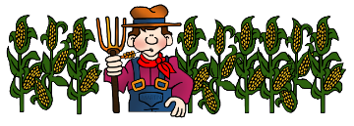

**Why did they go west?**

**Why was life difficult for homesteaders?**

**Reason 1: The actions of the US government**

In 1854 the government created two new territories, Kansas and Nebraska these had previously been behind the permanent Indian frontier. Now they were opened up to white settlers. The Homestead Act was passed in 1862. It was intended to encourage people to settle in the West by allowing each family 160 acres of land. The land was given to them for free provided they lived on it and farmed it for five years.

**Reason 2- The success of farming in California.**

In California and Oregon farming conditions were good. Thousands of disappointed gold miners found that California’s mild climate and fertile soils were excellent for growing spring wheat. By the 1850s, farmers there were producing so much wheat that California began exporting wheat to Europe. There was a lot of money to be made, and farming became big business, with large farms that could afford steam powered farm machinery and large workforce.

**Reason 3- The building of the railways**

The US government had long wanted to build a transcontinental railroad to link east and west. In the 1860s, two companies started building, one from the east, the other from the west. Eventually they met in Utah.

This had two main effects. Now it was easy for homesteaders to get to the Plains and it was also cheap to get land as the railroad companies sold off the land at either side of the track at low prices.

**Problems faced by the homesteaders**

|  |  |  |
| --- | --- | --- |
| The Sod Houses that the homesteaders built were made of earth and so were continually dirty. They leaked dirty water into the living accommodation. The floors were dirt. There were no medical facilities and diseases like cholera, pneumonia were common | Cattle and buffalo were a problem. The cows from neighbouring ranches would stray and trample the homesteaders’ crops. Buffalo were simply roaming wild, still in large herds until the 1870s.  The lack of trees on the Plains meant that there was no material to build adequate fences. | The grass that covered the Plains had thick deep roots that grew in tangled clumps that were difficult to cut. The traditional iron ploughs broke when used on the Great Plains. |
| The Plains are a vast open space with very few trees. The homesteaders needed to find other ways of building their homes. They could not get supplies of wood from the East as it would be too expensive, and a lack of money was one of the homesteaders’ major problems. | Homesteaders faced the risk of Indian attacks from 1860. Although many tribes had moved on to reservations, the reservations did not provide them with enough food or supplies.  There were outbreaks of violence in the Plains Wars in the 1860s and 1870s, During Little Crow’s War, over 700 Homesteaders were massacred by Santee Sioux warriors. | The Plains were known as the Great American Desert - annual rainfall on the Plains was only 38 cm, the hot summers evaporated any water that did fall. There were few lakes and rivers to provide water for irrigation, crops, or to drink |
| Homesteaders needed fuel to heat their houses against the cold Plains nights and freezing winters. They also needed fuel for their ovens.  The lack of tress on the Plains meant that wood was not available to them. The homesteaders had to find an alternative material. | Crops of maize and wheat that they brought with them from the Eastern states did not grow well on the dry hot Plains. No crops meant no food for the homesteaders. Even if they could grow enough to eke out a living, they could not grow a surplus to sell. This meant they had no income, and could not pay for supplies or machinery for their farms. | Plagues of grasshoppers destroyed everything the homesteaders possessed. They could eat a homesteader family’s entire crop in a few hours, leaving them with nothing to eat or sell. The grasshoppers ate boots, tools, clothes, even the wooden door frame of the sod house. |
| The Plains experienced massive variations in temperature. Winters were long with freezing temperatures and snow.  Summers were very hot. The Plains were also regularly struck by dust storms. The vast open spaces of the Plains encouraged high winds and tornadoes. Such storms did severe damage to the homes and equipment of the homesteaders. | The Homestead Act of 1862 gave the homesteaders 160 acres of land each. However this was not enough to support their families. The lower yields of crop caused by the harsh climate and lack of water meant that many thousands of homesteaders simply gave up their plots. | The dry Plains provided the perfect conditions for fires to start. The long hot summers left the Prairie Grass and the homesteaders’ crops bone dry. Accidental fires started by a spark or a bit of broken glass lying on the ground and reflecting the sun were a disaster for the homesteaders. |

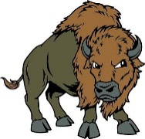

Life for both settlers and Plains Indians was very challenging because of the harsh environment of the West. One bad decision or one unfortunate accident could put a group of settlers or a band of Indians at great risk. This made settlers and Indians very wary of possible threats.

However this also included each other.

**Why did tension increase between settlers and Plains Indians?**

Conflict was an unavoidable part of life for Plains Indians because resources on the Plains were scarce and raiding other tribes for food, horses and people was an important survival strategy. When white settlers, travelling the Oregon Trail, got caught up in these conflicts, they often thought the war parties or warriors were threatening to attack them. Indian attacks on migrants were very rare, but white settlers scared each other with stories of Indian attacks and misunderstood the intentions of any Indian war parties they spotted on the trail.

White settlers had strongly racist views about Indians. Most were certain that the white race was naturally superior to the Indian race, which meant Indians were doomed to be swept aside by whites/ they felt contempt for Indians who begged supplies from them, and were angry when they stole horses and cows from them. At the same time, white settlers were very afraid that the Indians would attack them, scalp the men and carry the women and children off into slavery.

Some settlers did seek to benefit from Indian experience and knowledge about their environment. The Mormon settles for example, learned a lot about how to survive at Salt Lake Valley from studying the crops and farming methods of the Pueblo Indians. Some Indians also went to live among white people and learn more about white laws, religion and culture. However this sort of interaction was not common. It was more usual for both whites and Indians to have very little understanding of how each other lived and why they acted as they did. This led to mistrust.

The discovery of gold in California meant hundreds of thousands of whites travelled along the Oregon Trail in 1849 and 1850. This led to serious problems for Plains Indians along the Oregon Trail because the migrants caused disruption to buffalo hunting. The whites killed large numbers of buffalo along the trail for meat. Also, the Indian way of hunting buffalo depended on managing the herd carefully, but the migrants spooked the buffalo and caused stampedes. Hundreds of thousands of migrants also meant hundreds of thousands of oxen pulling their wagons and many migrants brought livestock with them. This meant shortages of grass in a wide area along the Oregon Trail for all the animals the Indian’s hunted and for the Indians horses.

Tribes did keep an eye on the migrants, therefore. The migrants tended to assume that any Indian warriors they saw watching them were actually planning to attack them. More and more migrants demanded that the government protect them. They wanted forts along the Oregon Trail so soldiers could crack down on any hostile Indian threat.

 **Why did tension increase between settlers and Plains Indians?**

A

T

S

|  |  |  |
| --- | --- | --- |
| Read through the information on page 32. Highlight the big box in three ways:   * Reasons for conflict * Examples of conflict * Examples of cooperation.   Once you have done this complete one of these Acorn challenges: | | |
| Why was there so much conflict between white settlers and Plains Indians? | What do you think the biggest reason for conflict was? Why do you think this was the biggest reason for conflict? | Was there anything that could have been done to stop this conflict from taking place? Explain your answer using your knowledge of the unit so far. |

R

Return by:

|  |  |  |
| --- | --- | --- |
| **Correct level of challenge completed?** | **Yes** | **Too low** |

|  |  |  |
| --- | --- | --- |
| **Effort grade for your homework:** | | |
| Exceptional effort going above and beyond expectations. | 10 APs |  |
| Good homework completed with additional effort/information. | 3 APs |  |
| Homework completed to expected standard. |  |  |
| Poor effort or incomplete homework. | Redo/complete |  |

|  |
| --- |
| **Teacher Comment:** |

|  |
| --- |
| **Spellings:** |

|  |
| --- |
| Acorn Challenge |
|  |
|  |
|  |
|  |
|  |
|  |
|  |
|  |
|  |
|  |
|  |
|  |
|  |
|  |
|  |
|  |
|  |
|  |
|  |
|  |
|  |
|  |
|  |
|  |
|  |
|  |
|  |
|  |
|  |
|  |
|  |
|  |
|  |
|  |
|  |
|  |
|  |

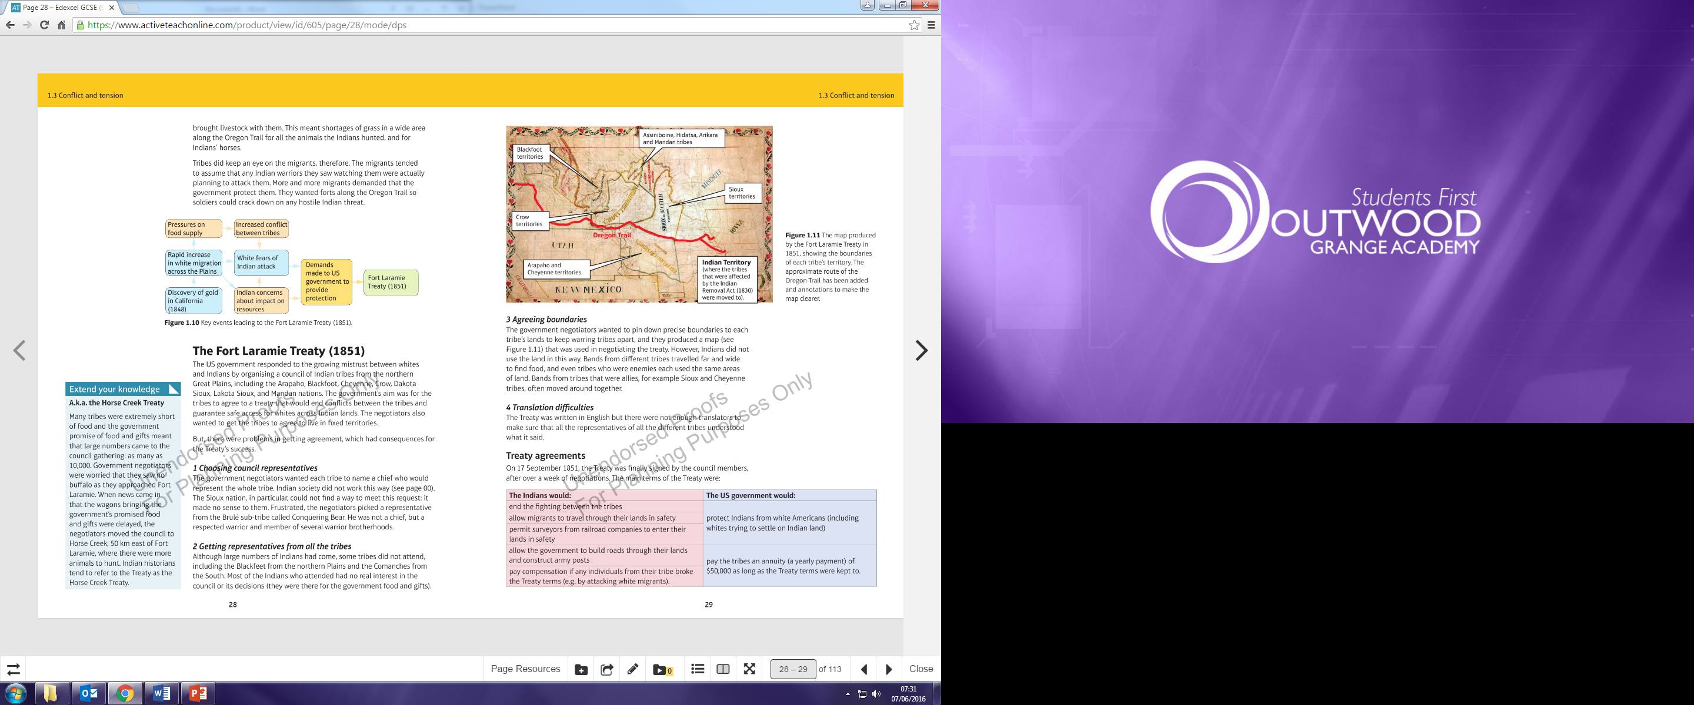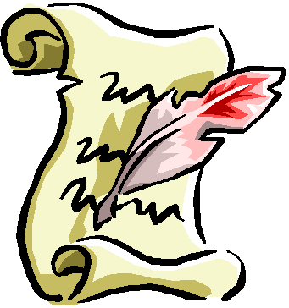

**What was the significance of the Fort Laramie treaty?**

|  |
| --- |
| **Problem** |
| **Choosing council representatives:** the government negotiators wanted each tribe to name a chief who would represent the whole tribe. Indian society did not work this way. The Sioux nation in particular could not find a way to meet this request. Frustrated, the negotiators picked a representative from the Brule subtribe called Conquering Bear. He was not a chief but a respected warrior. |
| **Getting representatives from the tribes:** Although a large number of Indians had come, not all tribes attended, including the Blackfoot and the Comanche’s. Most of the Indians who attended had on real interest in the council or its decision, they were therefore the government food and gifts. |
| **Agreeing boundaries:** The government negotiators wanted to pin down precise boundaries to each tribes land to keep warring tribes apart, and they produced a map that was used in negotiations. However Indians did not view the land in this way. Bands from different tribes travelled far and wide to find food and even tribes who were enemies used the same land. Bands from tribes that were allies, for example the Sioux and Cheyenne often moved together. |
| **Translation difficulties:** The treaty was written in English but there were not enough translators to make sure that all the representatives for the different tribes understood what it said. |

The US government responded to the growing mistrust between Whites and Indians by organising a council of Indian tribes from the northern Great Plains, including the Arapaho, Blackfoot, Cheyenne, Crow, Dakota, Sioux, Lakota Sioux and Mandan nations. The government’s aim was for the tribes to agree to a treaty that would end the conflict between the tribes and guarantee safe access for whites across Indian lands. The negotiators also wanted to get the tribes to agree to live in fixed territories.

But there were problems in getting agreement which had consequences for the treaty’s success.

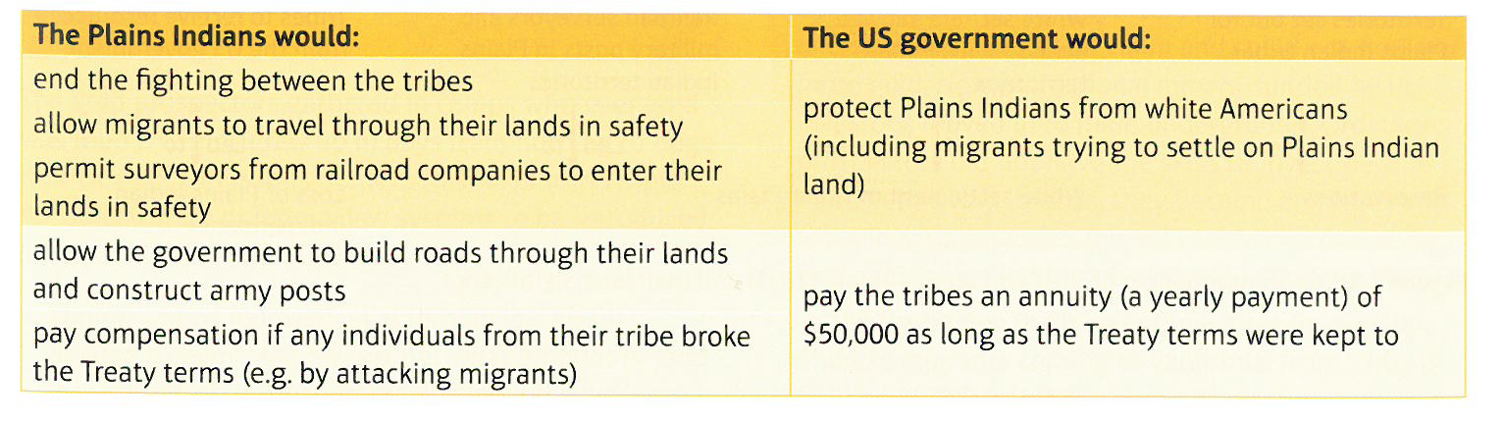

**The significance of the treaty:**

* The Fort Laramie treaty did not introduce reservations for the rest of the Plains Indians, but by identifying areas of territory for each tribe, it took the first step towards moving all of the Indians onto reservations. This, in turn, led to the opening up of what had been Indian land for settlement by non- Indians.
* The Fort Laramie Treaty stated that white travellers must be allowed to travel safely across the Plains. This undermined the Permanent Indian Frontier in the Northern Plains as the Indian Appropriations Act of 1851 had done for the frontier of Indian Territory.
* The US government introduced annuities, paid in food and products, to compensate Indians for allowing white Americans across their lands. Instead of remaining separate and independent of the US government, Indian tribes now had a relationship with the government that depended on Indians behaving as the government wished.

**Problems with the treaty:**

* There was no tradition in Plains Indian society for one man to represent the wishes to the whole tribe. Although individual chiefs had signed the treaty, each band would make its own decision about whether to follow it or not. For the Sioux, for example, Conquering Bear was not even a chief.
* Not all the Indian representatives understood what they signed up to, due to translation difficulties and because of completely different cultural understandings about land as property. This affected what they were able to tell their tribes about the terms of the treaty.
* The boundaries of the tribes’ territories were not seen as meaning anything serious. When the Sioux complained that their hunting grounds were larger than those on the map. The government representatives said that all Indians were still free to hunt in other tribes territories.

The result of these problems was that neither side had any lasting success in sticking to the treaty terms. Indian bands continued to fight each other, which the US government saw as breaking the treaty. And white Americans did not stick to the Oregon Trail but trespassed into areas that Indians views as strictly off limits, actions that should have been stopped by the US army, but were not.

On 17 September 1851, the treaty was finally signed by the council members, after over a week of negotiations.

The main terms of the treaty were:

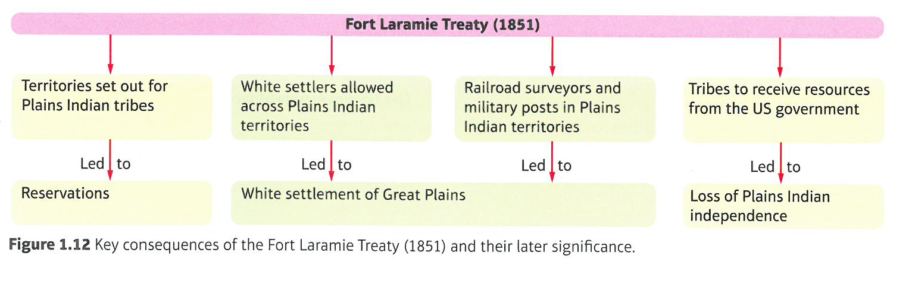

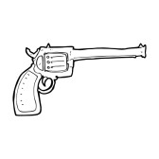

**1. Political factors**

The new mining towns which sprang up so quickly were particularly lawless in their early years. By 1855 there were 300,000 people in California. There was a shortage of reliable law enforcement officers and politicians did not think the issue was important enough to spend money on employing and training more, or better, officers.

**2. Social factors**

There were many potential sources of conflict between the different ethnic groups; blacks, Chinese, Europeans, Indians, Mexicans and settlers from the Eastern USA. In 1852, a famine in China led to a huge increase in Chinese migrants coming to California; from 2000 in 1851 to 20,000 in 1852. After the civil war thousands of soldiers, confederates and unionists were demobilised. For many, readjusting to civilian life was difficult. Also, many people on both sides were unable or unwilling to forgive or forget what had happened.

**3. Values and attitudes**

The west was dominated by a primitive code of honour: it was your responsibility to settle things yourself. You had no duty to retreat in a confrontation. Since most westerners carried guns this meant an argument could end in a shooting. If you shot a man in self-defence, then you had not broken the law, as long as the other man was armed. This attitude lay behind the willingness of big businessmen, cattle barons and railroad owners to resort to violence. There were also prostitutes and alcohol in mining camps which led to drunken fights between men who had formed attachments to the same women.

**4. Economic factors**

There were many potential sources of conflict between the different economic groups: between cowboys and townspeople, homesteaders and ranchers, miners and hunters, sheep herders and ranchers, cattle barons and small ranchers. Many of the thousands of disappointed prospectors who returned to San Francisco could not find work. This contributed to a wave of crime in 1851 as criminals would kill people, take their money and leave.

**5. Geographical factors**

The west was a vast area and transport was very slow. This made it very difficult to enforce law and order.

**How far were issues of law and order a problem in the West?**

|  |  |
| --- | --- |
| **Crime** | **Explanation** |
| Bank robbery | Ex confederate soldiers turned to bank robbery. The most famous were the James-Younger gang who carried out a series of robberies between 1866 and 1882. |
| Claim jumping | In the gold and silver mining areas claim jumping was a particular problem as late arrivals tried to steal the land others had already claimed. When mining first began in these places, the nearest forces or law and order were a long way away. |
| Horse stealing | This was seen as a serious crime. Horses were both valuable and vital for life on the Plains. Horse thieves were frequently hanged. |
| Racial attacks | Thousands of Chinese were encouraged to immigrate to the United States, where they made a major contribution to the building of the railroads. However they were often the victims of racial attacks in the mining and cow towns. These attacks often linked to fears about job competition. |
| Shootings | Some historians have estimated that between 1866 and 1900, 20,000 people died of shooting in the west. This works out at 600 a year. Others have argued this has been exaggerated. Much has been made of the violence in cow towns but whatever the number; some men did become famous gunslingers. |
| Robbery- road agents | http://www.clipartbest.com/cliparts/yio/nqr/yionqrniE.gifIn the vast open spaces, robbery was a common crime. Individual’s travellers and stage coaches could be held up well away from the towns and the forces of law and order. |

|  |
| --- |
| **Attempt to solve problems** |
| **Federal law enforcement and the sheriff:** the territories of the West were under the direct control of the federal government. Only when a territory reached a population of 60,000 could it apply to become a state and have its own state government, laws and legal system.  The federal system decided on the laws for each territory. They appointed a governor for the territory, three judges to hear court cases and a US marshal who was responsible for law enforcement. The marshal could also appoint deputies to help him and could order any man to join a posse to hunt down lawbreakers.  Once a territory had a population of 5000 it could elect a sheriff for their county. These had no legal training but were usually chosen for their ability to fight.  However there were problems with this system:  - Territories were huge with scattered settlements. News took too long to spread and there were not enough officers.  - The federal government did not spend much money so law enforcement was badly paid. This meant that many took bribes and were corrupt.  - With a lack of legal training, sheriffs did not always act fairly. This increased tension. |
| **Mining camps:** Mining communities did not have access to a legal system of judges and courts in order to settle disputes. Therefore they got together to agree and write down the rules that would govern all mining in their district. A recorder was chosen to record all the claims made in the district and who had claimed them. The community then created its own court, with someone that many prospectors respected being chosen to judge the disputes and a jury to make the ruling. |
| **Vigilance committees:** The gang crime wave in San Francisco produced a new form of law enforcement- the vigilance committee. This involved around 200 men who took the law into their own hands. The committee captured suspected criminals, tried them and punished those they found guilty. In 1851 89 suspects were captured and tried by the vigilance committee of whom around half were found not guilty, a quarter were deported, 15 were handed over to law enforcement and the rest were hanged. This idea spread rapidly through the mining towns. These were very effective however there was not often a fair trial, the committee had decided that someone was guilty by the time they came for them. This often led to the lynching of suspects. |
| **Dealing with racist crimes:** Attacks on people of race increased due to mass settlement in California. However the state government was also deeply racist. White Americans were encouraged to murder Californian Indians and laws were passed that discriminated against Chinese migrants. A law was also passed saying that Chinese people could not be witnesses in court- the same was true for black Americans and Indians. This meant that white men accused of killing Chinese men were not convicted when the only witnesses were other Chinese. |

 **How did the West develop between 1835 and 1862?**

A

T

S

|  |  |  |
| --- | --- | --- |
| For the table that follows complete the sections relevant to your MAG. | | |
| Complete section 1 of the table logging 5 dated events and describing what happened. | Complete sections 1 and 2 of the table, logging 5 dated events, describing what happened and explaining the importance of 2 events per section. | Complete sections 1 and 2 of the table, logging 5 dated events, describing what happened and explaining the importance of 2 events per section. Then complete the final question evaluating these events. |

R

Return by:

|  |  |  |
| --- | --- | --- |
| **Correct level of challenge completed?** | **Yes** | **Too low** |

|  |  |  |
| --- | --- | --- |
| **Effort grade for your homework:** | | |
| Exceptional effort going above and beyond expectations. | 10 APs |  |
| Good homework completed with additional effort/information. | 3 APs |  |
| Homework completed to expected standard. |  |  |
| Poor effort or incomplete homework. | Redo/complete |  |

|  |
| --- |
| **Teacher Comment:** |

|  |
| --- |
| **Spellings:** |

|  |  |  |  |
| --- | --- | --- | --- |
| **Topic** | **5 dated events and a description of what happened.** | | **Extension:** Can you explain the importance of 2 points? |
| **The Plains Indians** | **Date and event** | **Description** |  |
|  |  |
|  |  |
|  |  |
|  |  |
|  |  |
| **Government policy including Fort Laramie** | **Date and event** | **Description** |  |
|  |  |
|  |  |
|  |  |
|  |  |
|  |  |
| **Movement west- including reasons, events and the gold rush.** | **Date and event** | **Description** |  |
|  |  |
|  |  |
|  |  |
|  |  |
|  |  |
| **The Mormons** | **Date and event** | **Description** |  |
|  |  |
|  |  |
|  |  |
|  |  |
|  |  |
| **Homesteaders** | **Date and event** | **Description** |  |
|  |  |
|  |  |
|  |  |
|  |  |
|  |  |
| **Law and order** | **Date and event** | **Description** |  |
|  |  |
|  |  |
|  |  |
|  |  |
|  |  |

|  |
| --- |
| 3 Acorn Challenge |
| Choose one of the topics above. How do the events link together? Link them together in a flow diagram. Consider key phrases such this led to… as a result…This meant that… |
|  |
|  |
|  |
|  |
|  |
|  |
|  |
|  |
|  |
|  |
|  |
|  |
|  |
|  |
|  |
|  |
|  |
|  |
|  |
|  |
|  |
|  |
|  |
|  |
|  |
|  |
|  |
|  |
|  |
|  |
|  |
|  |
|  |
|  |
|  |
|  |